# DAY 1

**SETUP YOUR INSTANCE:**

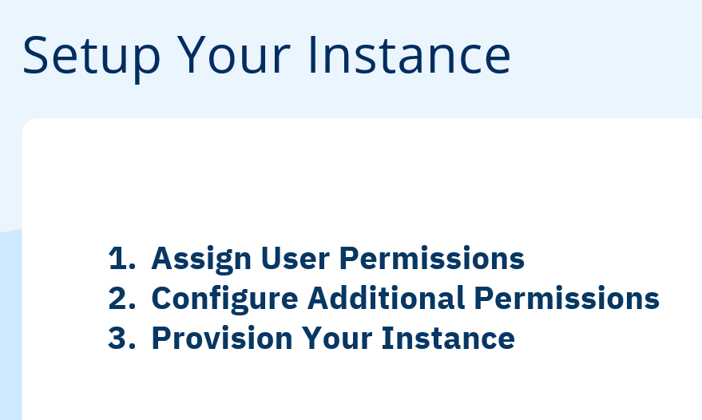

**Setup Steps**

**Step 1 - Assign User Permissions**

To setup and configure your Data Cloud instance it is required to enable **Admin** permission set to the relevant Salesforce CRM user. Login to your Salesforce CRM instance where Data Cloud licenses were provisioned and validate whether or not the necessary permission has been pre-assigned to your user.

Click on the application switcher (top left) and type data in the search field (see example on the right).

If the Data Cloud application is found and you can navigate to it then proceed to the [**Step 2**](https://salesforce.quip.com/7IusAboUvMj4#TKJACAZ6hMe) below.

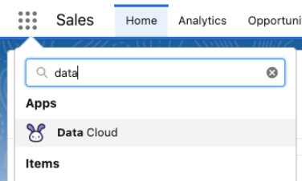

If you don’t see the Data Cloud application in the application switcher then complete the following task:

* Following the instructions in [this help article](https://help.salesforce.com/s/articleView?id=sf.c360_a_setup_walkthrough.htm&type=5):
  + Assign Data Cloud Admin permission set to your Salesforce CRM admin user

**Step 2 - Configure Additional Permissions**

In order to support proper data generation in your learning org enable below specified feature and assign additional permission to your user.

Navigate to **Setup** and in the Quick Find search for the User Interface and click on **User Interface** link at the bottom of the menu items:

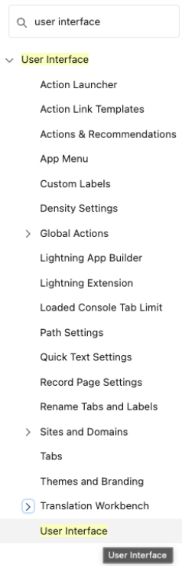

Enable Set Audit Fields upon Record Creation... option under **Setup** and save settings.

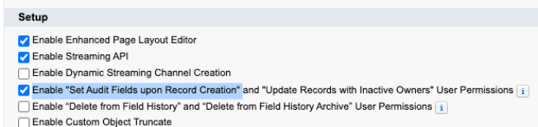

Navigate to **Users > Permissions Sets** and configure new permission set:

Click “New” -> Allow modification for date field -> save-> manage assignment->select your user’Swati’-> Save & Assign

* Label = Allow modification for case dates
* Click on **System Permissions** link in the **System** section:
* 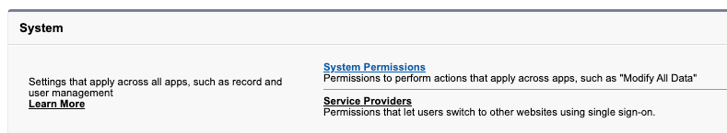
* Click **Edit**, search and enable Set Audit Fields upon Record Creation option:
* 
* Click **Save** and confirm in the confirmation dialog.
* Click **Manage Assignments** and assign that permission set to your user.

**Step 3 - Provision Your Instance**

Make sure to complete the Data Cloud provisioning process. You only need to complete it once, after assigning your user **Admin** permission set.

* Click on the **Setup ⚙️** in the top right (you might need to reload the page to account for above-assigned permission sets)
* Navigate to **Data Cloud Setup > Setup Home**
* 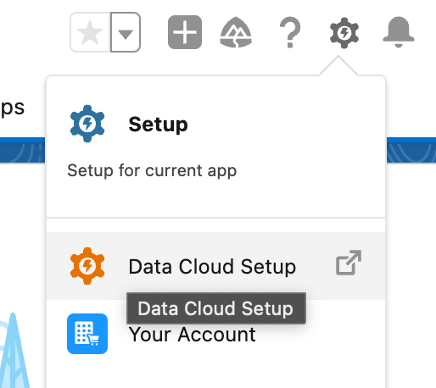
* Provision the instance from the **Are you ready to setup** prompt by clicking on the **Get Started** button
* 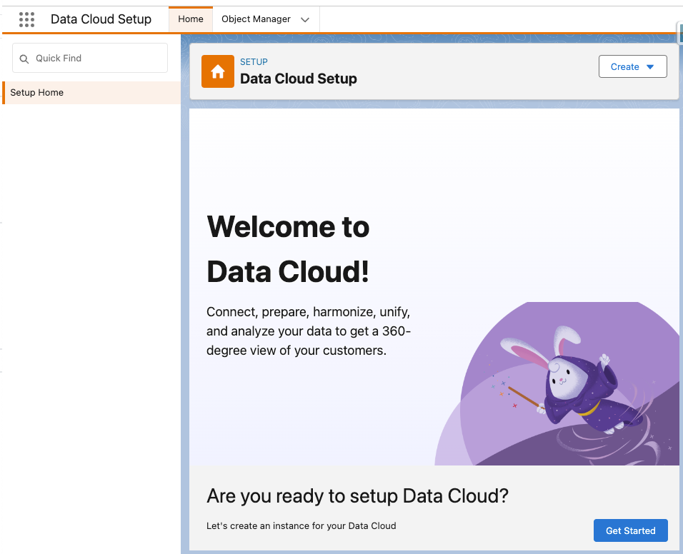
* Confirm that all steps completed successfully (as per the screenshot below)

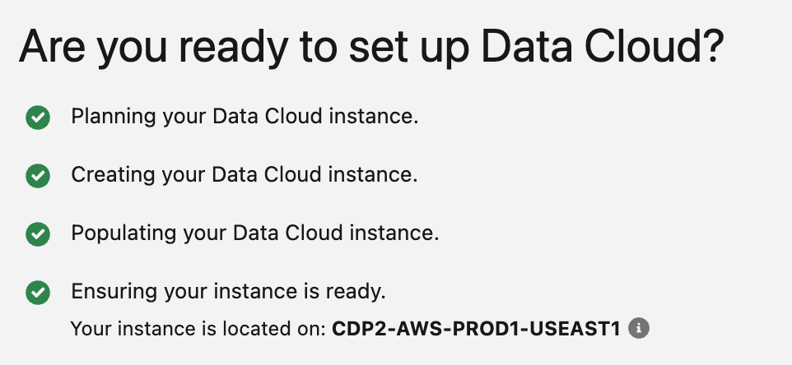

**⚠️**You may see “Failed to populate your Data Cloud instance, retrying now”. This happens when there’s a high volume of new provisioning requests. In most cases, **this process is resolved by simply waiting until the process completes.** Thanks for your patience as we do everything to meet the extreme demand of this program.⚠️

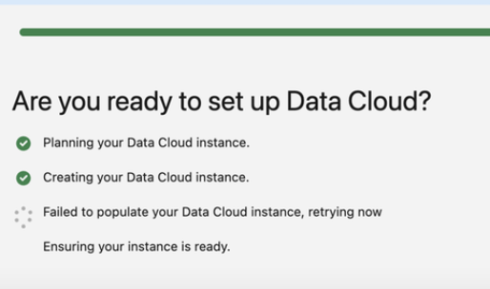

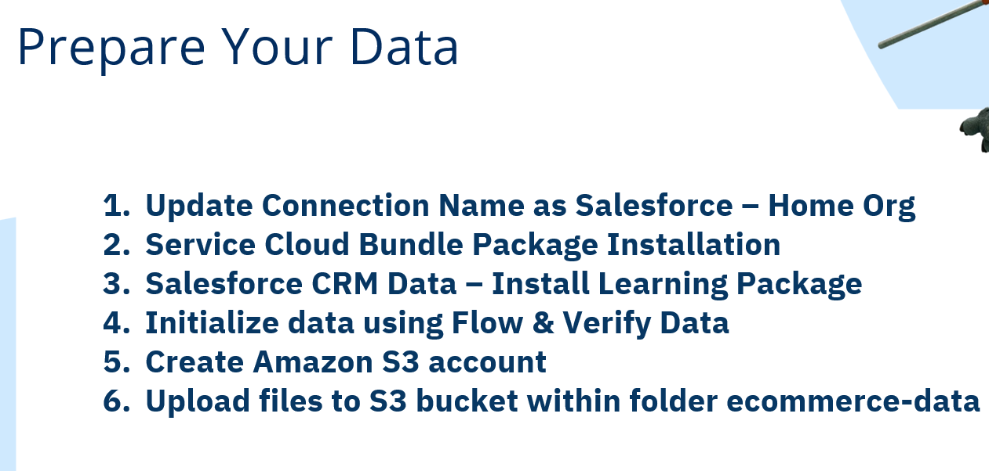

**Step 4 - Update Connection Name**

For our scenario we are loading data from the same Salesforce CRM org where Data Cloud instance is provisioned in. This org is usually referred to as “home org”.

Once the Data Cloud provisioning completes the connection to that CRM org will be established. All that is required here to update the name of that connection.

* Navigate to **Data Cloud Setup > Salesforce CRM**
* Confirm that your connection was established and has Active status:
  + 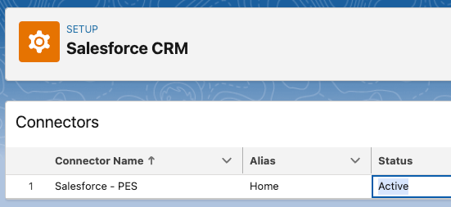
* Next update the name of the connector. This is quite helpful when you connect to more than one org, especially when you start configuring data ingestion.
  + Click on the edit icon in the Name column:
  + 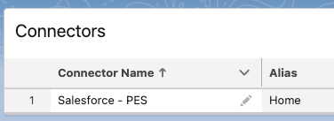
  + Update the name to Salesforce - Home Org and save the change:
  + 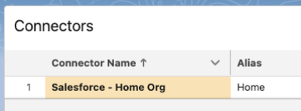

At this stage the connector for Salesforce CRM will enable data ingestion, but if you need to ingest data using standard data bundles then these will need to installed separately (as a package), below from the same screen:

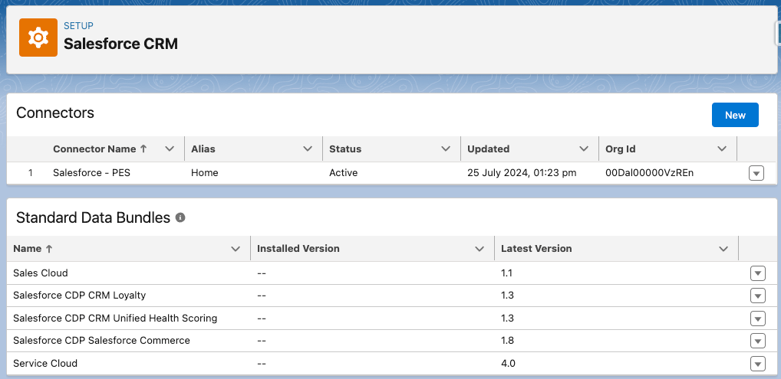The latest Service Cloud bundle has compatibility issues with the current version of the learning course and will raise conflicts in your trial version of Data Cloud environment. Instead install version 1.2 that was used when this guide was developed and published.

1. In the browser window copy the URL and paste it into the new tab/window.
   1. In the URL remove anything after the top level domain of your instance, and append the following: /packaging/installPackage.apexp?p0=04tB0000000UpWu
      1. e.g. something like https://mydc-dev-ed.lightning.force.com/packaging/installPackage.apexp?p0=04tB0000000UpWu
      2. where mydc-dev-ed.lightning.force.com is the top level domain of my org
   2. Alternatively you can also click on this link and login with your org credentials:<https://login.salesforce.com/packaging/installPackage.apexp?p0=04tB0000000UpWu&isdtp=p1>
2. Choose Install For Admin Only option and install the package:
   1. 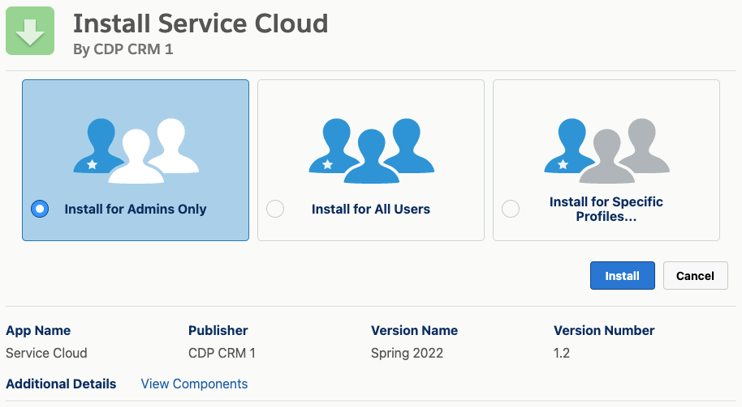

Wait until package install completes or you receive confirmation via email:

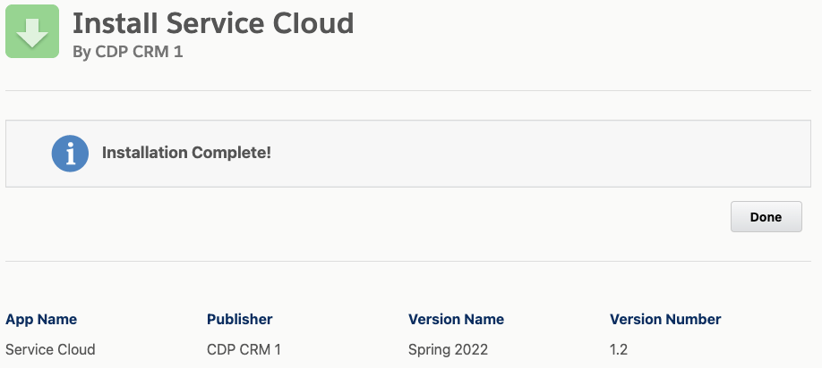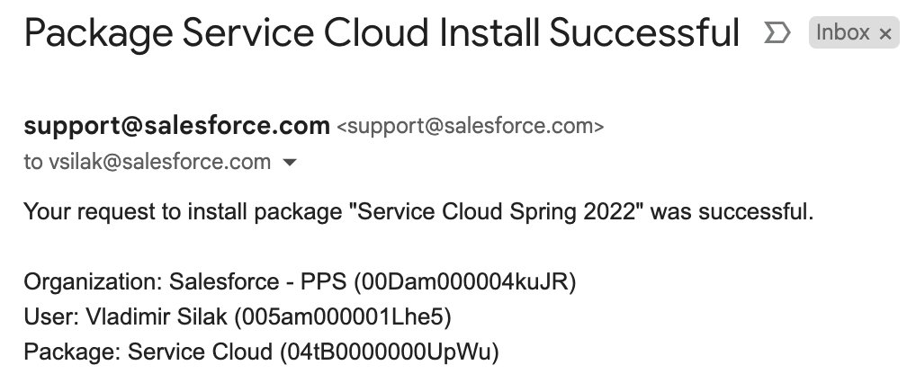You can close the tab of the browser and return to the **Data Cloud Setup > Salesforce CRM**. Verify that bundle package now has installed version populated:

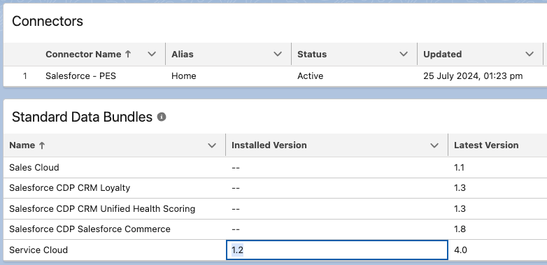

***Objectives*:** In the course of this exercise you will:

* Initialize and verify sample data in your CRM org
* Download sample commerce data files and upload them to Amazon S3 bucket

**1. Salesforce CRM Data**

To configure necessary data model in your CRM org and generate records to be used in this workshop install learning package and run flow included in it.

**1.1. Install Learning Package**

NOTE: The Learning Data Model Package has only been tested with the Data Cloud Trial Org provided as part of the Partner Learning Camp Training Curriculum. It has not been tested with the different SDO, IDO and EDO orgs.

1. Assuming you are logged into your org and have it opened in the browser window copy the URL and paste it into the new tab/window.
   1. In the URL remove anything after the top level domain of your instance, and append the following: /packaging/installPackage.apexp?p0=04tDm0000000yOj
      1. e.g. something like https://mydc-dev-ed.lightning.force.com/packaging/installPackage.apexp?p0=04tDm0000000yOj
      2. where mydc-dev-ed.lightning.force.com is the top level domain of my org
   2. Alternatively you can also click on this link and login with your org credentials:<https://login.salesforce.com/packaging/installPackage.apexp?p0=04tDm0000000yOj&isdtp=p1>
2. Choose Install For Admin Only option and install the package:
   1. 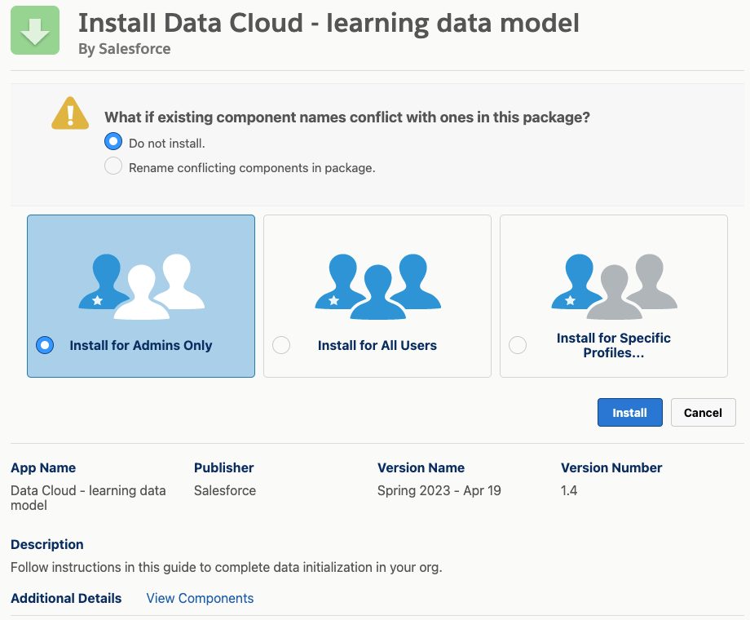

Click **Done** when installation completes.

NOTE: If you get an error stating that ‘There are problems that prevent this package from being installed’ make sure you have followed all of the hands on instructions in the ‘Setup’ hands on activity detailed in [Ex: Data Cloud - Setup Your Instance ⚙️](https://quip.com/xtBkAY1bZLhV) including the Set Audit Fields upon Record Creation... option

**1.2. Initialize and Verify Data**

In order to prepare the records within your learning org run the flow deployed with the learning package.

* Navigate to **Setup > Process Automation > Flows**
* Locate and open Initialize Learning Environment flow
* Click **Run** button to execute flow
* 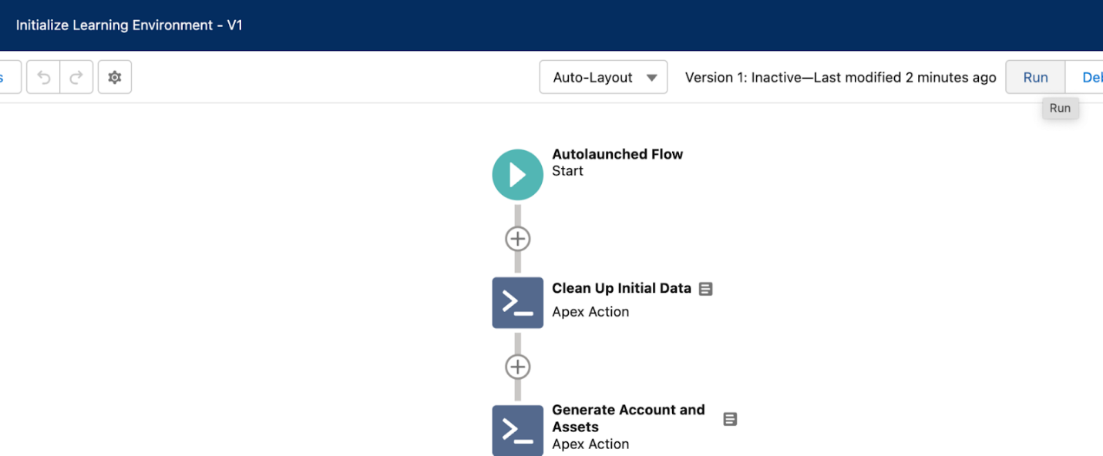
* The system will open new tab/window and upon completion you should see the following message:
* 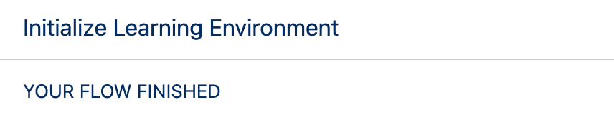
* Close this browser tab/window.
* Next verify records that were created as a result of this flow execution.
* In the application switcher (top left) locate and open **Vehicle Rentals** application.

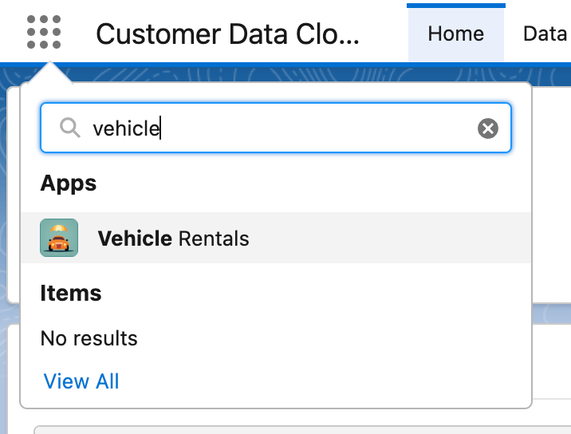

* On the **Rentals** tab change list view to All and verify that there are 22 records

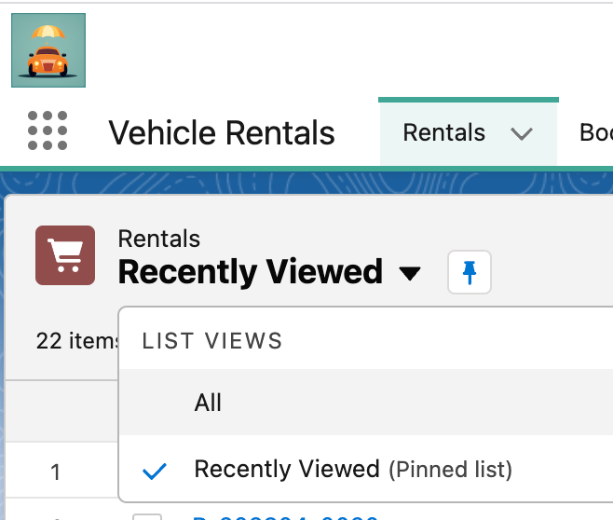

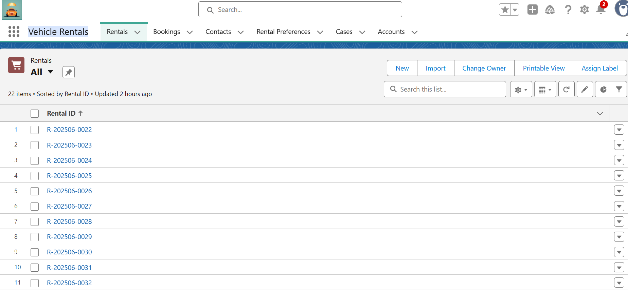

* Similar to that verify other tabs:
  + Bookings = 8 records
  + Contacts = 100 records
  + Rental Preferences = 7 records
  + Assets = 25 records
  + Cases = 5 records

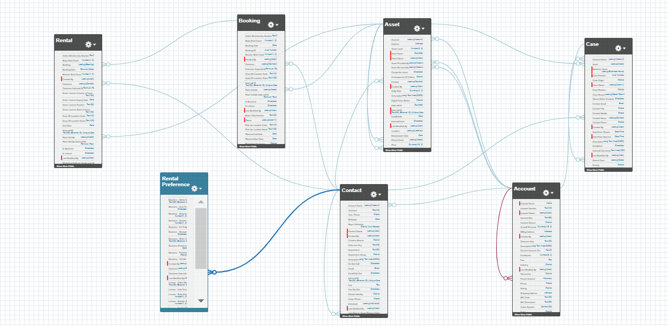

As long as you’ve got all the counts as expected the data is ready and you can proceed to the next step.

**2. S3 Data From Commerce Platform**

If you already have an S3 instance that you can use no need to sign up for a new one. Take a note of your [programmatic credentials](https://docs.aws.amazon.com/general/latest/gr/aws-sec-cred-types.html#access-keys-and-secret-access-keys) (Access Key ID and Secret Access Key) that can be used to access the account.

If you don’t have [Amazon S3](https://trailhead.salesforce.com/en/content/learn/v/modules/aws-storage/get-object-storage-with-amazon-s3) account - [register for the free tier](https://aws.amazon.com/free/), and then follow instructions in [Setup Amazon S3 User For Data Cloud Guide 🔰](https://quip.com/Ge0zAXFPcYLE) to create dedicated user with limited permissions for this workshop.

After signup:

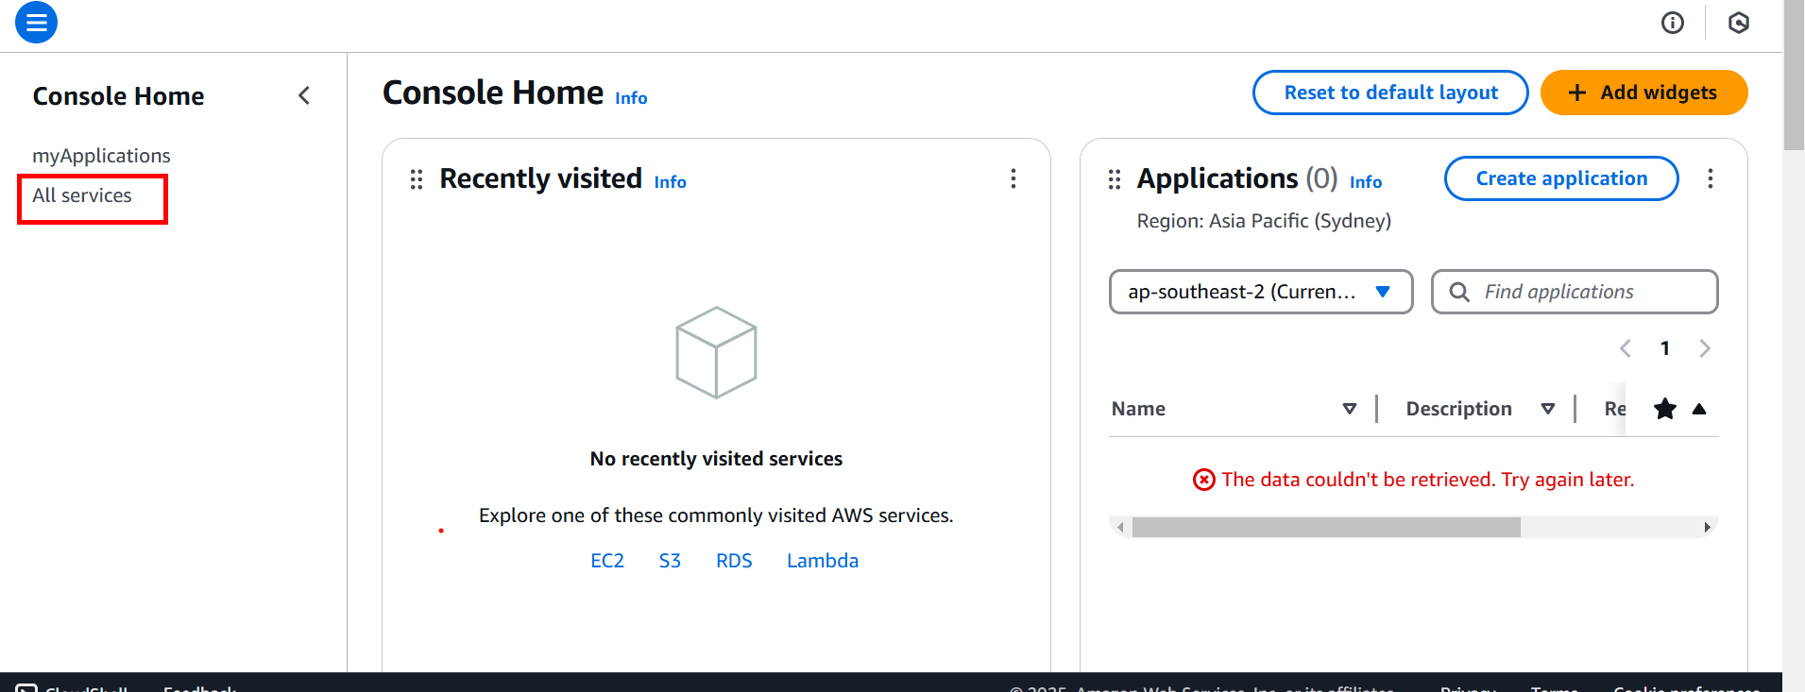

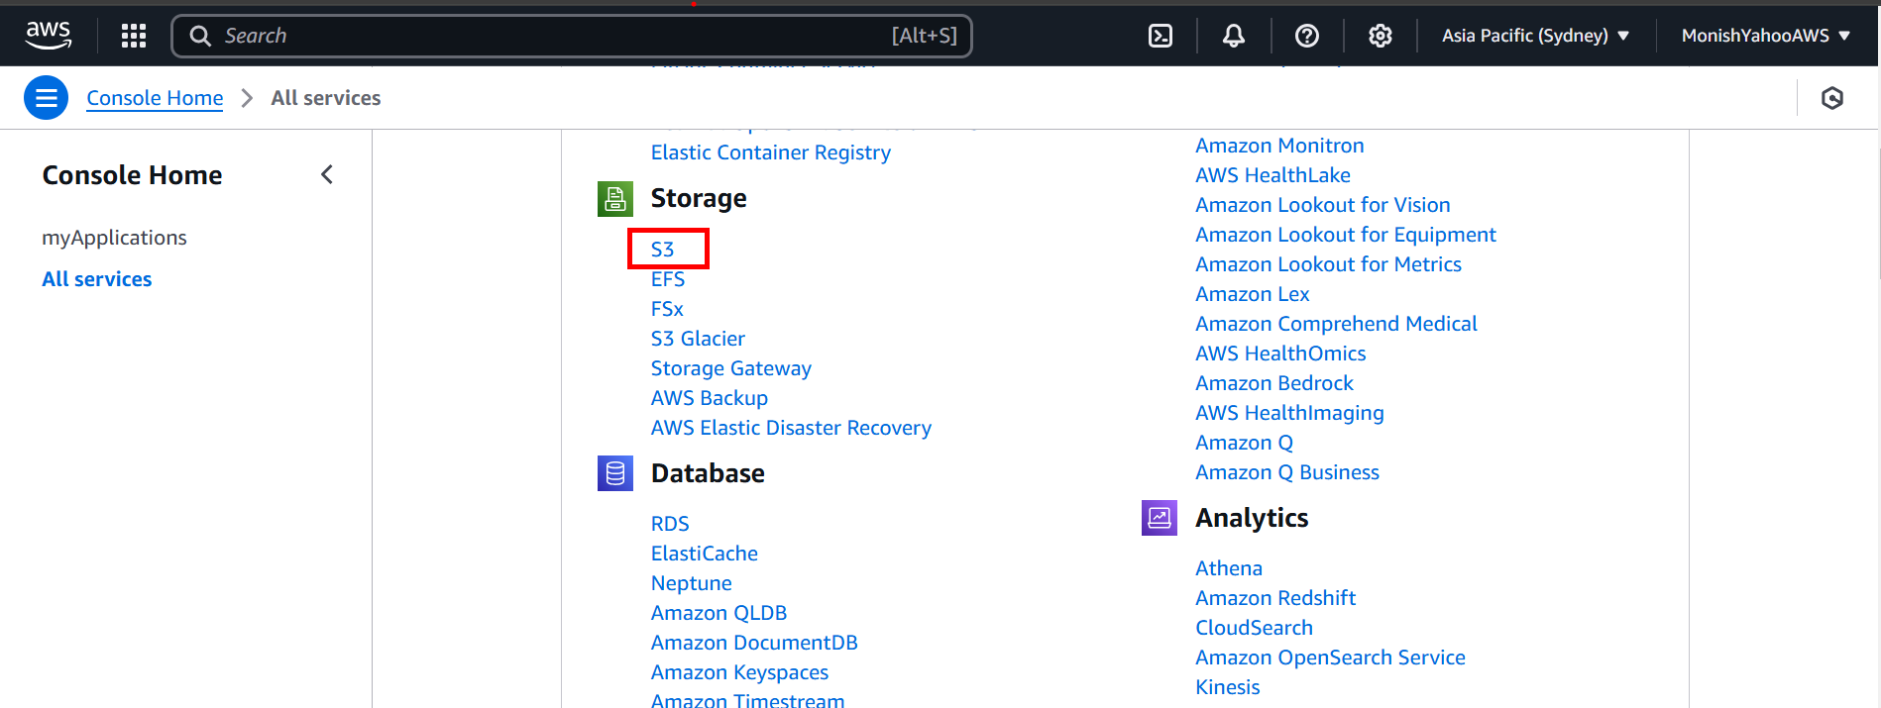

Bucket Name - <monish>s3bucket

Leaving all default options and submit

Click on bucket <monish>s3bucket

Create folder:

ecommerce-data

 Leave all default options and scroll down - Create it

Select folder -> Click upload – Add files

Select 3 files shared in the Teams

Upload

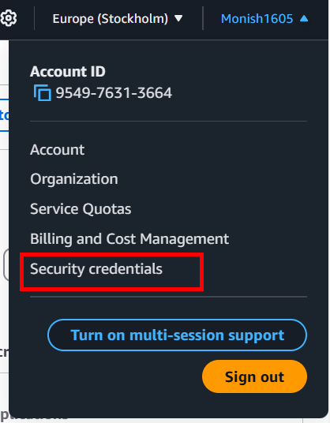

On Top Right profile - > Security Creds -> Access Key - Create access key

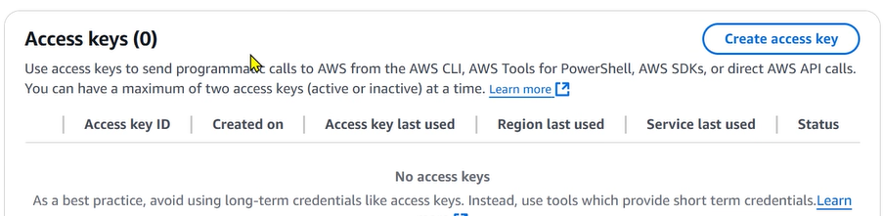

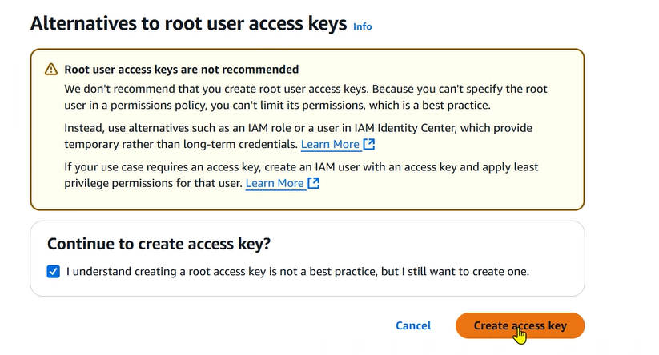

Copy paste Access Key and Secret access Key

**⚠️ Note:** for the workshop we use .csv files that are ingested from S3. The import process supports GZIP compression too, so if the inbound data volume is large it might be practical to compress it before deploying to S3 and subsequently ingesting into Customer Data Platform. ZIP compression while supported might cause long term challenges as this compression is not supported with **Aggregate Mode** setting that results in multiple files being combined prior to import.

**2.1 Upload files to S3 bucket**

Log into Management Console and proceed to [S3 service](https://s3.console.aws.amazon.com/s3/home) and create a new bucket (name it as you wish). *Note, if you followed the guide to setup permissions you don’t need to create another bucket.*

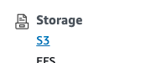

Download following files to your computer:

* [S3 Customer Profile.csv](https://quip.com/-/blob/SaXAAAE6BaL/esYFmhMZYqJlMDq3bx8LRg?name=S3%20Customer%20Profile.csv&s=OjXSA7LMp8N5) (100 records)
* [S3 Order Headers.csv](https://mc-00tq6cdjppzlxr9vvx98rqyy1.pub.sfmc-content.com/k32upi32nsn) (252 records)  
   *depending on your browser you might need to use Right-Click + Save As to save this (Order Headers) file*
* [S3 Order Line Items.csv](https://quip.com/-/blob/SaXAAAE6BaL/Q_RPBKMpnun2zRpcmOpUXw?name=S3%20Order%20Line%20Items.csv&s=OjXSA7LMp8N5) (649 records)

To download the S3 Order Headers.csv file, please Right+Click and Save As

In your S3 bucket create a folder called ecommerce-data and upload previously downloaded files in this directory.

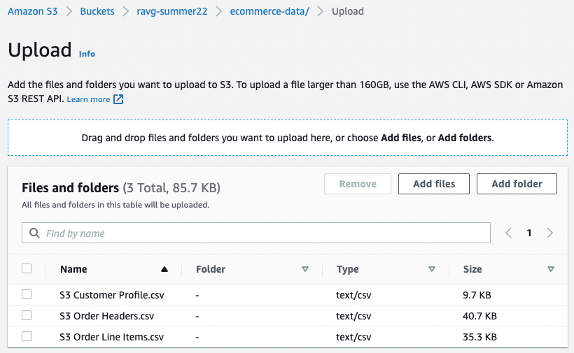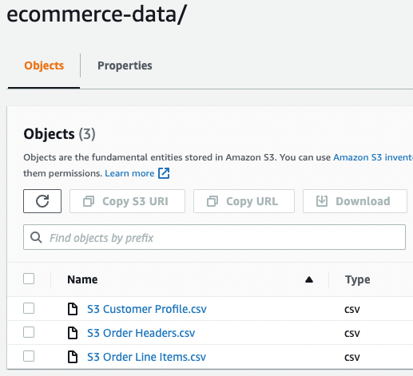

**CONFIGURE DATA INGESTION:**

In this exercise you will go through the configuration of the required data streams to ingest the data from multiple sources into your Data Cloud instance.

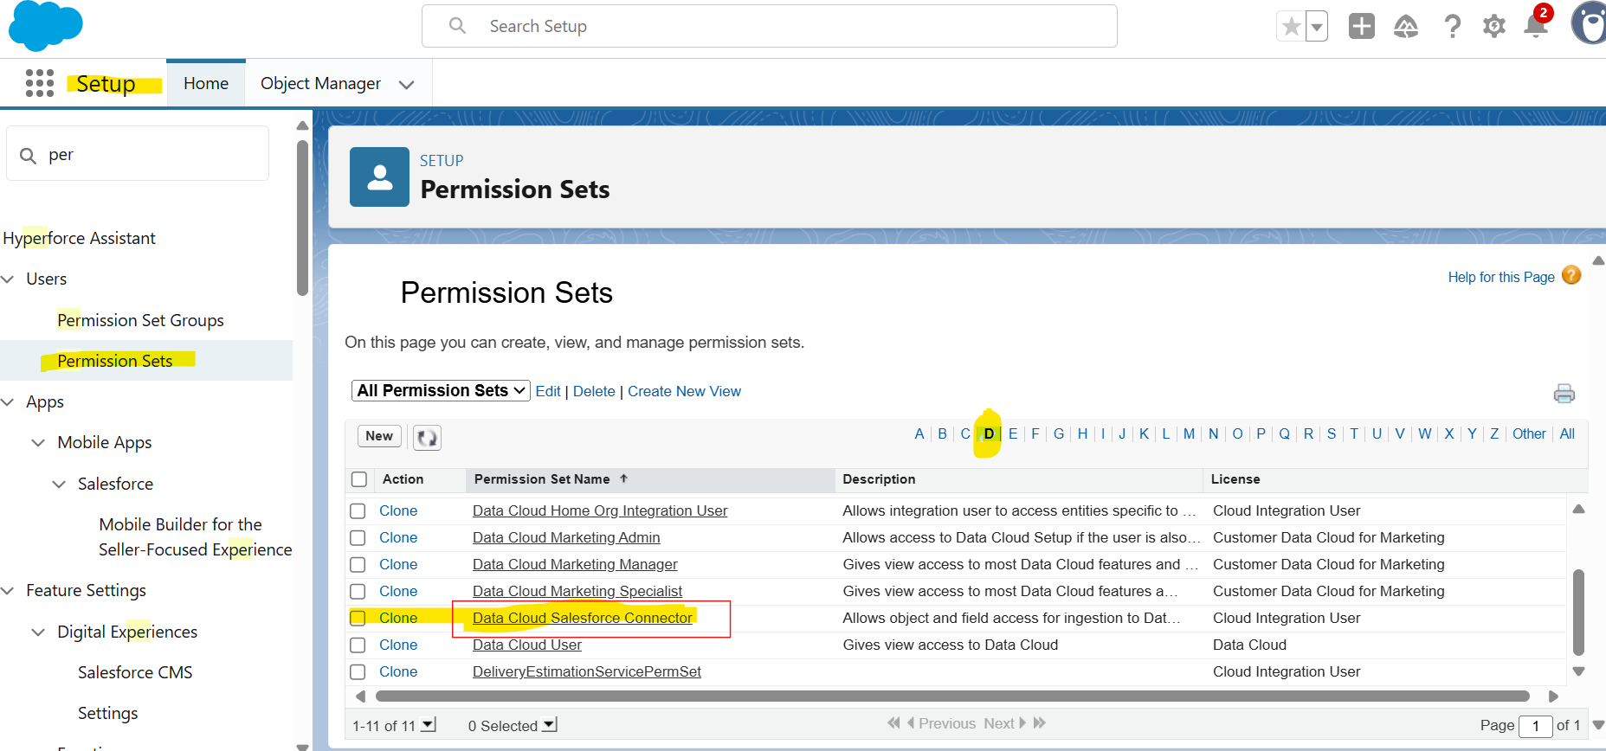

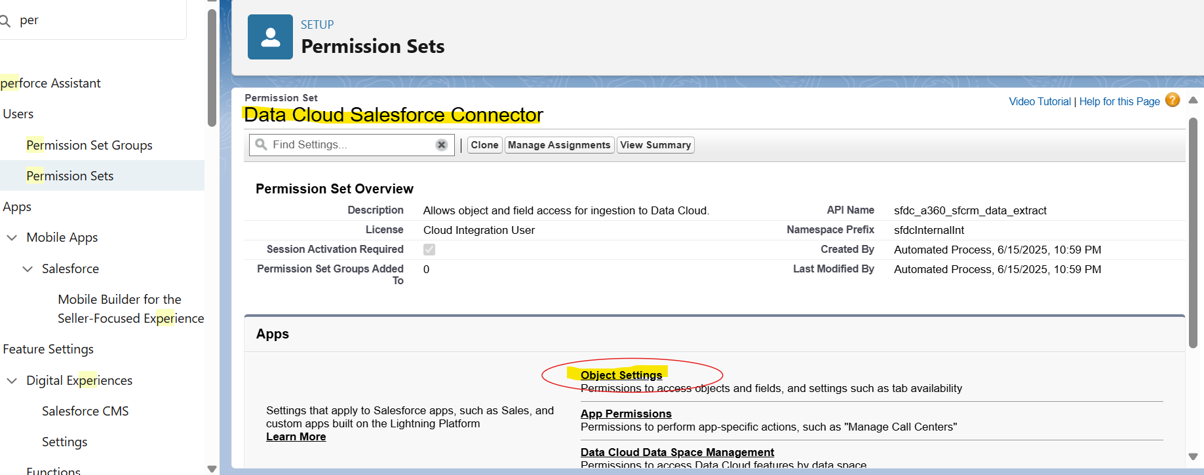

Go to contact Object in Object setting and give Read access

Same step to case , account object for Read access.

Click Edit and at field level, check the Read only check box and SAVE.

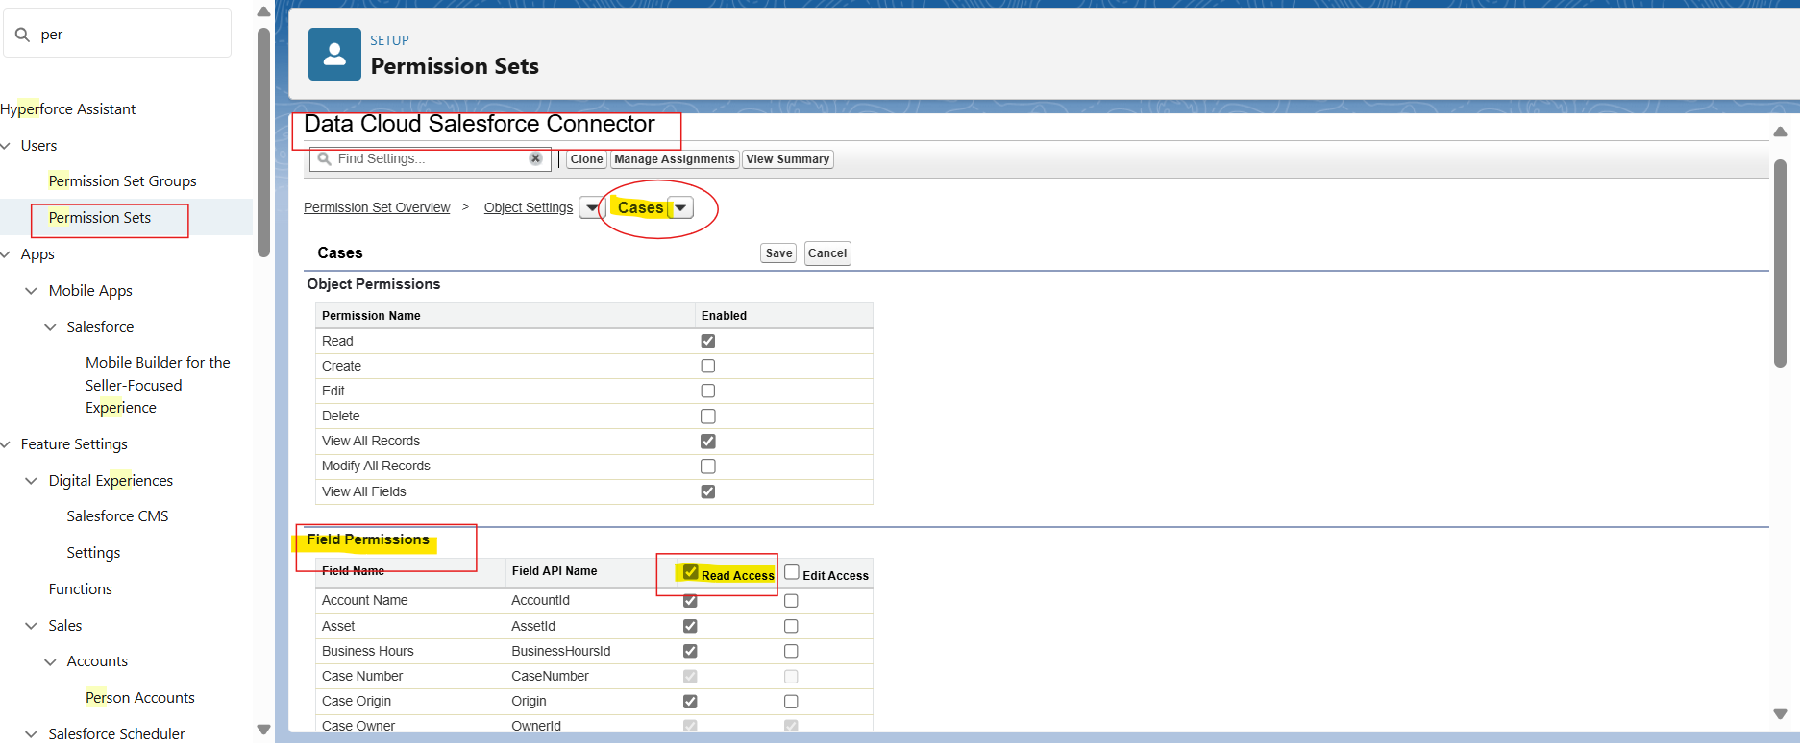

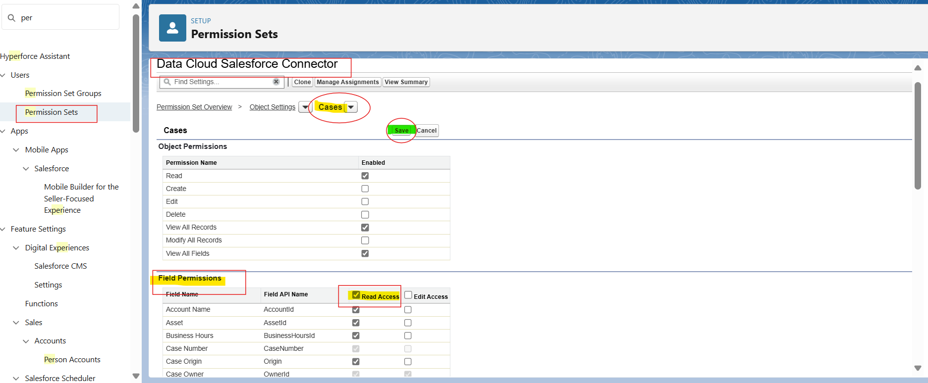

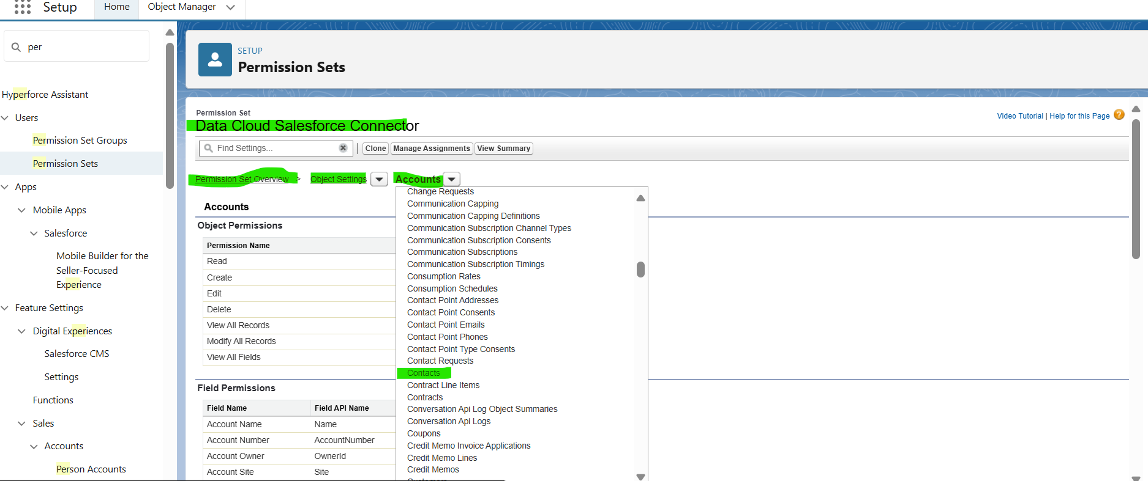

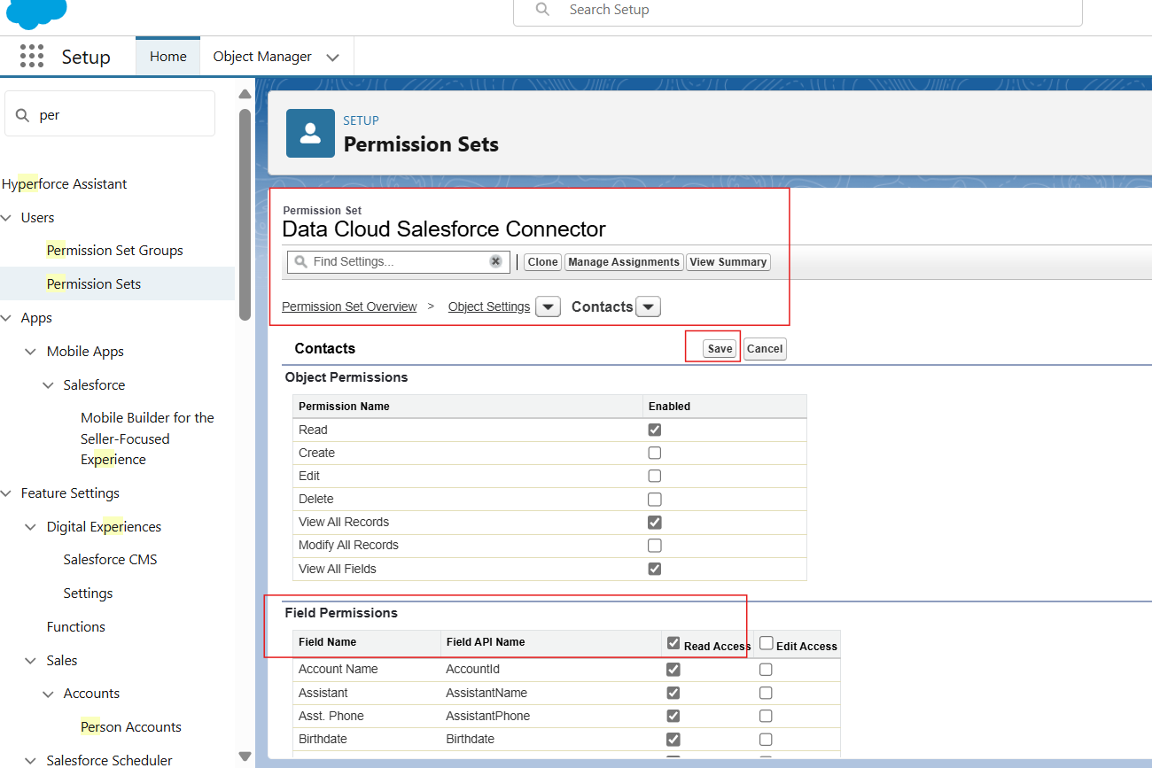

***Data cloud in Applauncher***

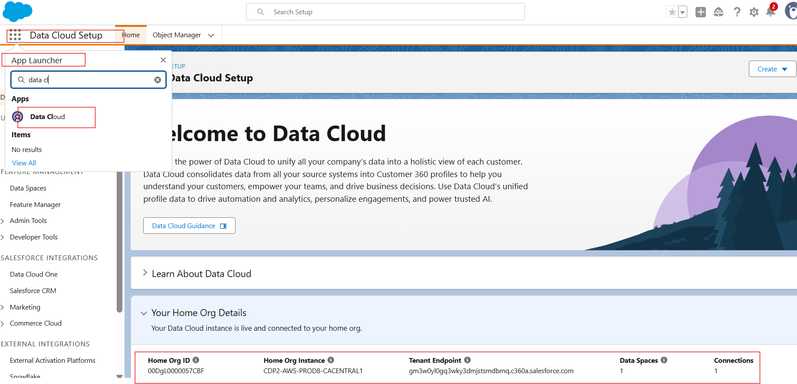

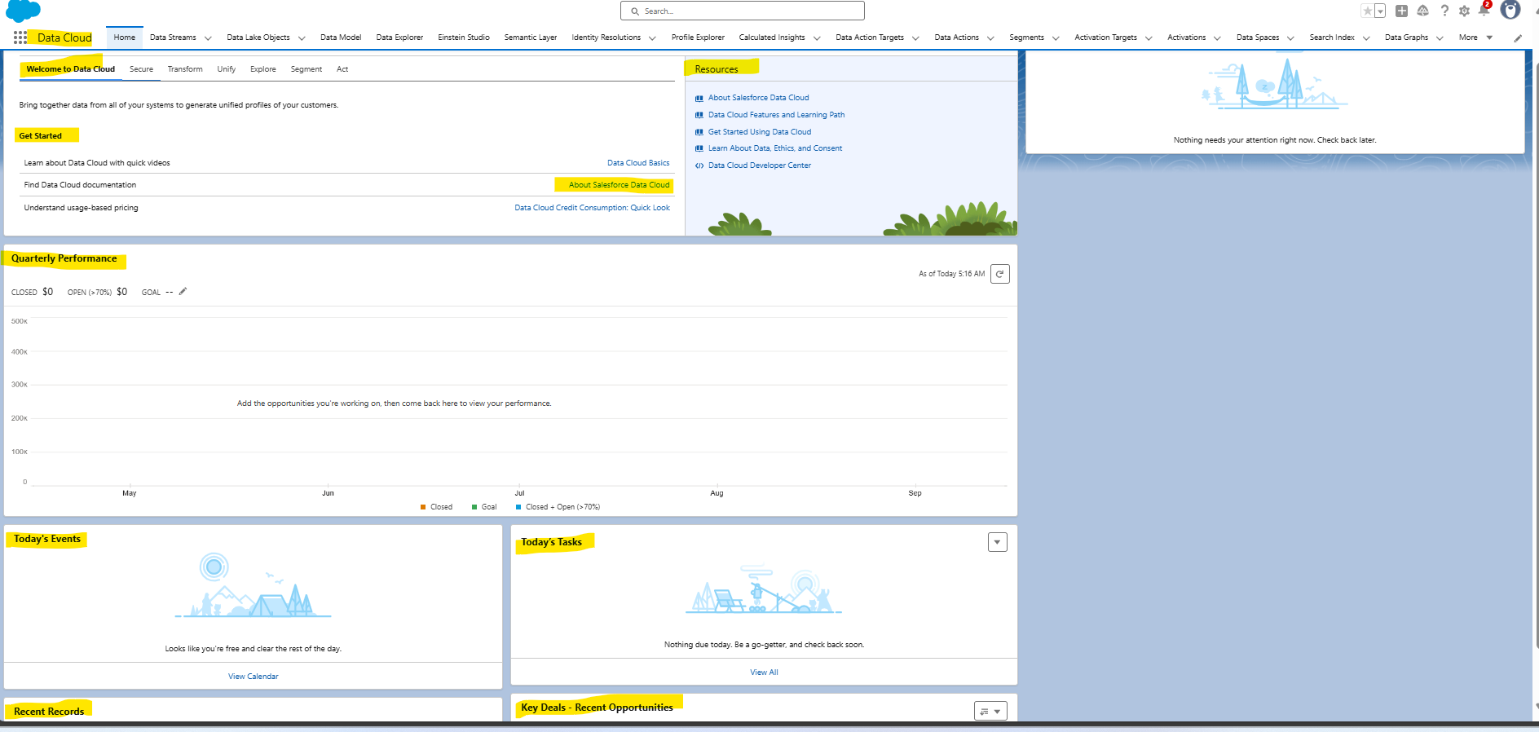

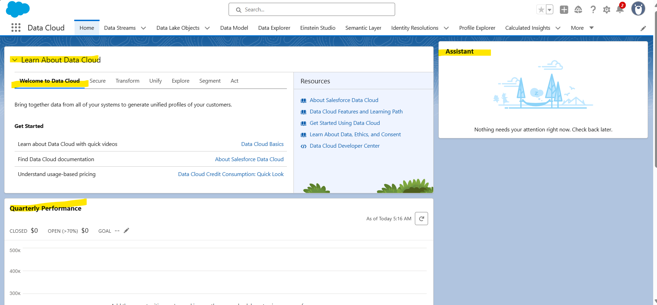

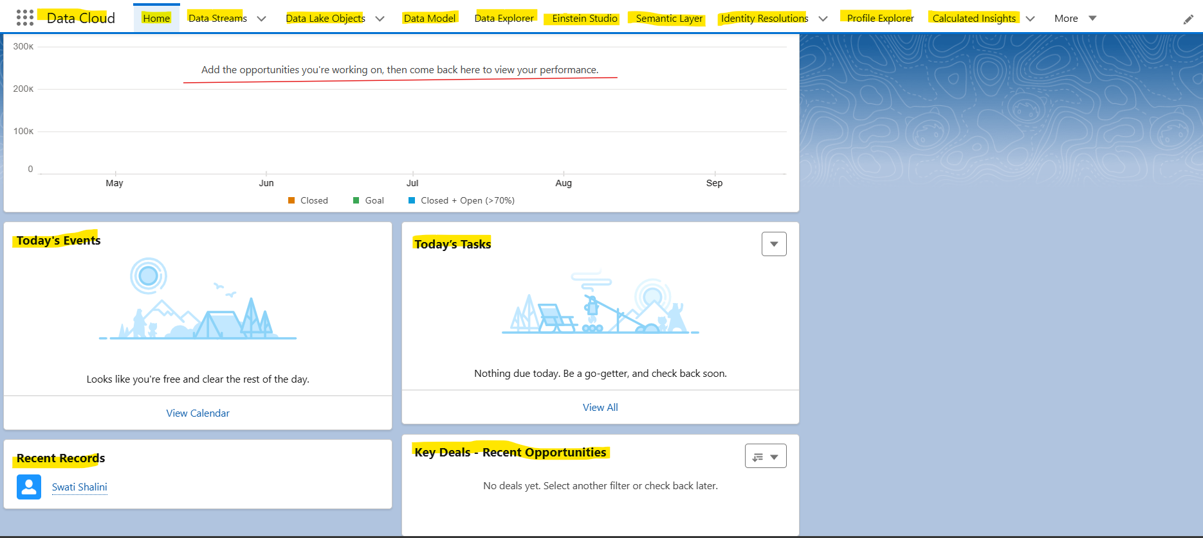

***Data Stream:***

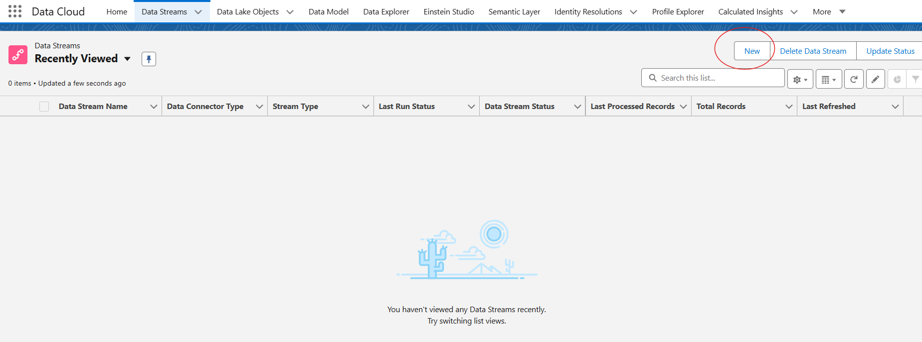

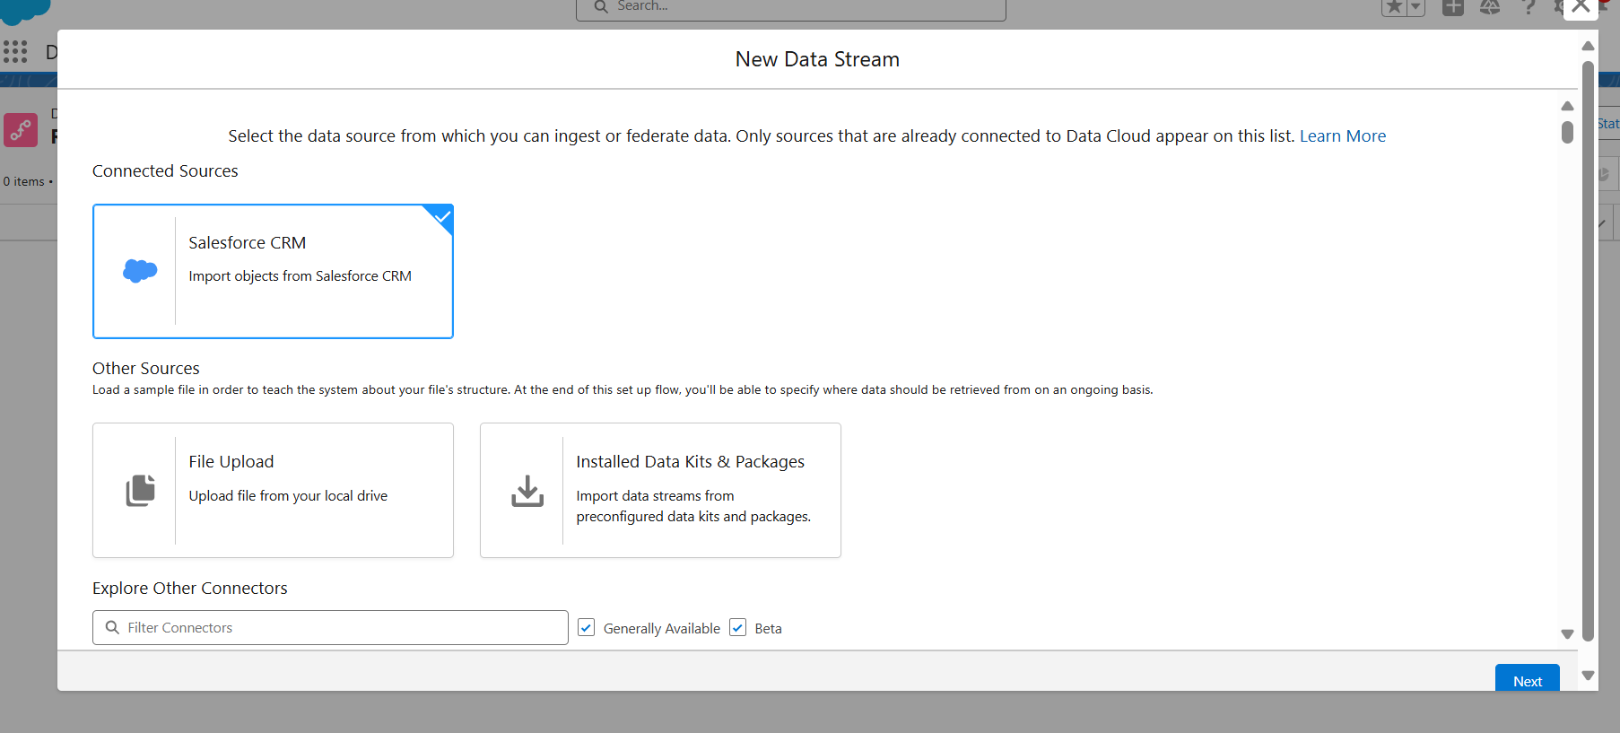

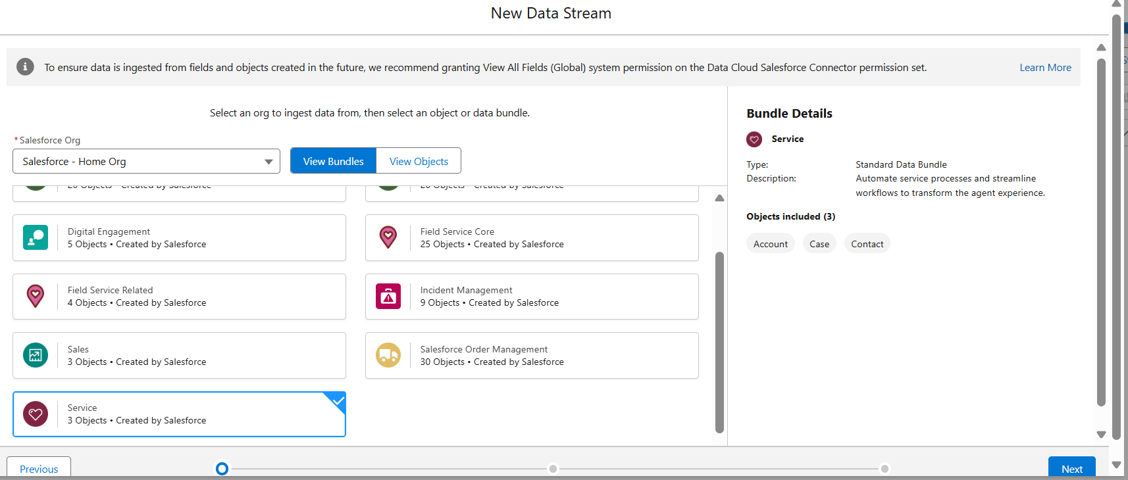

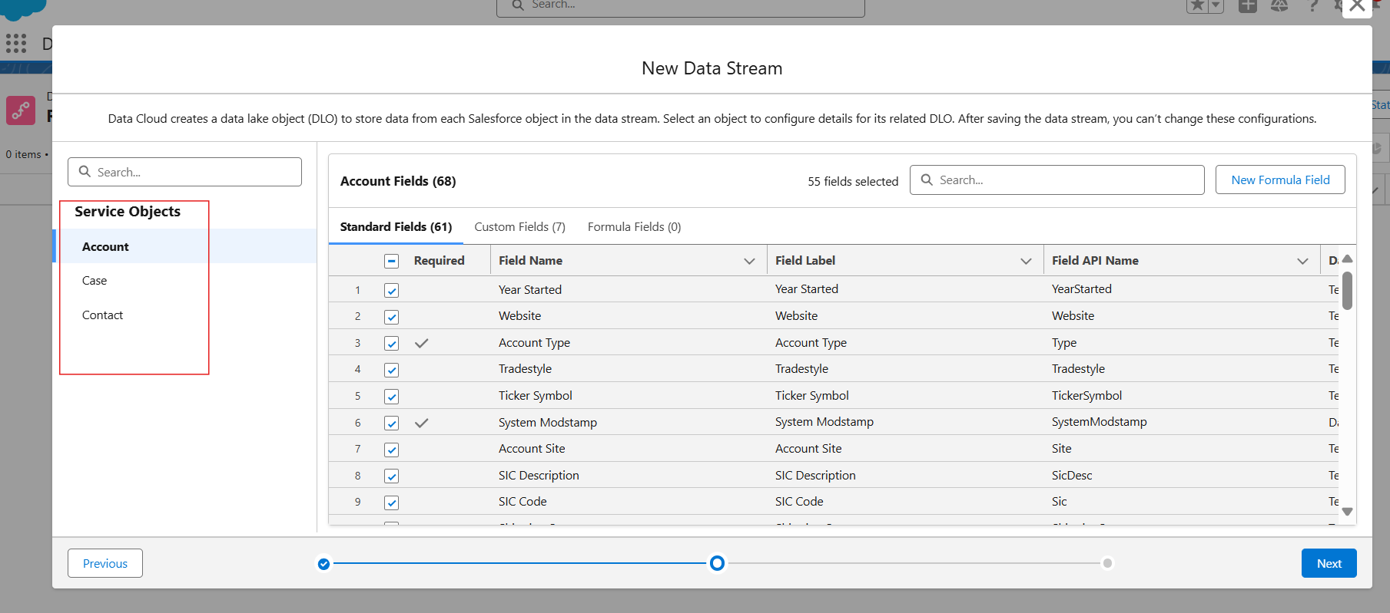

***Go to contact and EDIT custom field, API field n save***

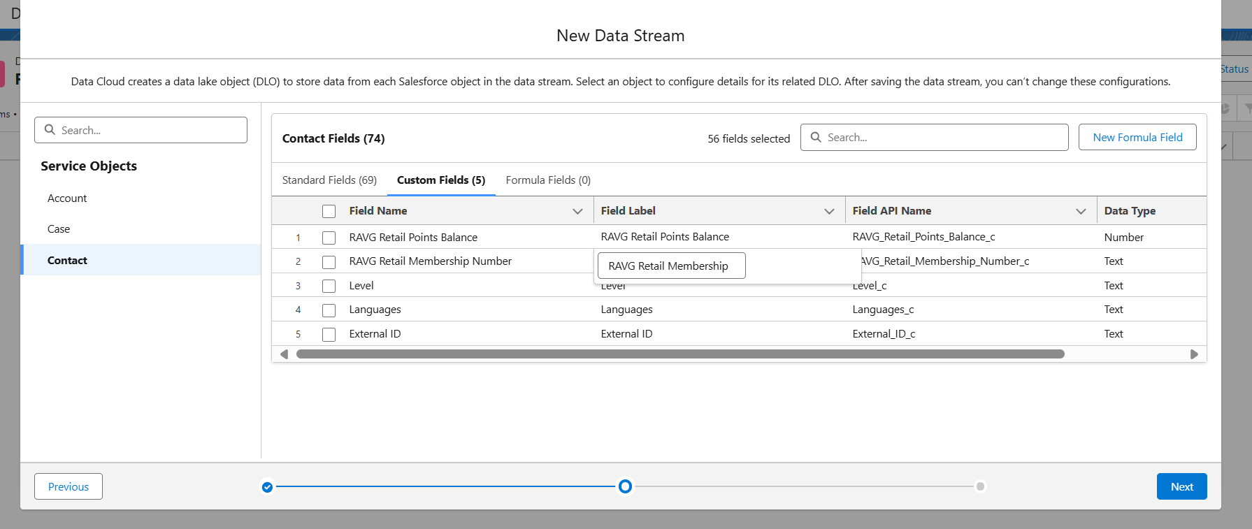

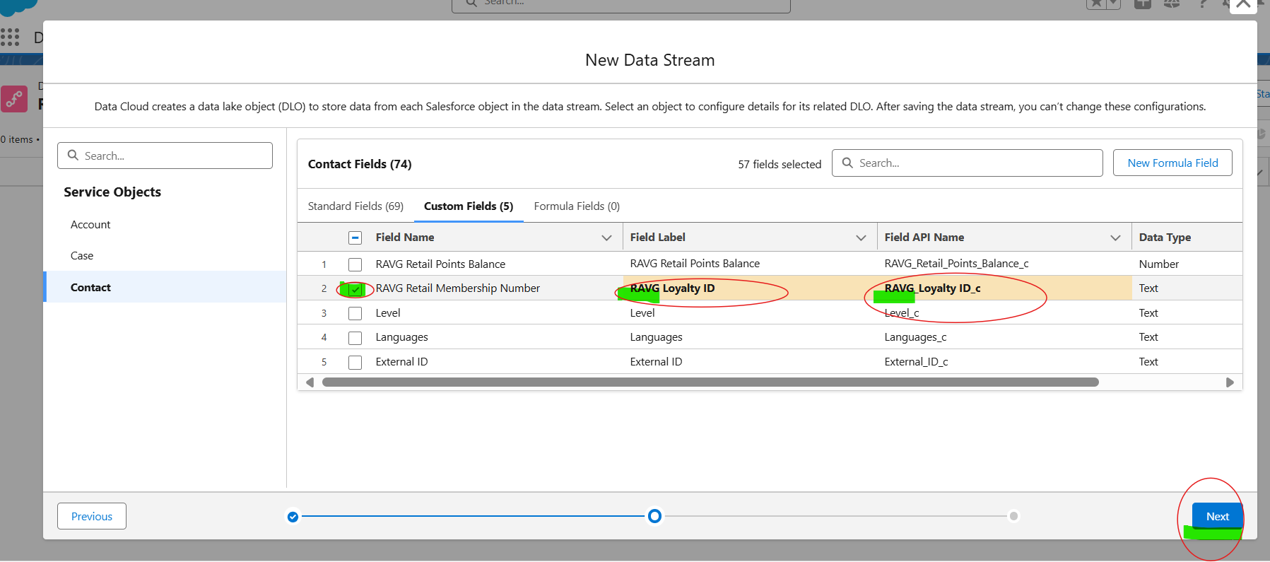

***No space so below is right one:***

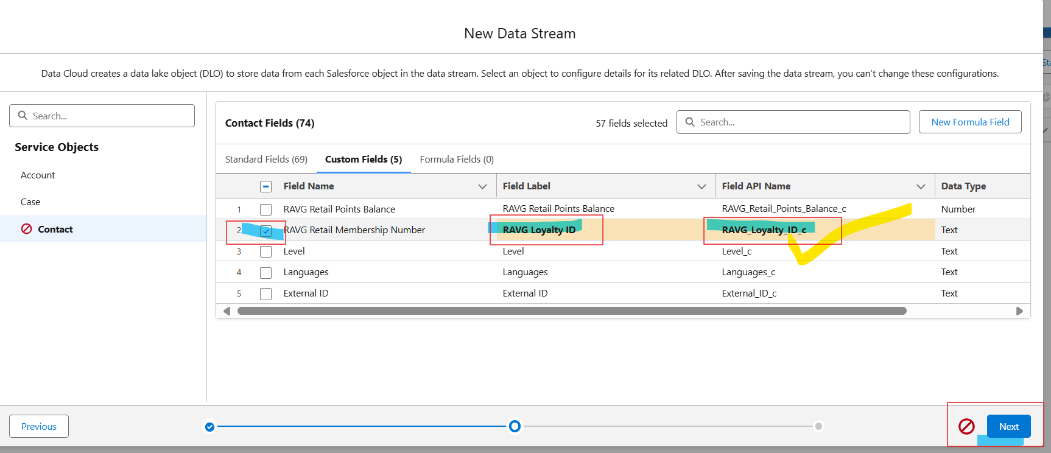

***Deploy***

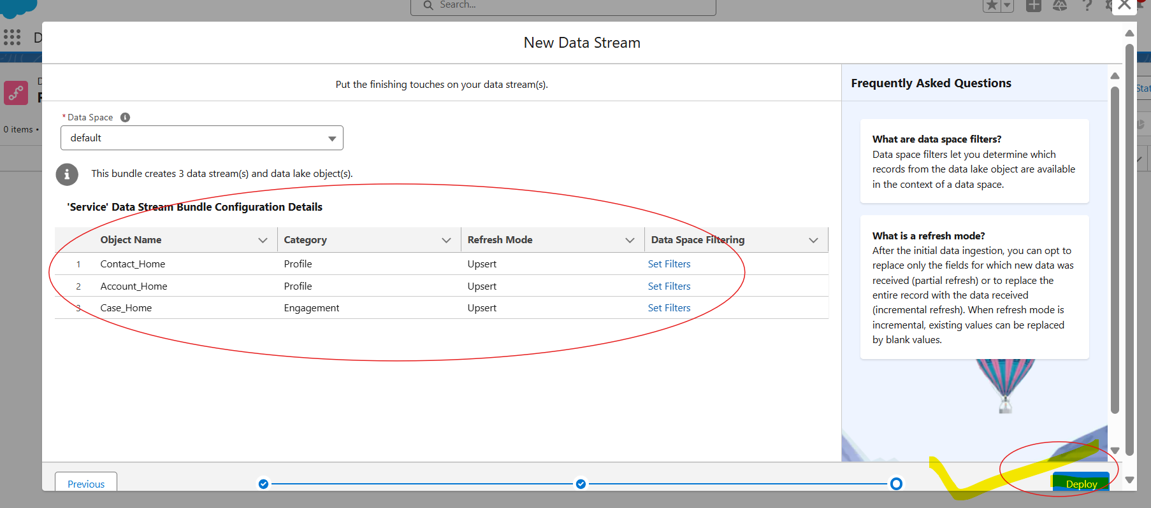

***You can create a formula field in contact / case / account Obj and Deploy….***

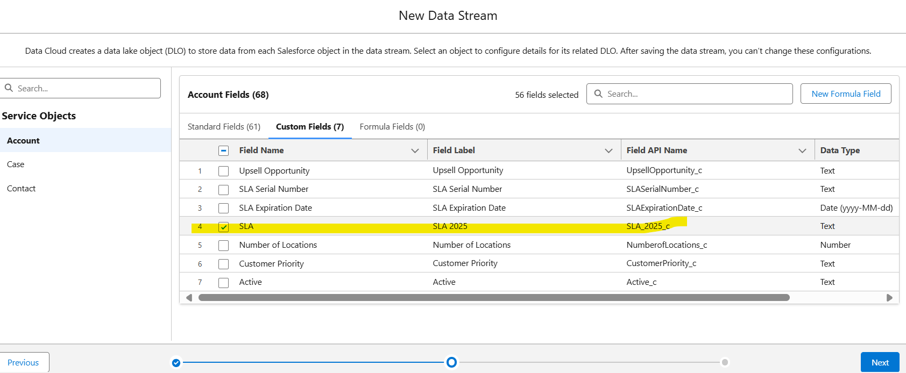

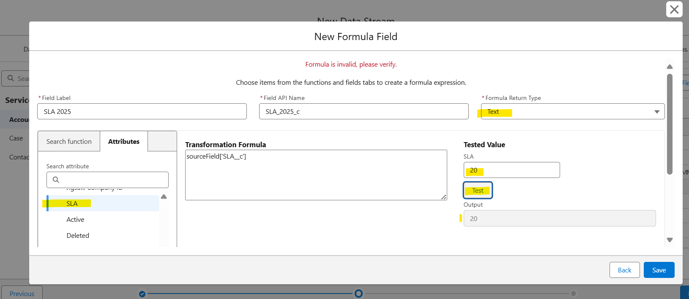

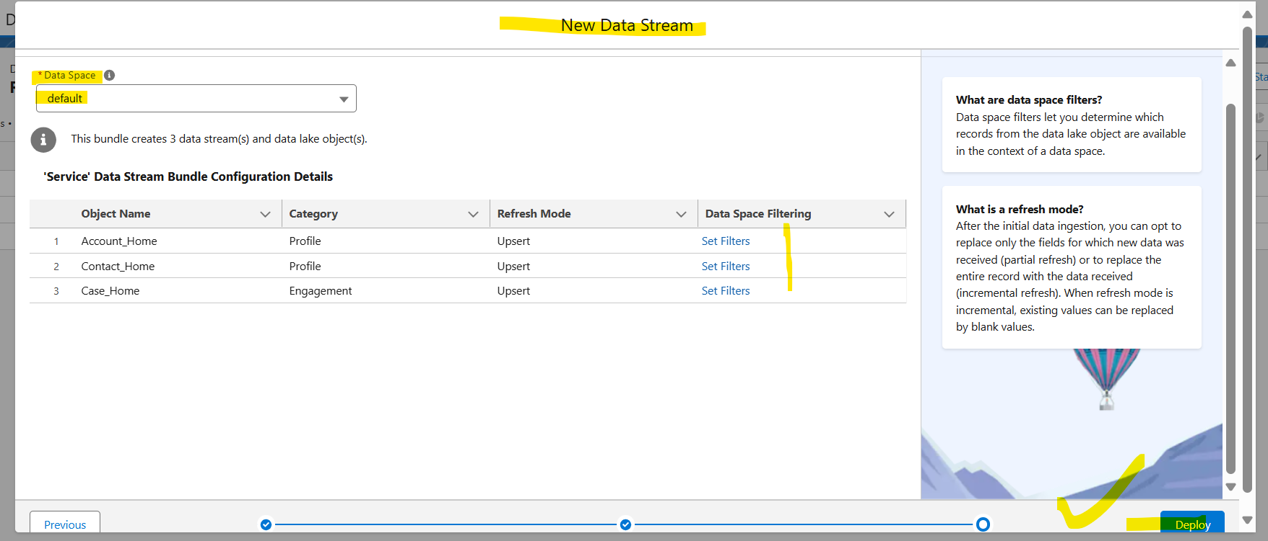

***You can Refresh or Run the Obj***

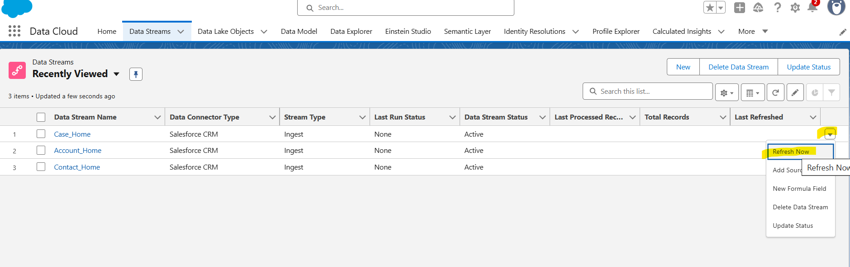

***Objectives*:** In the course of this exercise you will:

* Configure data ingestion from Salesforce CRM and Amazon S3 bucket
* Apply on-import transformation to data
* Define additional auxiliary attributes to assist with data modelling and support data lineage

***Note:*** Throughout this exercise you will require to replace following placeholders with respective values:

<ORG_ALIAS> = your Salesforce CRM instance identifier (15 char org ID), appended to the data stream names by default.

**Preamble**

As you complete the tasks in this exercise notice additional formula fields that are created throughout the data streams. These mainly fall into 3 categories:

* referential data points enabling data lineage (e.g. supporting feeds from multiple geographies)
* elements of clean-up and encapsulation of business logic to derive simple values to be used in segmentation
* additional auxiliary data points that enable distributed, normalized data load fit for Customer 360 Data Model

The last category is the trickiest as you need to ensure uniqueness of the values across one or more entities. Due to “flattened” incoming data set where multiple normalized entities in other system(s) were included in single record often without additional required identifiers these are now need to be created before we can map data to the Customer 360 Data Model.

Please note that we provide implementation approach that works for the simplified use case that underpins current workshop. In real life implementations these decisions need to be made way before implementation, during the data discovery, audit and mapping design exercises.

**Lookup Objects**

There are number of attributes designed to be used as foreign keys within the Customer 360 Data Model objects. And subset of the above-mentioned auxiliary data points provide values for these objects. We will refer to these as **Lookup** **entities** within the workshop guide and use additional data streams that make use of the same data sources, although configured with variations to avoid creation of the duplicate values in the Data Model.

**1. Salesforce CRM Data**

**1.1. Service Cloud Data Bundle**

This data bundle includes **Account**, **Contact** and **Case** objects. For the purpose of our workshop we will only make use of **Contact** and **Case** objects. We will go through the experience of removing unnecessary object (Account) from the deployed bundle configuration.

* Navigate to **Data Cloud** application and open **Data Streams** tab
* Following instructions from [help page](https://help.salesforce.com/s/articleView?id=sf.c360_a_create_crm_starter_bundle.htm&type=5)
  + Start configuration of the **Service** Standard Data Bundle
  + Upon selection of the bundle and attempt to proceed further you’ll get an error message
  + 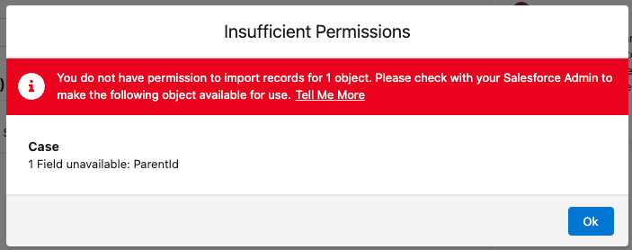
  + Follow the steps outlined in the help page [linked in the notification](https://help.salesforce.com/s/articleView?id=sf.c360_a_enable_user_permissions_external_salesforce_org.htm&type=5) to enable **Read Access** field level permission for the Parent Case field of the **Cases** object.
  + 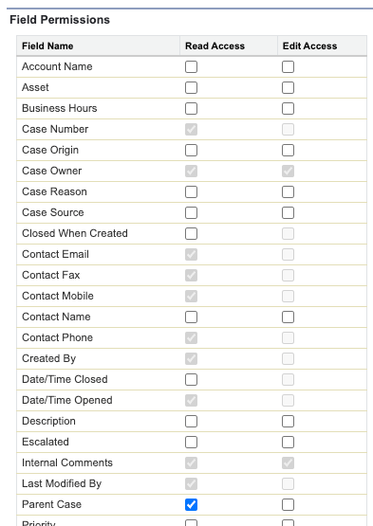

Do take a note about the need to enable necessary access permissions when connecting to the Salesforce CRM platform. While current error only highlights the need to update field level in real implementations you’ll find the need to enable access to objects as well as fields.

* Following similar steps update field level permissions for **Contacts** object, custom fields External ID and RAVG Retail Membership Number enabling **Read Access**.
* Once permissions updated retry selecting the bundle and proceeding to the next step of the configuration wizard

During this configuration step you can rename the Field Label and Field API Name values for the fields that will be ingested into the platform. Use it as an opportunity to simplify or refine the source field names to ease mapping steps later in the process.

⚠️ At the time of writing should you make any changes to the field selections prior to renaming Field Label and/or API Name, or adding new formula field these selections will be reset and all fields will be re-selected again. Hence the steps below are structured in a way that avoids repetitive actions.

* Select the **Contact** object in the list of **Service Objects** on the left side of the modal to begin configuring Contact fields
  + By clicking on the name of the field in the **Field Label** column modify the details of the following field:
    - Update the **RAVG Retail Membership Number** Field Label to RAVG Loyalty ID
      * 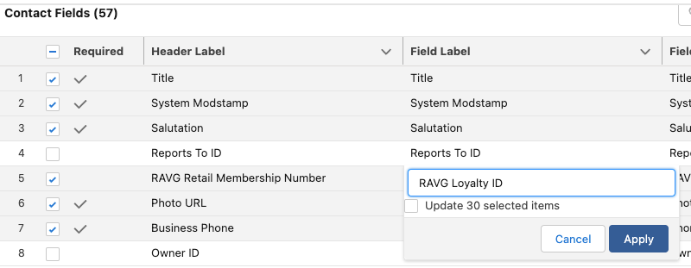
    - Update the **RAVG_Retail_Membership_Number_c** Field API Name to RAVG_Loyalty_ID_c
      * 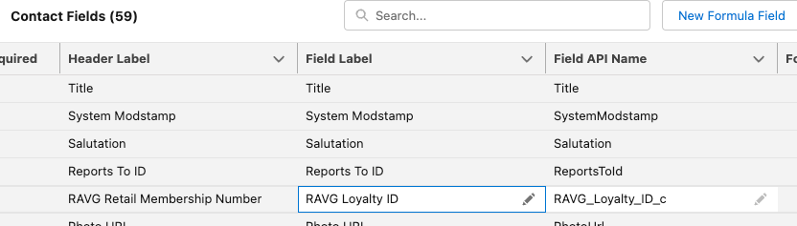

In order to later align the field that contains Birth Date from eCommerce source we need to adjust the data type for the **Birthdate** field of the Contact object. If we don’t make this change now, it would be quite challenging to apply that change later. Although you will notice that you are not able to modify system proposed data types. Therefore instead we need to configure new formula field.

* Add a new formula field to the Contact object:
  + Field Label = Birth Date
  + Formula Return Type = Date
  + Transformation Formula = sourceField['Birthdate']
    - ℹ️ [Good article](https://help.salesforce.com/s/articleView?id=sf.c360_a_data_types_and_date_formats.htm&type=5) to understand how date/time types work in Data Cloud

In order to later include data from this object into profile matching rules we need to configure few additional fields that will be mapped to the Party entity later. These attributes don’t exist by default, but are required for Party Identification mapping in order for it to be used in the Identity Resolution.

* Add a new formula field:
  + Field Label = Identification Name
  + Formula Return Type = Text
  + Transformation Formula = "RAVG Retail Membership" (notice the double-quotes around the value, these need to be included)
* Add another formula field:
  + Field Label = Party Identification Type
  + Formula Return Type = Text
  + Transformation Formula = "Loyalty Program" (notice the double-quotes around the value)

As an example of data transformation on-load to provide simple calculations and enable encapsulation of the business logic right from the start. The formula attributes can be immediately used for segmentation use cases once the field is mapped into the data model. Take a note that formula syntax is case sensitive. And the way the formula is constructed in the example the values testing is also case sensitive.

* Select the **Case** object in the list of **Service Objects**
  + Create new formula field by clicking the **New Formula Field** button in the top right area of the New Data Stream modal:
    - Label = Action Priority
    - Formula Return Type = Text
    - Using appropriate [functions & operators](https://help.salesforce.com/articleView?id=sf.c360_a_formula_expression_library.htm&type=5) calculate the value as follows:
      * Priority = **High** and Escalated = **true** > P1 - Escalated High
      * Priority = **High** and Escalated = **false** > P2 - High
      * Priority = **Medium** and Escalated = **true** > P3 - Escalated Medium
      * Priority = **Low** and Escalated = **true** > P4 - Escalated Low
      * Priority = **Medium** and Escalated = **false** > P5 - Medium
      * Priority = **Low** and Escalated = **false** > P6 - Low
    - Test your formula for following values (case sensitive):
      * true + High = P1 - Escalated High
      * true + Low = P4 - Escalated Low
      * false + Medium = P5 - Medium
      * false + High = P2 - High
    - If you can’t make the working formula or getting unexpected results have a look at the [reference below](https://quip.com/SPlZAtNbuzOh#temp:C:fDN9f167ec1945744478385b7a35).
    - Click **Save** to save your formula

If you made any mistakes you can edit a formula field by going to the Data Stream and clicking on ‘Edit Formula’ on the right hand side.

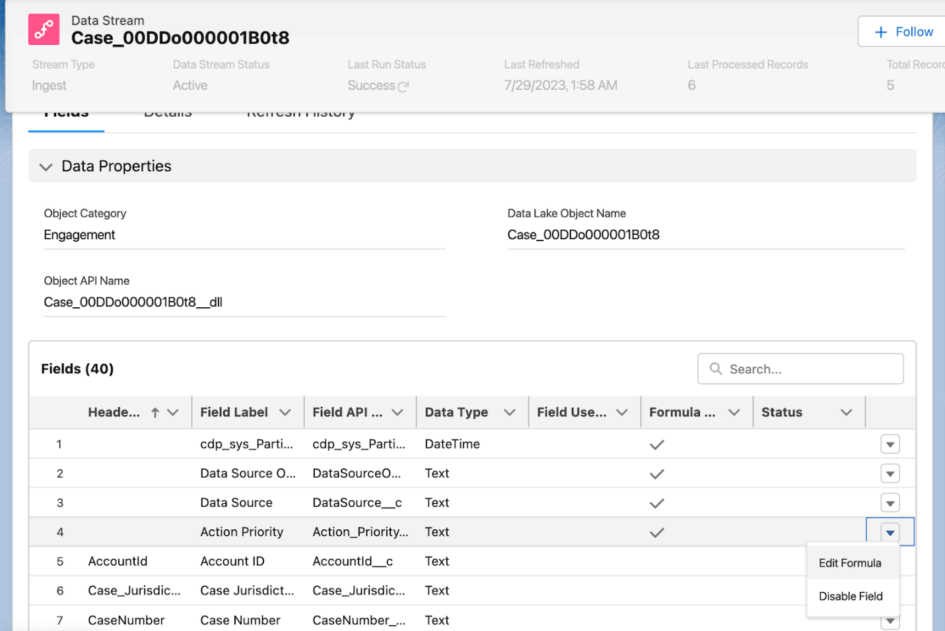

As you observe objects and fields selected for the setup notice that while you can choose fields that you need and exclude those that you don’t, the objects that are included in the bundle are not selectable. You can however configure each object separately without using the bundle. For now we will proceed with deselecting some of the fields on Case and Contact objects

* For the **Case** object let’s remove following fields that we won’t be using in this workshop:
  + Company
  + Last Viewed Date
  + Last Referenced Date
  + Last Modified By ID
  + Contact Phone
  + Contact Fax
  + Internal Comments.
* Select the **Contact** Service Object and remove all non-required fields using checkbox next to **Required** header and then include following fields:
  + RAVG Retail Membership Number
  + Party Identification Type (earlier created formula field)
  + Mobile Phone
  + Identification Name (earlier created formula field)
  + External ID
  + Birth Date (earlier created formula field)
* Proceed to the next step, review the automatically assigned **Category** values for each of the data streams to be created, **Refresh Mode** and **Refresh Schedule** and deploy the bundle.

Notice that we did not specify **Data Space Filtering** options for any of the object, and they will be associated with **default** Data Space automatically.

**\*** Functional formula for the Action Priority field:

IF(sourceField['IsEscalated'] == "true"

 , IF(

     sourceField['Priority'] == "High", "P1 - Escalated High",  IF(

     sourceField['Priority'] == "Medium", "P3 - Escalated Medium", "P4 - Escalated Low"

 ))

 , IF(

     sourceField['Priority'] == "High", "P2 - High",  IF(

     sourceField['Priority'] == "Medium", "P5 - Medium", "P6 - Low"

 ))

)

**1.2 Remove Account Data Stream**

One of the implications from using data bundle is that it is not possible to choose which objects should be included or excluded from the deployed configuration. The implied benefit though is that bundle deploy not only configures data streams, but it also takes care of the data modelling step for the standard fields.

For the purpose of our solution the **Account** object is not included in the design, therefore we want to remove it. This will minimize unnecessary costs associated with processing of the records.

* Navigate to **Data Streams** tab, click on the action arrow on the right and choose **Delete Data Stream** option:
  + 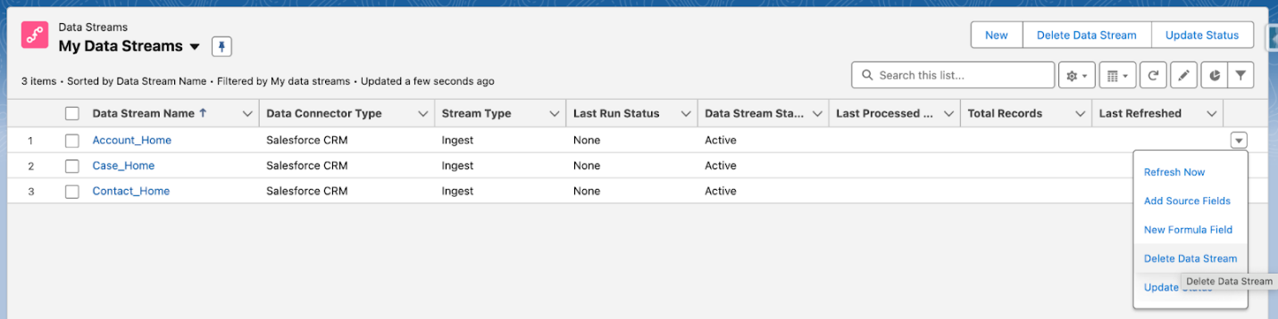
* Confirm the action in the dialog clicking on **Delete** button and you will get the error message:
  + 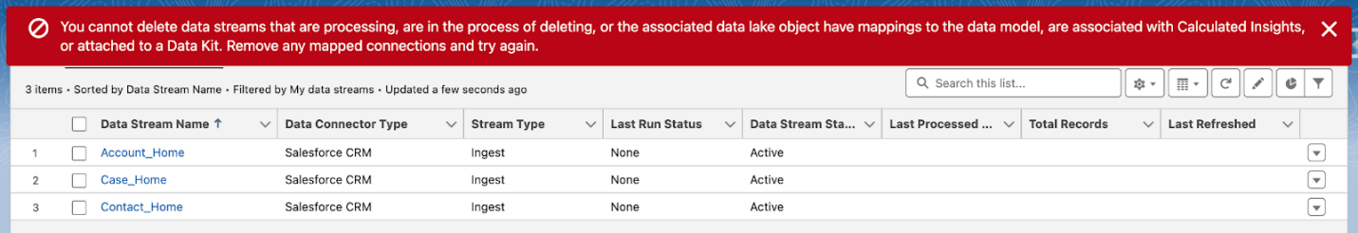

As the data stream is mapped into the data model we can’t simply delete it without removing all those mappings first. Even though we will be going through the mapping process later in the workshop at this stage we will look into removal of the pre-configured mappings.

* Click on the **Account** data stream name
* Click on the **Review Mappings** link on the right

If you are unable to see ‘Review Mappings' on a Data Stream, make sure you are accessing it from the 'Data Cloud' app.

* In the mapping canvas you’ll notice that **Account** data stream is mapped to 3 data model objects: **Account**, **Contact Point Address** and **Contact Point Phone**. We’ll remove the mappings one by one.
* Start with **Account**,click on the **Remove Mappings** (🗑️) icon on the right to it’s name:
  + 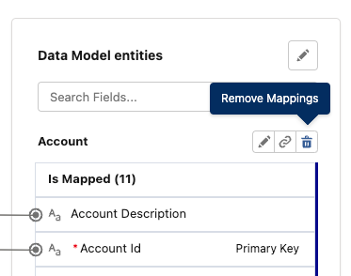
* Notice in the confirmation dialog the **Remove Mappings** button is disabled and you can only **Delete Object**:
  + 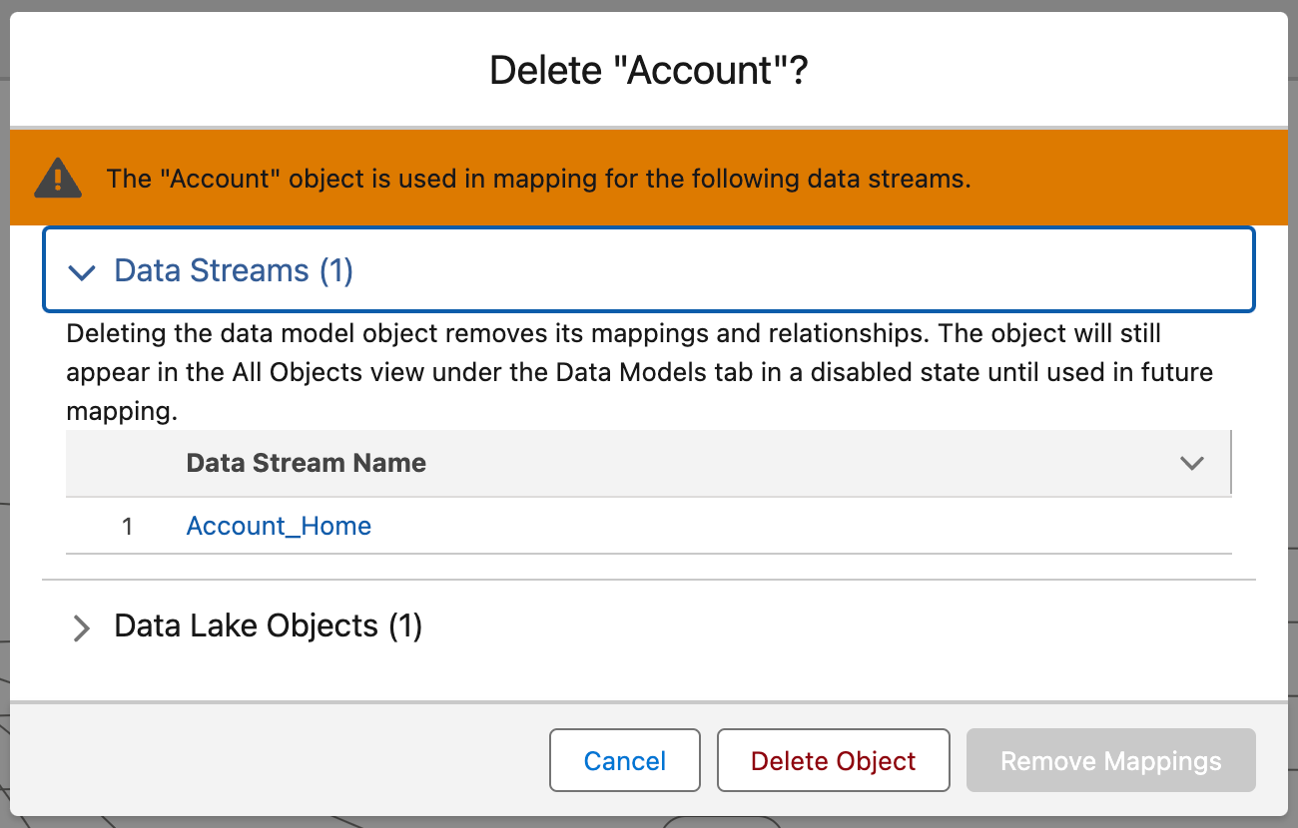

This is expected as the **Account** data model object is not used in any other configuration, such as identity resolution or segmentation. And there is only single data stream that provides data for this model. Therefore removing of mapping will result in no data to be exposed as this model and instead the platform guides you to delete the object instead.

ℹ️ Do take a note that deletion in this case (due to **Account** being a standard data model object) will not delete object definition itself, rather it will simply remove that object from any place where data model is used until another data stream is mapped to it. For any **custom** data model entities that you might create this action will actually delete the definition as well.

* Click **Delete Object** to proceed with mappings removal.
* Now proceed with the similar steps for the **Contact Point Address**
* Notice that in this case both actions **Delete Object** and **Remove Mappings** are enabled:
  + 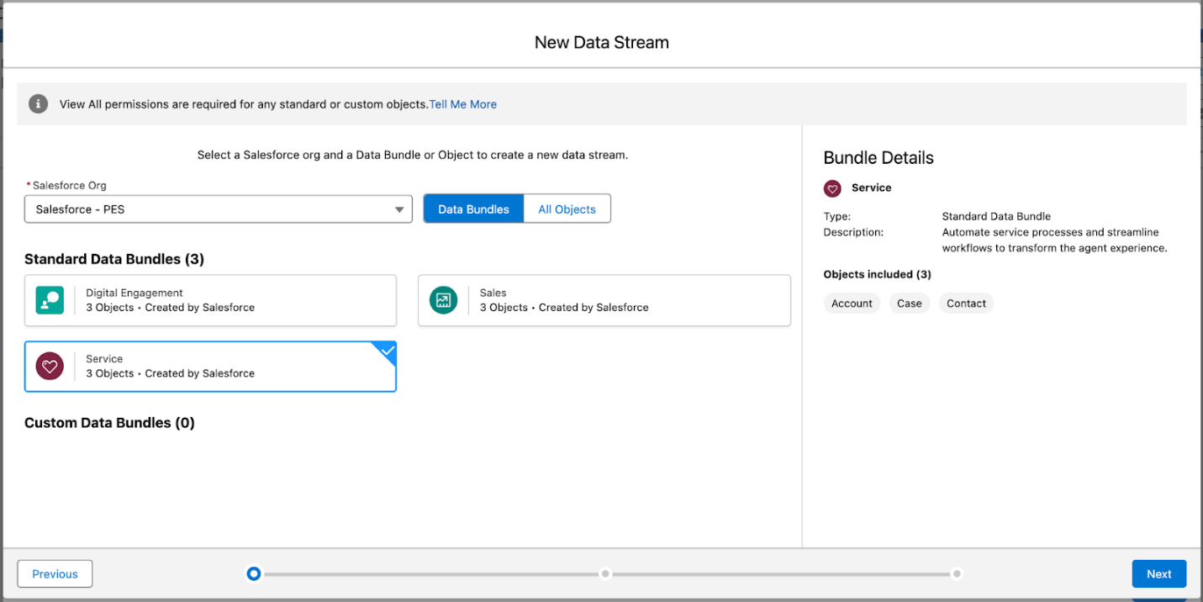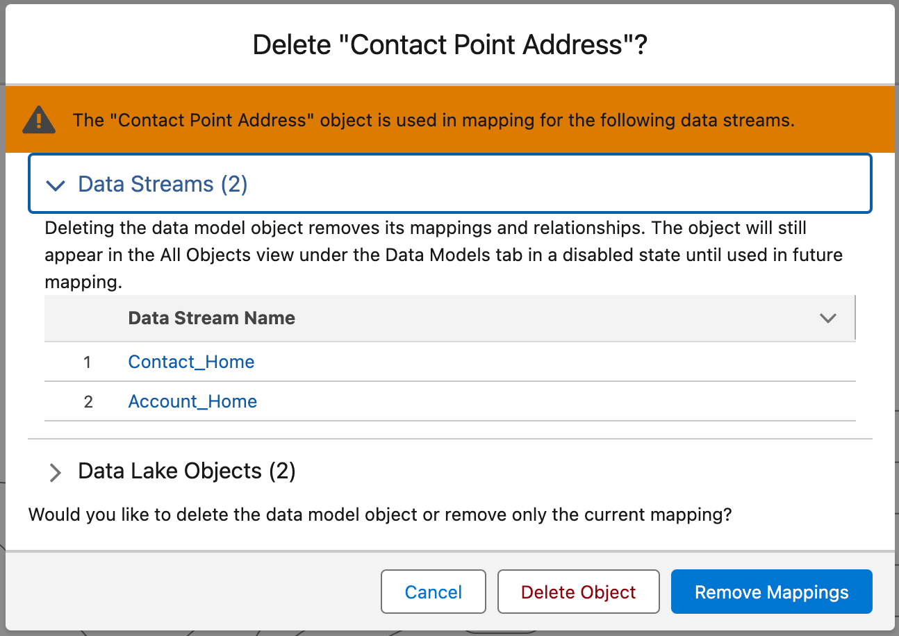
* As in this case the data model object is used in more than a single mapping the system provides a choice to remove only current (**Account**) data stream mapping or for all streams.
* We want to preserve mapping for **Contact** data stream, therefore choose **Remove Mappings** as an action.
* Lastly repeat the steps for the **Contact Point Phone** object with **Remove Mappings** action and not deleting the object.
* Once all of the mappings removed close the canvas.
* On the Details screen of the **Account** data stream click on the action menu (top right) and choose **Delete Data Stream** action:
* 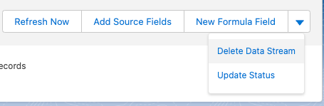
* Confirm the deletion in the dialog to proceed with deletion.
* The details screen will close and you’ll notice that the status of the data stream changed to **Deleting**
* At this stage since there was no data synchronized the process should complete reasonably quick. Try refreshing the list view after a minute or so to confirm that the stream was deleted.

⚠️ In your implementations the process of deleting the data stream might take noticeable time. There are few factors involved in the processing speed, one of which is data volume. So keep that in mind and just patiently wait until completion if you need to reconfigure the stream for example.

If you experience any issues deleting the Account stream, leave it as-is and move forward. As long as the object is not mapped into the data model it will not interfere with any further activities.

**1.3 Booking Custom Object**

Records in the Booking object represent vehicle booking information made by prospects and customers. As this is a custom object by default access to it from the Data Cloud will not be enabled. Comparing to the **Case** object earlier where you’ve experienced the error when trying to deploy the bundle due to the field not being available in this case you would not even see the object.

* Navigate to **Data Streams** tab and create new data stream
* Choose **Salesforce CRM** source and instead of bundle selection choose **All Objects** option
* 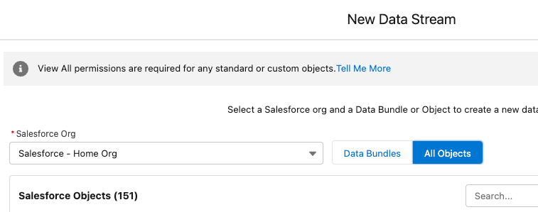
* Try searching for **Booking** object and confirm it does not appear in the list
* Using instructions on [this help page](https://help.salesforce.com/s/articleView?id=sf.c360_a_enable_user_permissions_external_salesforce_org.htm&type=5) enable **Read** and **View All** permissions for **Bookings, Rental Preferences** and **Rentals** objects as well as enable **Read Access** to all fields for these objects.

💡 Usability tip - when you need to enable **Read Access** for a large number of fields depending on your preference you can use mouse clicks or navigate with the keyboard once you click on the first checkbox using **Tab/Shift+Tab** and **Space** to change the selection.

* Restart configuration of the new data stream from **Salesforce CRM** source and under **All Objects** this time locate **Booking** and proceed to next step.
* Review fields and deselect those that we won’t need in our solution. Note that unlike bundle objects you can remove any field from the Booking fields except **Record ID** that is already identified as a Primary Key and **System Modstamp**.
  + Remove Last Modified By ID and Last Referenced Date fields

The significance of inclusion or exclusion of the fields from the object might not appear as high in our scenario. In practice when you implement customer solutions the objects quite often get very “wide” with large number of fields. Minimizing number of ingested fields simplifies the need to revisit each and every field during ingestion and mapping configurations.

* Add a new formula field to encapsulate some of the business logic from two into a single field:
  + Label = Purpose
  + Formula Return Type = Text
  + Using appropriate [functions & operators](https://help.salesforce.com/articleView?id=sf.c360_a_formula_expression_library.htm&type=5) calculate the value as follows:
    - If only Is Leisure attribute value equals true use Personal
    - If only Is Business attribute value equals true use Business
    - If both Is Leisure and Is Business attribute values equal true use Mixed
    - If both Is Leisure and Is Business attribute values equal false use Unspecified value
  + Test your formula for following values:
    - Is Leisure = true, Is Business = true = Mixed
    - Is Leisure = false, Is Business = true = Business
    - Is Leisure = false, Is Business = false = Unspecified
  + If you can’t make the working formula or getting unexpected results have a look at the [reference below](https://salesforce.quip.com/Y4wrA79tvqlT#temp:C:XWTecb0f54b7a31483eb5d869abc).
* As booking represents the event choose **Category** = Engagement

⚠️ Notice that for **Engagement** category you are required to choose the field that represents the Event Time. It might not always be straight forward when it comes to choosing the “right” field, especially if you have more than one date. As you’ve learnt in the lesson prior to this hands on exercise the **Engagement** category requires immutable field, meaning that value of the event time should not change over lifetime of the record.

* When in focus you can see there are quite a few fields available for selection as **Event Time Field**:
* Choose Booking Date field.
* Proceed to the next step.
* Notice that unlike with bundle you can update the name of the stream prior to deploying it. Leave it without changes for consistency, so that all CRM streams will have org ID appended to it and deploy the stream.
* Also leave selection of the **default** Data Space.
* Click “Deploy” to deploy the Data Stream

* Functional formula for the Purpose field:

IF(

 AND(sourceField['Is_Leisure__c'] == "true", sourceField['Is_Business__c'] == "true")

 , "Mixed"

 , IF(

   AND(sourceField['Is_Leisure__c'] == "true", sourceField['Is_Business__c'] == "false")

   , "Personal"

   , IF (

     AND(sourceField['Is_Leisure__c'] == "false", sourceField['Is_Business__c'] == "true")

     , "Business"

     , "Unspecified"

   )

 )

)

⚠️ **Note:** the data stream for the **Booking** object can fail to refresh on the first run. This will not prevent the data from flowing through later and on the subsequent runs the data will be populated. So if you experience that, please don’t get alarmed and simply wait for an hour until the stream refreshes successfully. ⚠️

**1.4 Rental Custom Object**

Records in the Rental object represent vehicle rental information made by customers. As you’ve already enabled access to this object you can proceed right to the configuration of the new data stream.

* Navigate to **Data Streams** tab and create new data stream
* Choose **Salesforce CRM** source and locate **Rental** and proceed to the next step
* Remove Last Modified By ID and Last Referenced Date fields
* Add a new formula field to encapsulate some of the business logic similar to Booking:
  + Field Label = Purpose
  + Formula Return Type = Text
  + Using appropriate [functions & operators](https://help.salesforce.com/articleView?id=sf.c360_a_formula_expression_library.htm&type=5) calculate the value as follows:
    - If only Is Leisure attribute value equals true use Personal
    - If only Is Business attribute value equals true use Business
    - If both Is Leisure and Is Business attribute values equal true use Mixed
    - If both Is Leisure and Is Business attribute values equal false use Unspecified value
  + Test your formula for following values:
    - Is Leisure = true, Is Business = true = Mixed
    - Is Leisure = false, Is Business = true = Business
    - Is Leisure = false, Is Business = false = Unspecified
  + If you can’t make the working formula or getting unexpected results have a look at the [reference above](https://salesforce.quip.com/Y4wrA79tvqlT#temp:C:XWTecb0f54b7a31483eb5d869abc).

ℹ️ For the following formula the source fields already have appropriate data type as they have been defined accordingly in the source system. In practice ensure to always review the data type of the fields you use for calculations or use appropriate function to convert original value to the needed target type.

* Add new formula field to categorize family rentals:
  + Field Label = Combined Children Seat Count
  + Formula Return Type = Number
  + Using appropriate [functions & operators](https://help.salesforce.com/articleView?id=sf.c360_a_formula_expression_library.htm&type=5) calculate the value as the sum of Baby Seat Count and Booster Seat Count attribute values.
  + Test and validate your formula with empty and few combinations of values.
  + If you can’t make the working formula or getting unexpected results have a look at the [reference below](https://salesforce.quip.com/Y4wrA79tvqlT#temp:C:XWTc7c81ff6e7a64424b59709f7a).
* Set following properties:
  + Category= Engagement
  + Event Time Field = Created Date
* Proceed to the next step and deploy the stream.

* Functional formula for the Combined Children Seat Count field:

NUMBER(sourceField['Baby_Seat_Count__c']) + NUMBER(sourceField['Booster_Seat_Count__c'])

**1.5 Rental Preference Custom Object**

Records in the Rental Preference object represent customer personal preferences for the vehicles they rent. These form an expedited search for each customer profile when they are making new reservation.

* Navigate to **Data Streams** tab and create new data stream
* Choose **Salesforce CRM** source and locate **Rental Preference** and proceed to the next step
* Set Category= Other

At this stage of configuration it is important to review how the system parsed the inbound data file and assigned a **data type** to each of the identified fields. The main reason for that is later in the configuration when you’ll need to map these fields into the data model **any type mismatch will prevent you from doing so**, resulting in the need for you to go back to data stream setup and redo it.

* Review and confirm that both **Leisure Preferences Last Updated Date** and **Business Preferences Last Updated Date** have been identified as **Date (yyyy-MM-dd)** data types:
* 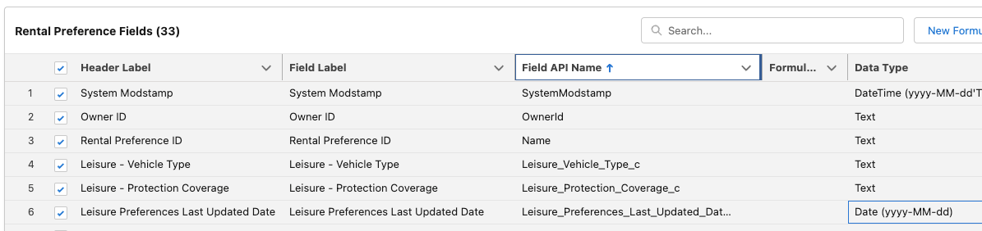
* For our data model these fields need to be of **Date** type. The CRM connector does not allow modification of the data type, therefore if these need to be corrected, you’ll need to create formula fields with required data type and use those in data modelling exercise.
* If your fields have been correctly identified - skip the following steps and don’t create custom fields. Move to [this step](https://salesforce.quip.com/Y4wrA79tvqlT#temp:C:XWT19ebf8e6b6394f48a0770b49d) instead.
  + **Only** if in your environment these fields have been misidentified with **DateTime (yyyy-MM-dd)** perform the following steps:
    - Update field label for the following fields (note these should be under 40 characters):
      * Leisure Preferences Last Updated Date = Leisure Pref Last Updated DateTime
      * Business Preferences Last Updated Date = Business Pref Last Updated DateTime
    - Add new formula field:
      * Field Label = Leisure Preferences Last Updated Date
      * Formula Return Type = Date
      * Formula = sourceField['Leisure_Preferences_Last_Updated_Date__c']
    - Add new formula field:
      * Field Label = Business Preferences Last Updated Date
      * Formula Return Type = Date
      * Formula = sourceField['Business_Preferences_Last_Updated_Date__c']
* Update field label for the following fields (note these should be under 40 characters):
  + Leisure - Protection Coverage = Leisure - Protection Coverage - Source
  + Business - Protection Coverage = Business - Protection Coverage - Source
* Add new formula field:
  + Field Label = Leisure - Protection Coverage
  + Formula Return Type = Text
  + Using appropriate [functions & operators](https://help.salesforce.com/articleView?id=sf.c360_a_formula_expression_library.htm&type=5) calculate the value as follows:
    - If Leisure - Protection Coverage attribute supplied - use its value
    - Otherwise use NONE value
  + Test and validate your formula with empty and any values.
  + If you can’t make the working formula or getting unexpected results have a look at the [reference below](https://salesforce.quip.com/Y4wrA79tvqlT#temp:C:XWT4c44d4884dae4d31a008b62da).
* Add another formula field called Business - Protection Coverage using the same approach and logic as for the Leisure - Protection Coverage field.
* Proceed to the next step and deploy the stream.

* Functional formula for the formula fields

Leisure - Protection Coverage

IF(ISEMPTY(sourceField['Leisure_Protection_Coverage__c']), "NONE", sourceField['Leisure_Protection_Coverage__c'])

Business - Protection Coverage

IF(ISEMPTY(sourceField['Business_Protection_Coverage__c']), "NONE", sourceField['Business_Protection_Coverage__c'])

**2. Applying Data Transforms**

As you went through the configuration and review of the data streams you might have noticed that **Rental** stream in particular contains mixed data. The majority of attributes are relevant to the engagement (rental transaction), such as vehicle details, insurance coverage, start and end date and so forth. But there are a few attributes that are relevant for the customer profile, such as details of their driver license and various membership program numbers.

When the data stream is mapped to the data model it is not possible to map a given data stream to the mixed categories data model objects. Therefore we will take advantage of [Data Transform functionality](https://help.salesforce.com/s/articleView?language=en_US&id=sf.c360_a_streaming_transform_overview.htm&type=5), extracting various identifiers such as membership and driver license numbers and storing them in a separate data lake object.

ℹ️ Comparing Data Transforms with formula fields you’ll notice that former operates within the stream context, meaning you can access all records within the data stream. While formulas as you now know only operate in the context of a single record / row of data.

💡 This guide walks you through the configuration of the Streaming Data Transform. If you are interested to explore Batch Data Transform as alternative, while achieving the same outcome you can follow [Ex: Data Cloud - Configure Batch Data Transform](https://quip.com/821CAbfVeG1T) guide instead of step 2.2 below.

**2.1 Create New Data Lake Object**

Before configuring the Data Transform it is necessary to create a destination data lake object where resulting records will be stored. Similar to data streams this choice affects billing as well as what objects in the data model can be mapped to.

* Navigate to **Data Lake Objects** tab and create new object choosing **New** option in method selection
* Set following properties:
  + Data Lake Object Name = Party Identification Collection
  + Category = Profile
* Notice 4 default fields that were created for you. These enable maintenance of data lineage as well as other system usage

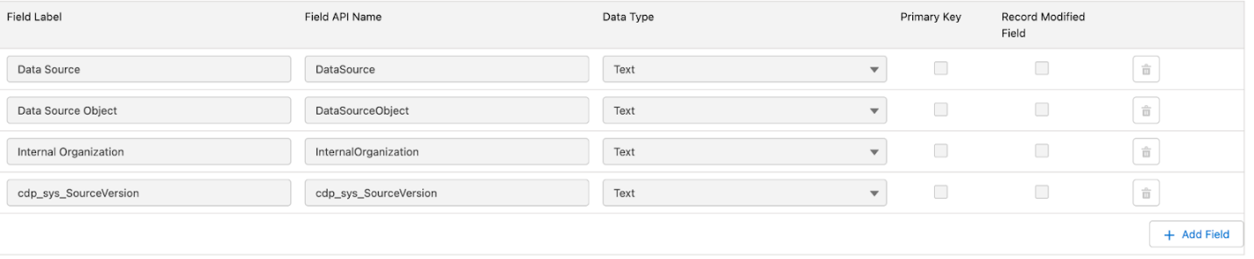

* Add following new fields:

|  |  |  |
| --- | --- | --- |
| **Field Label** | **Data Type** | **Primary Key** |
| **Party Identification ID** | **Text** | 1 |
| Party | Text | 0 |
| Party Identification Type | Text | 0 |
| Identification Name | Text | 0 |
| Identification Number | Text | 0 |

* 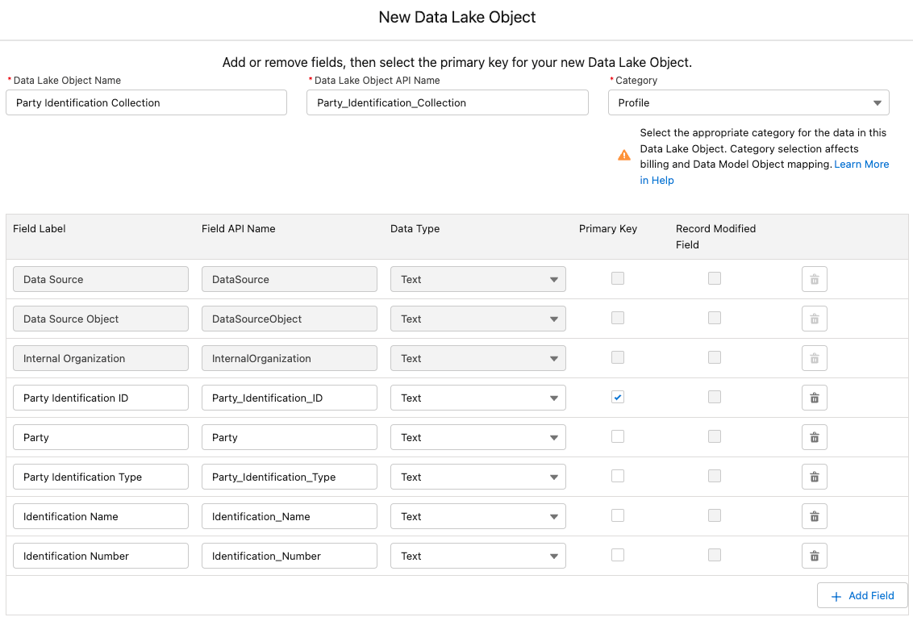
* Save the object.

**2.1.1 Add the newly created Data Lake Object to your default Data Space**

During configuration of the data streams you’ve noticed that all objects have been associated with **default** [Data Space](https://help.salesforce.com/s/articleView?language=en_US&id=sf.c360_a_data_spaces.htm&type=5). While for the newly created Data Lake Object this is not the case. This will prevent it from being available in subsequent exercises. Therefore let’s address it now.

* Go to the **Data Spaces** tab
* Select the **default** Data Space
  + 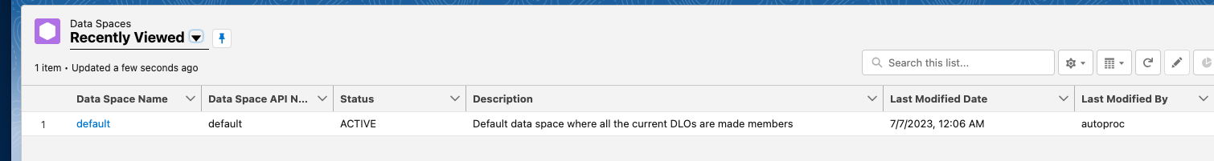
* Click on **Add Data**
* Select the Party Identification Collection Data Lake Object and click **Next**
  + 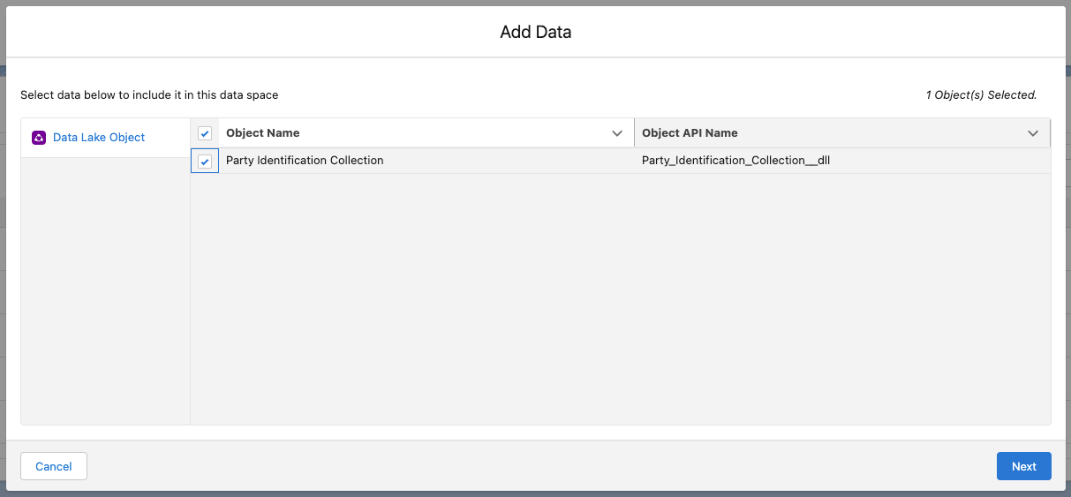
* Select ☑️ **Add objects without filter**
  + 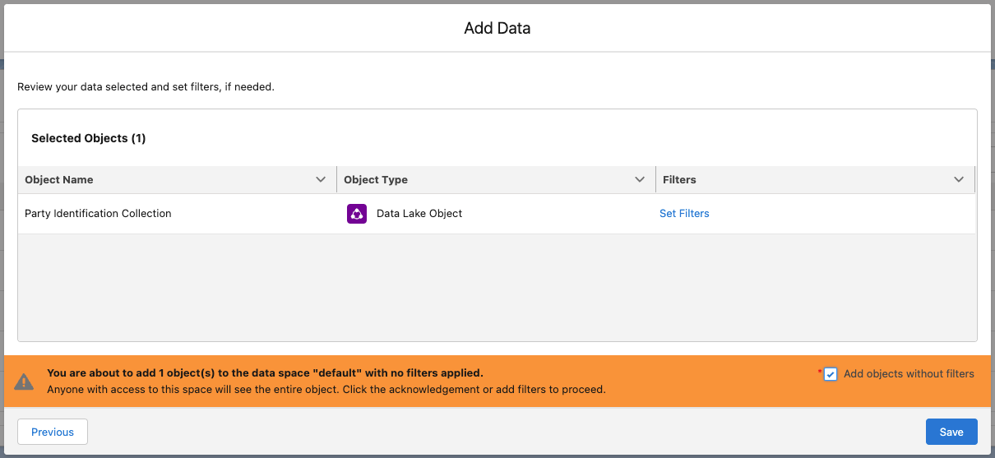
* Save the configuration

**2.2 Create New Streaming Data Transform**

⚠️ If you want to explore Batch Data Transform as an alternative approach with the same outcome please follow [Ex: Data Cloud - Configure Batch Data Transform](https://quip.com/821CAbfVeG1T) guide instead of current section of the guide. If you want to configure both types of data transforms please follow additional instructions at the start of the batch data transform configuration guide. ⚠️

As we now have a destination object to keep records we can configure new data transform.

* Navigate to **Data Transforms** tab and create new data transform.
  + ***Note***: You may need to click the **More** in the navigation bar in order to view this tab:
  + 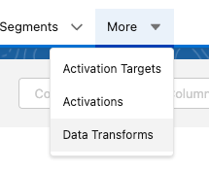
* Select Streaming Data Transform

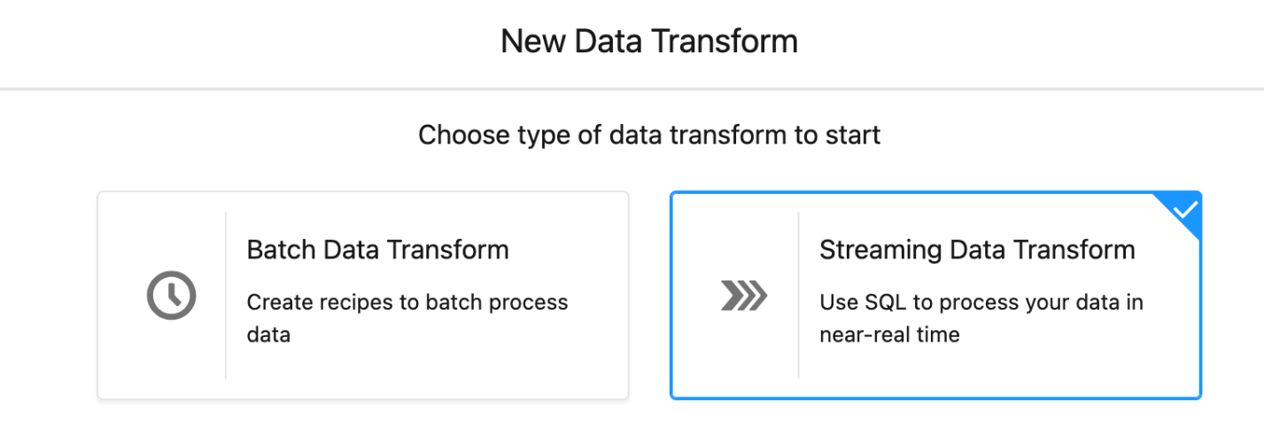

* Set following properties:
  + Data Transform Label = Extract Party Identifiers from Rentals
  + Target Data Lake Object = Party Identification Collection
  + Description = Extract driver license and loyalty program membership numbers from car rentals
  + Click **Next** to proceed to the next screen

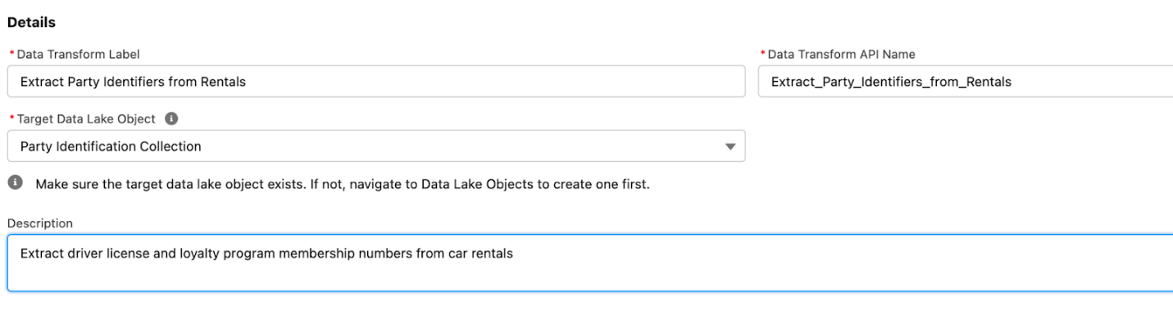

* Exploring examples (click on the **Examples** button above the query editor) and/or [functions reference](https://help.salesforce.com/s/articleView?id=sf.c360_a_streaming_transform_supported_functions.htm&type=5) create a SQL expression that extracts below listed identifiers following these rules:
  + <Customer> field is always selected as Party target field
  + <Customer>_<Membership Number> is selected as Party_Identification_ID__c target field
  + For **Airline Membership Number**
    - "Loyalty Program" text is selected as Party_Identification_Type__c target field
    - "Airline Membership" text is selected as Identification_Name__c target field
    - <Airline Membership Number> field is selected as Identification_Number__c target field
  + For **Driver License Number**
    - "Person Identification" text is selected as Party_Identification_Type__c target field
    - "Driver License" text is selected as Identification_Name__c target field
    - <Driver License Number> field is selected as Identification_Number__c target field
  + For **Motor Club Number**
    - "Loyalty Program" text is selected as Party_Identification_Type__c target field
    - "Motor Club Membership" text is selected as Identification_Name__c target field
    - <Motor Club Number> field is selected as Identification_Number__c target field
  + For **RAVG Retail Membership Number**
    - "Loyalty Program" text is selected as Party_Identification_Type__c target field
    - "RAVG Retail Membership" text is selected as Identification_Name__c target field
    - <RAVG Retail Membership Number> field is selected as Identification_Number__c target field
  + Always add a criteria to only choose records that contain value (not null or empty) in respective identification number field.
  + Ensure to use **Check Syntax** button to validate your expression and save it.
  + If you find it difficult writing a query have a look at the **reference below**.

**\* Query Expression for the Extract Party Identifiers from Rentals**

Ensure to replace <ORG_ALIAS> (including < and > characters) with the value of your org ID from respective DLO object names:

SELECT Rental_c_<ORG_ALIAS>__dll.Customer_c__c as Party__c

 , Concat(Rental_c_<ORG_ALIAS>__dll.Customer_c__c, "_", Rental_c_<ORG_ALIAS>__dll.Airline_Membership_Number_c__c) as Party_Identification_ID__c

 , "Loyalty Program" as Party_Identification_Type__c

 , "Airline Membership" as Identification_Name__c

 , Rental_c_<ORG_ALIAS>__dll.Airline_Membership_Number_c__c  as Identification_Number__c

 FROM Rental_c_<ORG_ALIAS>__dll

WHERE Rental_c_<ORG_ALIAS>__dll.Airline_Membership_Number_c__c <> ''

  AND Rental_c_<ORG_ALIAS>__dll.Airline_Membership_Number_c__c <> ""

UNION

SELECT Rental_c_<ORG_ALIAS>__dll.Customer_c__c as Party__c

 , Concat(Rental_c_<ORG_ALIAS>__dll.Customer_c__c, "_", Rental_c_<ORG_ALIAS>__dll.Driver_License_Number_c__c ) as Party_Identification_ID__c

 , "Person Identification" as Party_Identification_Type__c

 , "Driver License" as Identification_Name__c

 , Rental_c_<ORG_ALIAS>__dll.Driver_License_Number_c__c as Identification_Number__c

 FROM Rental_c_<ORG_ALIAS>__dll

WHERE Rental_c_<ORG_ALIAS>__dll.Driver_License_Number_c__c <> ''

  AND Rental_c_<ORG_ALIAS>__dll.Driver_License_Number_c__c <> ""

UNION

SELECT Rental_c_<ORG_ALIAS>__dll.Customer_c__c as Party__c

 , Concat(Rental_c_<ORG_ALIAS>__dll.Customer_c__c, "_", Rental_c_<ORG_ALIAS>__dll.Motor_Club_Number_c__c) as Party_Identification_ID__c

 , "Loyalty Program" as Party_Identification_Type__c

 , "Motor Club Membership" as Identification_Name__c

 , Rental_c_<ORG_ALIAS>__dll.Motor_Club_Number_c__c  as Identification_Number__c

 FROM Rental_c_<ORG_ALIAS>__dll

WHERE Rental_c_<ORG_ALIAS>__dll.Motor_Club_Number_c__c <> ''

  AND Rental_c_<ORG_ALIAS>__dll.Motor_Club_Number_c__c <> ""

UNION

SELECT Rental_c_<ORG_ALIAS>__dll.Customer_c__c as Party__c

 , Concat(Rental_c_<ORG_ALIAS>__dll.Customer_c__c, "_", Rental_c_<ORG_ALIAS>__dll.RAVG_Retail_Membership_Number_c__c) as Party_Identification_ID__c

 , "Loyalty Program" as Party_Identification_Type__c

 , "RAVG Retail Membership" as Identification_Name__c

 , Rental_c_<ORG_ALIAS>__dll.RAVG_Retail_Membership_Number_c__c  as Identification_Number__c

 FROM Rental_c_<ORG_ALIAS>__dll

WHERE Rental_c_<ORG_ALIAS>__dll.RAVG_Retail_Membership_Number_c__c <> ''

  AND Rental_c_<ORG_ALIAS>__dll.RAVG_Retail_Membership_Number_c__c <> ""

As an example here is the part of the functional query for the reference:

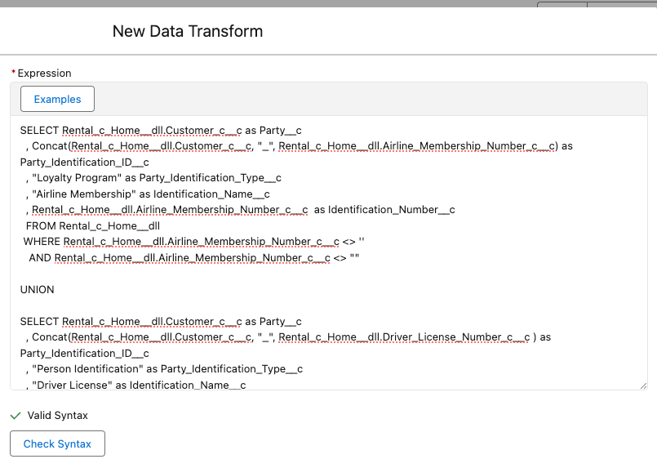

Once the Data Transform is deployed it will continuously stream data from the source DLO.

ℹ️ Few things to take a note of with regards to Data Transform:

* There is a limited number (3) of Data Transforms that are included with the org, additional transforms can be purchased, with [total limit of 25](https://help.salesforce.com/s/articleView?id=sf.c360_a_limits_and_guidelines.htm&type=5#:~:text=Data%20Transforms%20Guidelines%20and%20Limits).
* Data Transform can use only one source DLO, e.g. in our case we would not be able to combine same identifiers from the **Booking** DLO. Additional streaming data transform can be created that uses the same target DLO.
* Within a data transform with **UNION** statement there can be only up to 5 **SELECT** queries. For additional data points new data transform need to be created.

Take these into account when planning and designing your solutions for real customers.

**3. Commerce Platform Data**

***Note****: you will need your S3 details - bucket name, access and secret keys to configure data streams listed in this section.*

**3.1 Configure S3 Connector**

In order for us to configure ingestion from the S3 bucket it is necessary to configure it as a data source first.

* Navigate to **Data Cloud Setup > Connectors** and start configuration of a new connector
* Choose **Amazon S3** in the list of sources and proceed to the next step:
* Set following details:
  + Connection Name = RAVG Retail eCommerce S3
  + Authentication Option = Access Key/Secret Based
  + Specify your AWS access key, AWS secret access key and Bucket Name
  + Parent Directory = ecommerce-data/
* Click **Test Connection** and verify that connection was established successfully:
  + 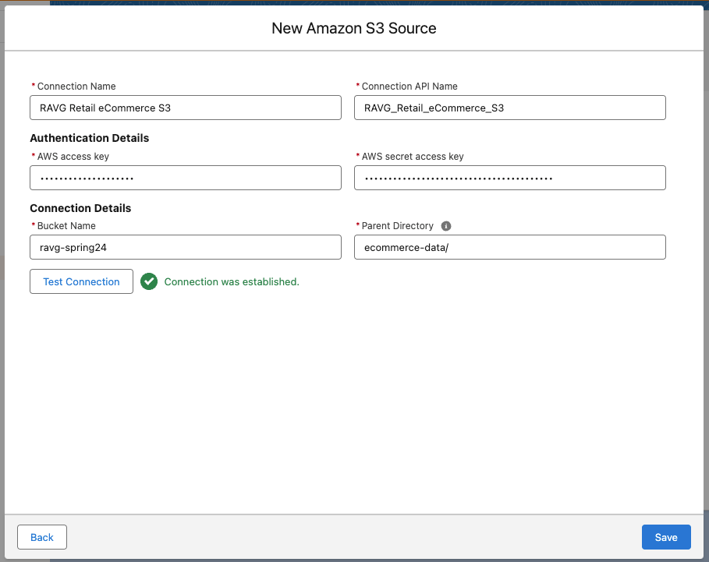
* Save the configuration.

The connection is now ready to be used in new data streams configurations:

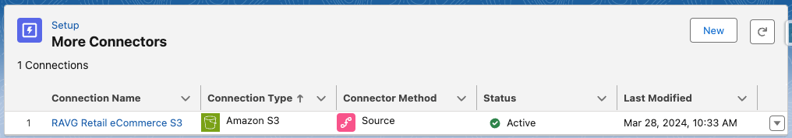

ℹ️ As you go through the configuration steps for eCommerce feeds notice that Source value is the same in all configurations. The feeds are sourced from the same system and that notion is carried forward into the platform. And while we not actively using it in this workshop, this creates additional data point that can be referenced when data is used in segmentation or insights.

**3.2 Customer Profile Feed**

Customer profile feed contains profile and demographics attributes of the customers similar to the Contact object in CRM that you configured earlier.

* Following instructions from [help page](https://help.salesforce.com/articleView?id=sf.c360_a_create_cloud_storage_data_stream.htm&type=5)
  + Configure **Amazon S3** data stream (notice new tile now appearing on the wizard dialog):
    - 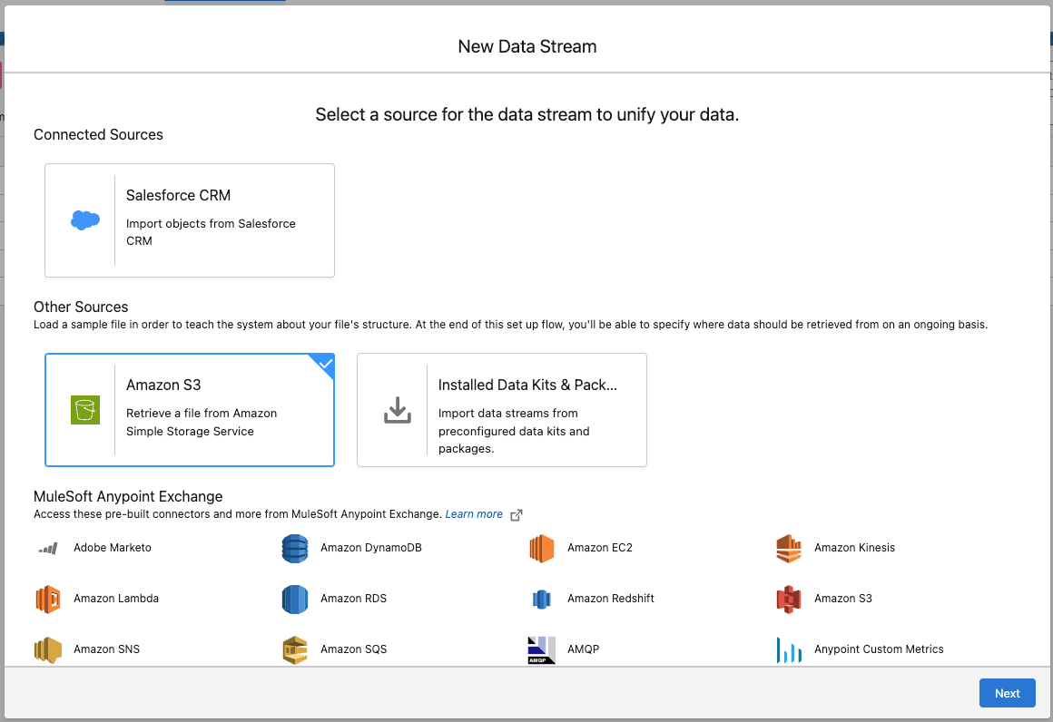
  + Set following properties:
    - Connection = RAVG Retail eCommerce S3
    - File Type = CSV
    - Import from Directory = leave empty
    - File Name = S3 Customer Profile.csv
    - Source = keep default value
    - 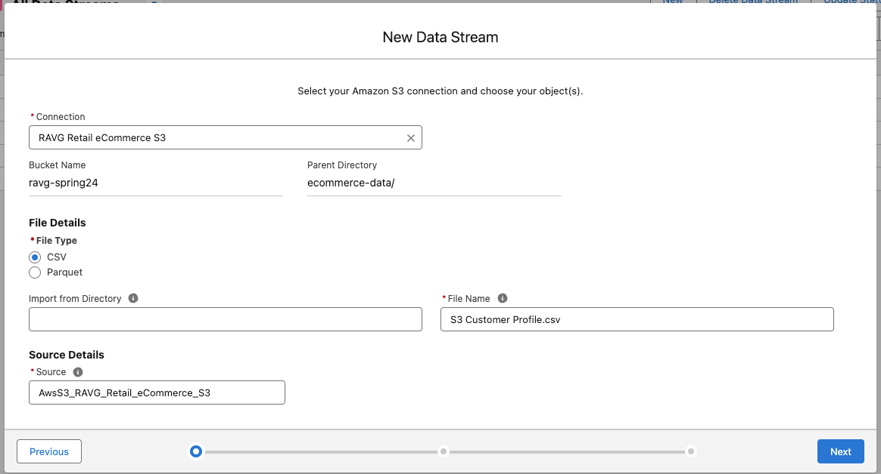
  + Proceed to the next step
    - Data Lake Object = + New Data Lake Object
    - Data Lake Object Label= eComm Customer Profile
    - Category = Profile
    - Primary Key = Customer Ref Number

Following formula fields will be mapped into the Party entity to support profile matching rules.

* Add a new formula field:
  + Label = Party Identification Id
  + Formula Return Type = Text
  + Using appropriate [function](https://help.salesforce.com/articleView?id=sf.c360_a_supported_library_functions.htm&type=5) calculate the value as follows:
    - LoyaltyProgram_RAVGRetailMembership_<Customer Ref Number>
    - If you can’t make the working formula or getting unexpected results have a look at the [reference below](https://salesforce.quip.com/Y4wrA79tvqlT#temp:C:XWTfb46dbe603404ef383c406593).
* Save & Add another formula field:
  + Label = Party Identification Type
  + Formula Return Type = Text
  + Transformation Formula = "Loyalty Program" (notice the double-quotes around the value)
* Save & Add another formula field:
  + Label = Identification Name
  + Formula Return Type = Text
  + Transformation Formula = "RAVG Retail Membership" (notice the double-quotes around the value)

Following formula field will be used as a unique identifier for the email address mapping.

* Save & Add another formula field:
  + Label = Contact Point Email Id
  + Formula Return Type = Text
  + Using appropriate [function](https://help.salesforce.com/articleView?id=sf.c360_a_supported_library_functions.htm&type=5) calculate the value as follows:
    - <Customer Ref Number>_ContactPointEmail_<Email>
    - If you can’t make the working formula or getting unexpected results have a look at the [reference below](https://salesforce.quip.com/Y4wrA79tvqlT#temp:C:XWTddb38887d6234f90a28573e35).

At this stage of configuration it is important to review how the system parsed the inbound data file and assigned a **data type** to each of the identified fields. In this file the platform result is actually quite accurate with the exception of one field.

* Update data type for **Email** field to Email:
  + 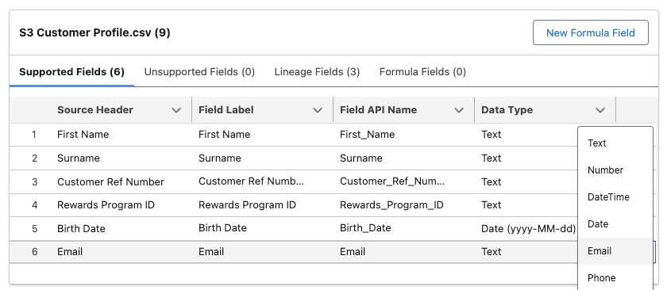
* Proceed to next step
* Keep **default** Data Space selected and Refresh Mode = Upsert
* Keep Schedule with the following settings:
  + Frequency = None
  + Ensure to ☑️ Refresh Data Stream immediately option
* Deploy the data stream.

**\*** Functional formula for the Party Identification Id field:

CONCAT("LoyaltyProgram_RAVGRetailMembership_", sourceField['Customer Ref Number'])

**\*** Functional formula for the Contact Point Email Id field:

CONCAT(sourceField['Customer Ref Number'], "_ContactPointEmail_", sourceField['Email'])

**3.3 Order Feed**

Order data feed contains details of the customer transactions, such as transaction date and total amount.

* Following instructions from [help page](https://help.salesforce.com/articleView?id=sf.c360_a_create_cloud_storage_data_stream.htm&type=5)
  + Configure **Amazon S3** data stream
  + Set following properties:
    - Connection = RAVG Retail eCommerce S3
    - File Type = CSV
    - Import from Directory = leave empty
    - File Name = S3 Order Headers.csv
    - Source = keep default value
  + Proceed to the next step
    - Data Lake Object = + New Data Lake Object
    - Data Lake Object Label= eComm Order
    - Category = Engagement
    - Event Time Field = Order Date
    - Primary Key = Order Number

Data lineage provides an opportunity to narrow result set during segmentation, especially for the cases when a single Data Cloud instance includes data feeds for more than one geography or sub-brand. It won’t be enforced, rather an additional element to control what data should be accounted for when targeting a certain segment.

* In order to associate the [reference of this dataset to a specific ecommerce realm/instance](https://help.salesforce.com/articleView?id=sf.c360_a_organization_unit_identifier.htm&type=5) create new formula field that will contain pre-defined text:
  + Field Label = Internal Business Unit
  + Formula Return Type = Text
  + Transformation Formula = "eComm_RAVG_Retail" (notice the double-quotes around the value)
* Set Organization Unit Identifier = Internal Business Unit

At this stage of configuration it is important to review how the system parsed the inbound data file and assigned a **data type** to each of the identified fields. In this file the platform result is actually quite accurate, but we still want to make one change.

* Depending on your preference you might horizontally scroll to the right in the fields pane or resize each column to make **Data Type** column visible:
  + 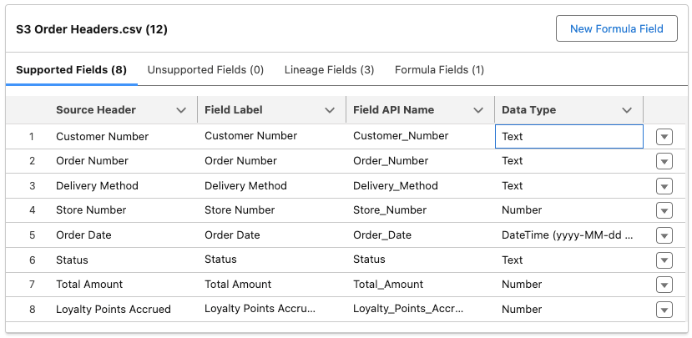
  + One of the key fields for our design is **Customer Number.** We are planning to use this as a customer identifier later on therefore ensure it to be a Text data type (which it is).
* Proceed to next step
* Keep **default** Data Space and Refresh Mode = Upsert
* Keep Schedule with the following settings:
  + Frequency = None
  + Ensure to ☑️ Refresh Data Stream immediately option
* Deploy the data stream.

**3.4 Store Lookup Data**

Order data feed includes details for the store at which a purchase occurred. One way to extract these would be to use Data Transforms. Another approach that we will follow this time is to re-ingest the same source file but using different settings for the data stream. With CRM this method would not work, as the connector only supports a single data stream to be configured for any given object.

Configure additional data stream to ingest unique set of store details that later will be mapped to the Sales Store entity.

* Following instructions from [help page](https://help.salesforce.com/articleView?id=sf.c360_a_create_cloud_storage_data_stream.htm&type=5)
  + Configure **Amazon S3** data stream
  + Set following properties:
    - Connection = RAVG Retail eCommerce S3
    - File Type = CSV
    - Import from Directory = leave empty
    - File Name = S3 Order Headers.csv
    - Source = keep default value
  + Proceed to the next step
    - Data Lake Object = + New Data Lake Object
    - Data Lake Object Label= eComm Store Number Lookup
    - Category = Other
    - Primary Key = Store Number

With this data stream we will be mapping a limited number of fields into the data model and data type assigned by the platform will suit our needs. Hence there is no need to review and make any changes for this data stream.

* Proceed to next step
* Keep **default** Data Space and Refresh Mode = Upsert
* Keep Schedule with the following settings:
  + Frequency = None
  + Ensure to ☑️ Refresh Data Stream immediately option
* Deploy the data stream.

**3.5 Line Items Feed**

Order Line Items data feed contains details of each item in the customer transactions, such as product name, quantity and cost.

* Following instructions from [help page](https://help.salesforce.com/articleView?id=sf.c360_a_create_cloud_storage_data_stream.htm&type=5)
  + Configure **Amazon S3** data stream
  + Set following properties:
    - Connection = RAVG Retail eCommerce S3
    - File Type = CSV
    - Import from Directory = leave empty
    - File Name = S3 Order Line Items.csv
    - Source = keep default value
  + Proceed to the next step
    - Data Lake Object = + New Data Lake Object
    - Data Lake Object Label= eComm Line Item
    - Category = Other

At this stage of configuration it is important to review how the system parsed the inbound data file and assigned a **data type** to each of the identified fields. The main reason for that is later in the configuration when you’ll need to map these fields into the data model **any type mismatch will prevent you from doing so**, resulting in the need for you to go back to data stream setup and redo it.

* Notice that **SKU** field was identified as Number data type, while we need it to be set as Text:
  + 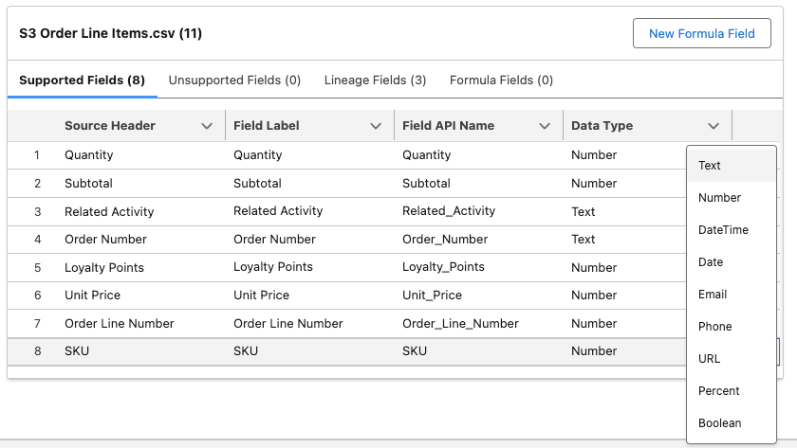
* In addition ensure that both Order Number and Order Line Number are marked as Text:
  + 
  + 

If you are to inspect the source file you’d notice that there is no single field that represents a Primary Key on the Order Line Item feed, although there is enough details to make a composite key using combination of few existing fields which can be achieved with a formula.

* Create new formula field that will combine Order Number and Order Line Number fields:
  + Field Label = Order Line Key
  + Formula Return Type = Text
  + Using appropriate [function](https://help.salesforce.com/articleView?id=sf.c360_a_supported_library_functions.htm&type=5) calculate the value as follows:
    - <Order Number>_<Order Line Number>
    - e.g. testing with values TRX-100 and 1 should result in TRX-100_1 (*notice that sequence of fields in* ***Tested Value*** *area might not be in order you expect them to be*)
    - If you can’t make the working formula or getting unexpected results have a look at the [reference below](https://salesforce.quip.com/Y4wrA79tvqlT#temp:C:XWTfdc34450f58a4bed81502e12a).
* **Save** & set Primary Key = Order Line Key and proceed to next step.
* Keep **default** Data Space and Refresh Mode = Upsert
* Keep Schedule with the following settings:
  + Frequency = None
  + Ensure to ☑️ Refresh Data Stream immediately option
* Deploy the data stream.

Functional formula for the Order Line Key field:

CONCAT(sourceField['Order Number']+'_'+ sourceField['Order Line Number'])

Further inspection of the Order Line Items feed would result in discovery of additional valuable data points that we want to represent and configure as separate objects in the resulting data model mapping to Goods Product and another custom entities. These are product SKUs and related activities associated with respective products in the same order line item record.

As you’ve already experienced one way to handle this would be by configuring additional data streams re-ingesting the same source file with different configurations of the primary keys. Another approach that we mentioned earlier would be by using Data Transforms. We already configured streaming version to extract party identification records from the Rental records. For the remaining data points we will use batch data transform option.

💡 As you are configuring batch data transform try to analyze and contrast this method with re-ingestion. Consider when you configure target lake object and as a result have upfront design vs resulting object is constructed for you. Also notice the difference in schedule to automate the process. While we set **Frequency =** None for the S3 data streams, you can explore the options by editing any of the data streams without saving any changes. Compare these options to the ones available for batch data transforms. Last but not least consider what transformations can be applied when using ingestion comparing to data transform. All those considerations are good to undertake when you are designing your solution for the customer implementations.

**3.6 Product SKU and Related Activity Lookup Data**

In order for us to configure data transforms for the product SKUs and related activities we need to create target data lake objects.

**3.6.1 Create Product SKU DLO**

* Navigate to **Data Lake Objects** tab and create new object choosing **New** option in method selection
* Set following properties:
  + Data Lake Object Name = eComm Product Lookup
  + Category = Other
  + Add following new fields:

|  |  |  |
| --- | --- | --- |
| **Field Label** | **Data Type** | **Primary Key** |
| **Product Id** | **Text** | 1 |
| Related Activity Id | Text | 0 |

* 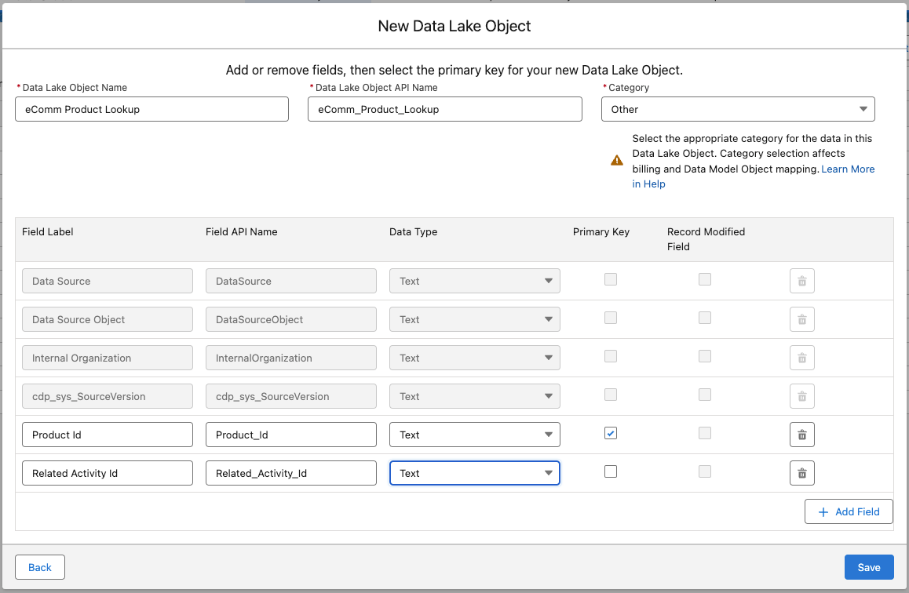
* Save the object.

Inspect the **Fields** section of the configured object and notice that in addition to default and custom fields that we specified one additional field was configured as a **Key Qualifier**:

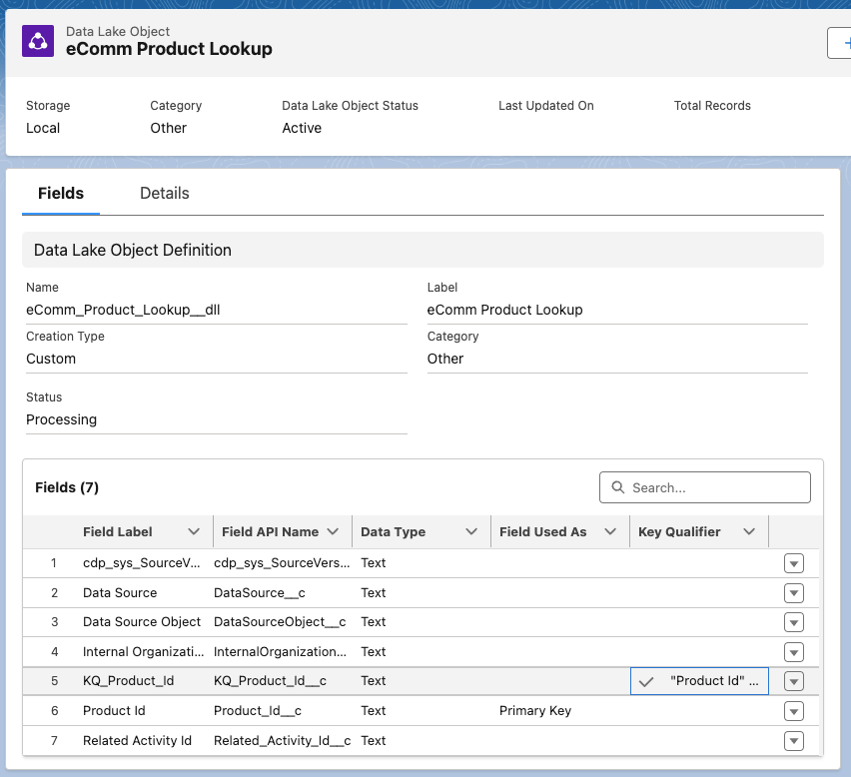

[This section](https://help.salesforce.com/s/articleView?id=sf.c360_a_fully_qualified_keys.htm&type=5) of the documentation provides great insights into what these qualifiers are and why/when they should be configured. In our scenario we don’t really have a chance for the key clashes as such, due to limited overlap across CRM and eCommerce data sources.

But as we have an opportunity let’s explore configuration of this feature too. Considering potential to add another source with transactional details that might include another set of SKU values. There is some level of likelihood for two systems to have same identifier value used as a SKU. And using this hypothesis let’s configure key qualifier for the **Product Id** field in our object.

* Click on the 🔽 to the right of the **Product Id** field and choose Add Key Qualifier option:
* Start creation of the new key qualifier and set following details:
  + Key Qualifier Label = Product Id PK
  + Description = Primary key of the eComm Product Lookup key qualifier
    - 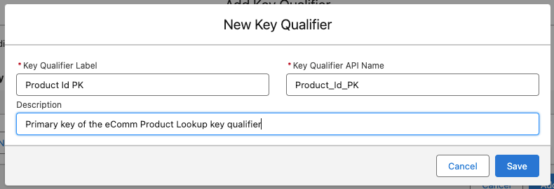
* Save the record. Then choose it in the list of qualifiers and click **Add**:
  + 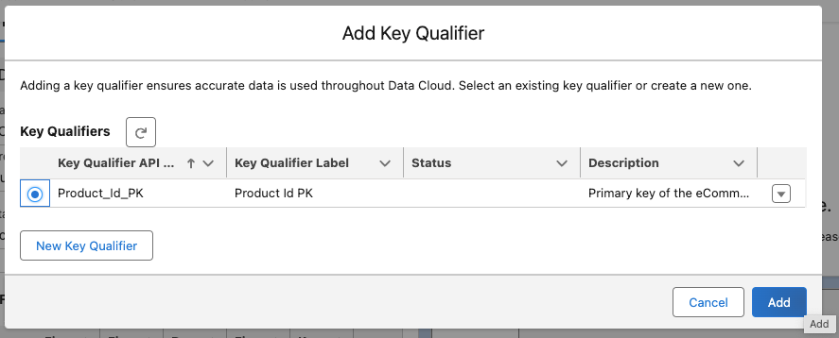
* Verify it was configured by clicking on the 🔽 next to **KQ_Product_Id** field and choosing View Key Qualifiers option:
  + 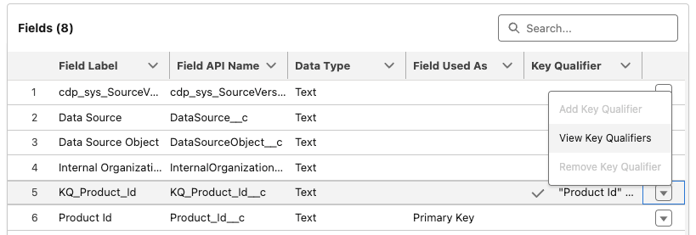
* You will see configured key qualifier in the list:
  + 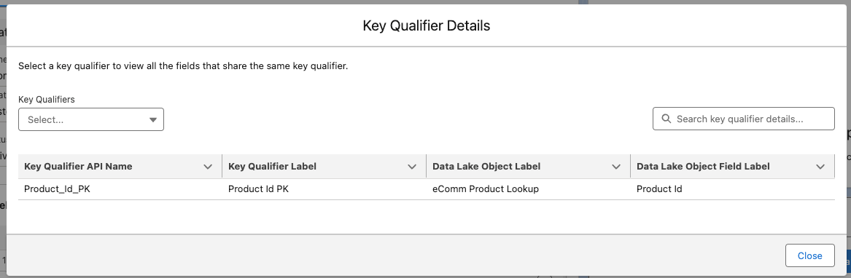

This key qualifier now when combined with primary key will provide accurate reference to the respective record in scenarios when there are multiple sources of data with same values.

**3.6.2 Create Related Activity DLO**

Next let’s configure another object for the related activity lookup records.

* From the **Data Lake Objects** tab create new object choosing **New** option in method selection
* Set following properties:
  + Data Lake Object Name = eComm Related Activity Lookup
  + Category = Other
  + Add following new fields:
    - Field Label = Related Activity, Data Type = Text, Primary Key = ☑️
      * 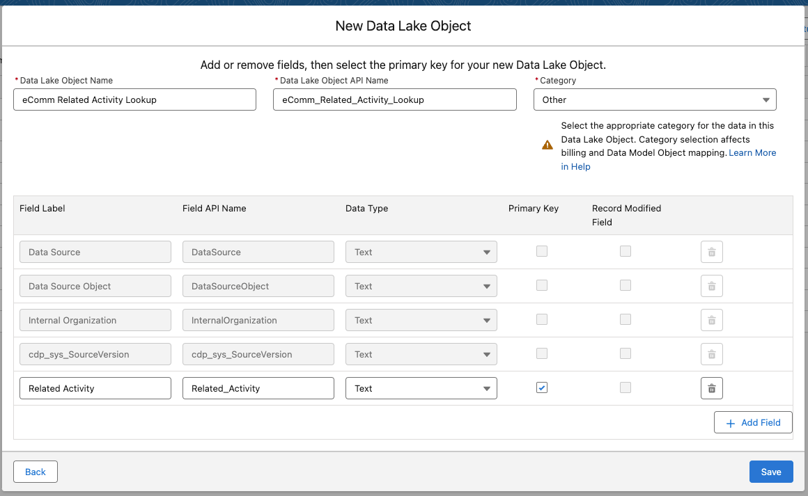
* Save the object.

We won’t configure key qualifier for this object, as it simply represents the collection of category values. Even if they will be coming from various sources the design of the object is quite simple and will handle same values without issues.

**3.6.3 Add Created DLOs to the Data Space**

In order for us to use the created DLOs in the solution configuration by mapping to the data model they need to be associated with the default data space.

* Navigate to **Data Spaces** tab and open **default** data space by clicking on it’s name
* Click **Add Data Lake Objects** in top right
* Choose both DLOs created in previous steps and proceed to the next step:
  + 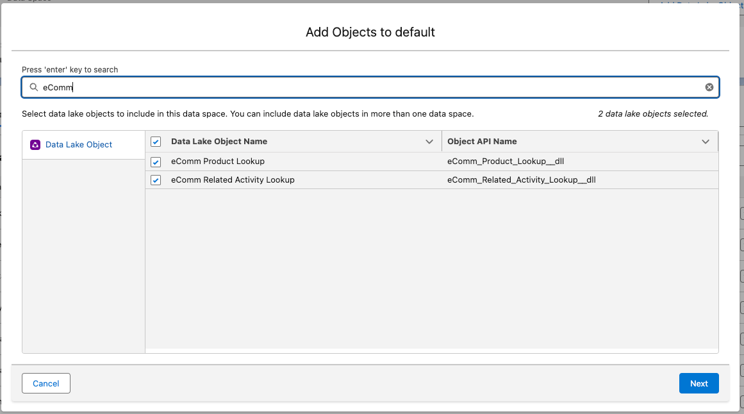
* Confirm your intent to add them without filters and save configuration:
  + 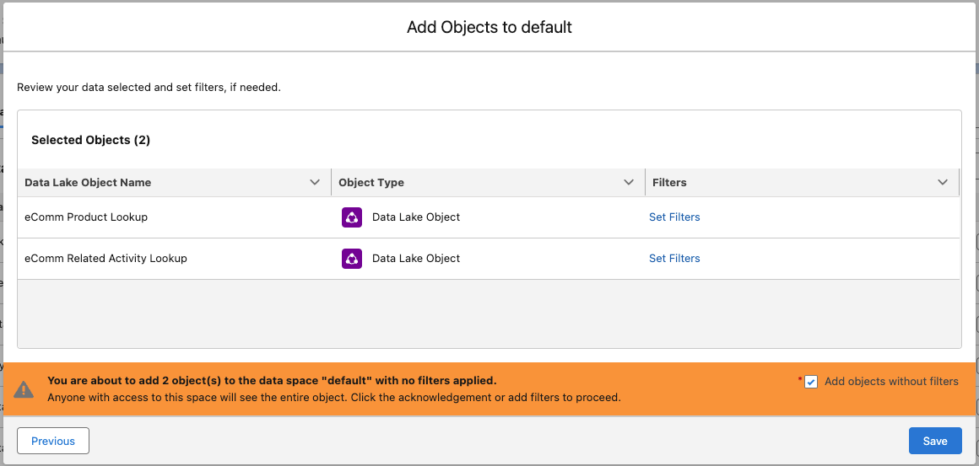

Next we proceed with creation of the data transform that will be used to populate those objects.

**3.6.4 Create Batch Data Transform populating Lookup DLOs**

For both lookup DLOs we need to extract unique set of records. To achieve this we will use **eComm Line Item** records, get unique product SKUs and related activities and then output the resulting data sets into previously configured DLOs.

* Navigate to **Data Transforms** tab and start configuration of a new data transform
* Choose **Batch Data Transform** type and proceed to the next step
* Choose **Data Lake Objects** and proceed to the next step

You’ll be taken to the Batch Data Transform canvas where you can author the actual transformations. Start by adding input data to the canvas:

* Choose **eComm Line Item** object, deselect all fields and re-select only following:
  + Related Activity
  + SKU
    - 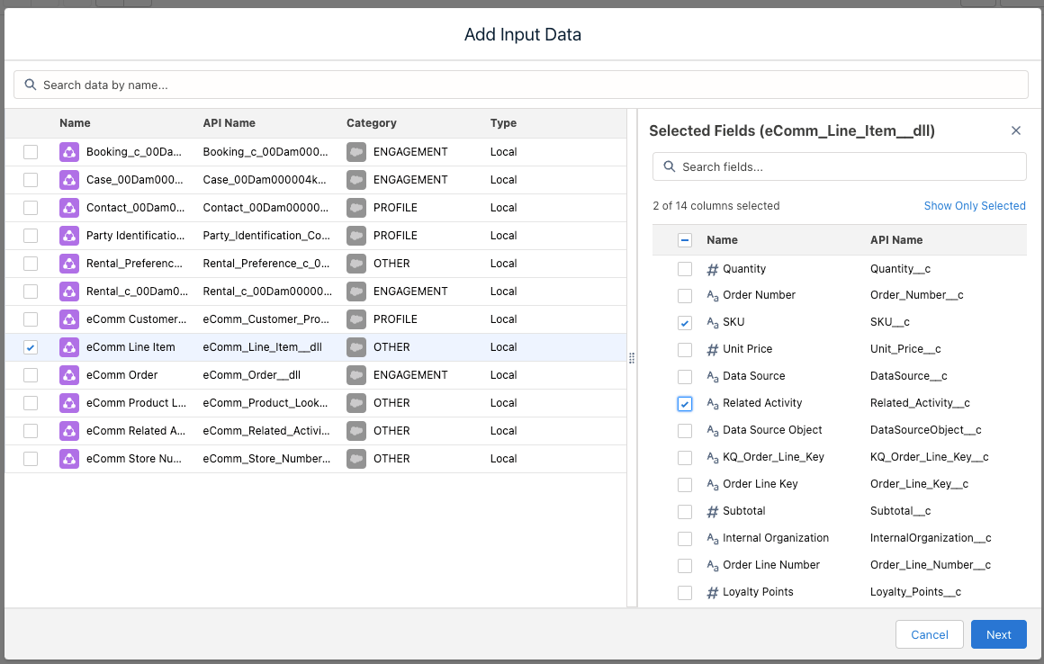
* Proceed to the next step
* Add an aggregate node to the data source:
  + 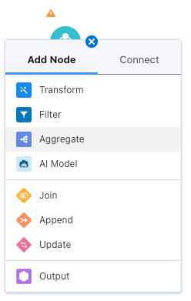
  + Update the name to Get Unique Related Activities
  + Add an aggregate:
    - UniqueRelated Activity
  + Add a row grouping:
    - Related Activity
  + 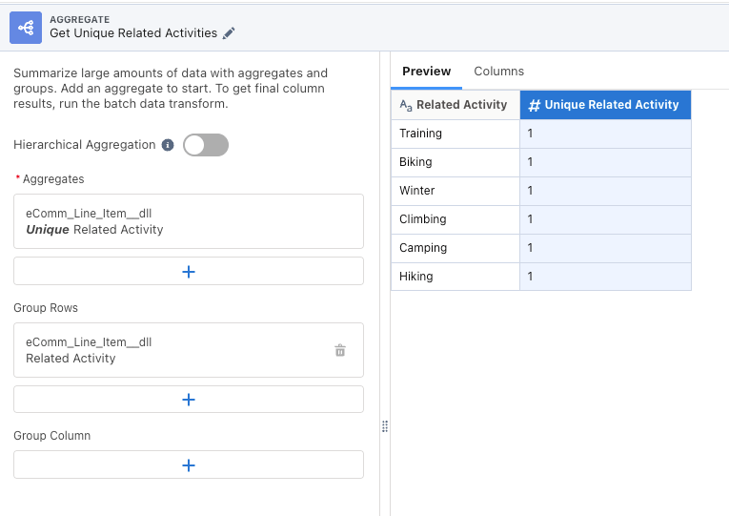
  + Click **Apply** to save the configuration of the aggregate node.
* Add another aggregate node to the data source:
  + Update the name to Get Unique Product SKUs
  + Add an aggregate:
    - UniqueSKU
  + Add a row grouping:
    - SKU
    - Related Activity
  + 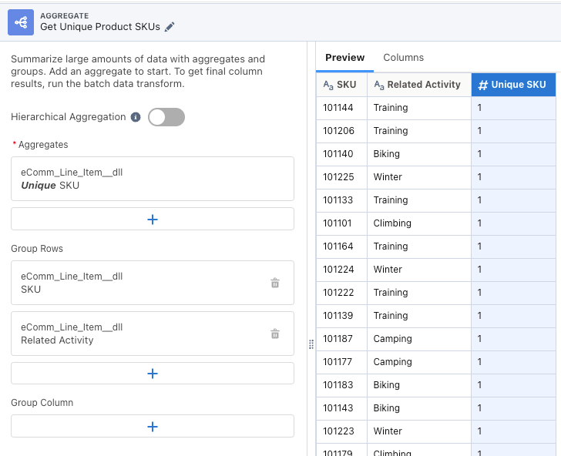
  + Click **Apply** to save the configuration of the aggregate node.
* Your canvas should now look like this:
  + 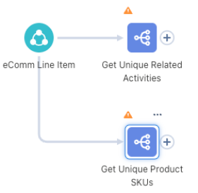
* Add an output node to the **Get Unique Related Activities** aggregate node:
  + 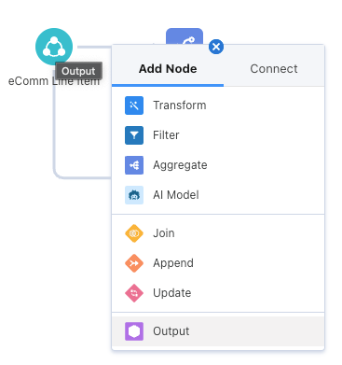
  + Rename to Output Related Activities
  + Set Data Lake Object Name = eComm Related Activity Lookup
  + Keep suggested mapping of Related Activity to Related_Activity__c
    - 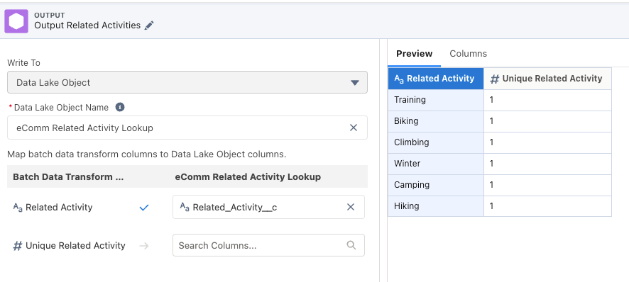
  + Click **Apply** to save the configuration of the output node.
* Following similar process add an output node to the **Get Unique Product SKUs** aggregate node
  + Rename to Output Product SKUs
  + Set Data Lake Object Name = eComm Product Lookup
  + Map SKU to Product_Id__c
  + Keep suggested mapping of Related Activity to Related_Activity_Id__c
    - 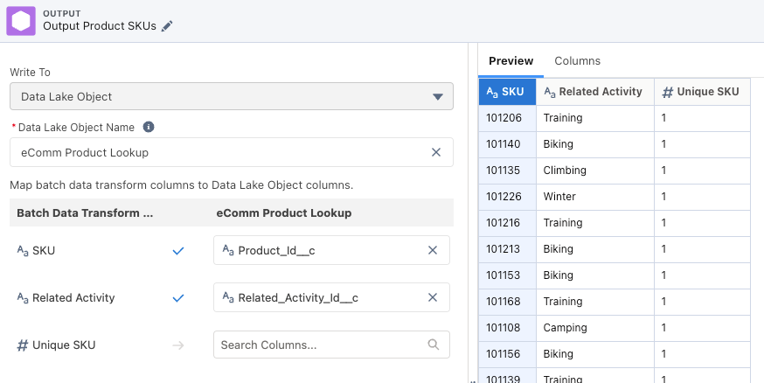
  + Click **Apply** to save the configuration of the output node.

Your canvas should now look like this:

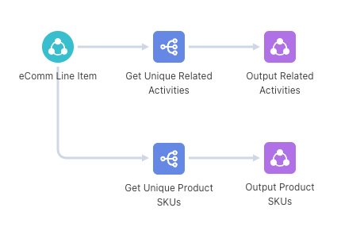

Click **Save** button and set name = Extract Unique Product SKUs and Related Activities and save the data transform. Click **← Back to Data Transforms** button to close the editor and return to the Data Transforms tab. In the list click on the 🔽 button on the right of the newly created data transform and choose **Schedule** option:

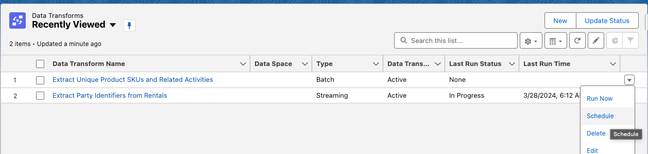We won’t be scheduling the run of the data transform, but to compare review available options under the **Scheduled** option of **Run Mode**:

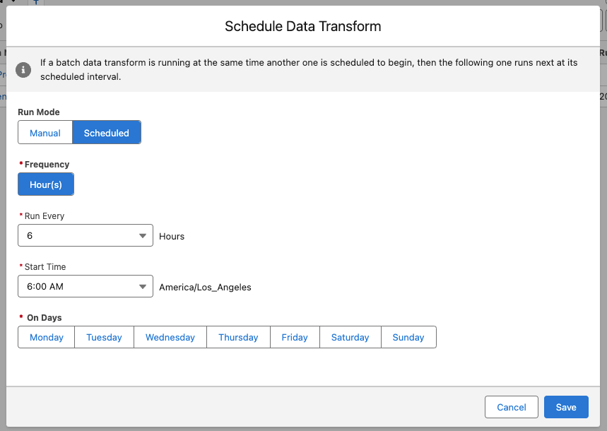Cancel the setting and using the same 🔽 control open menu and choose **Run Now** option:

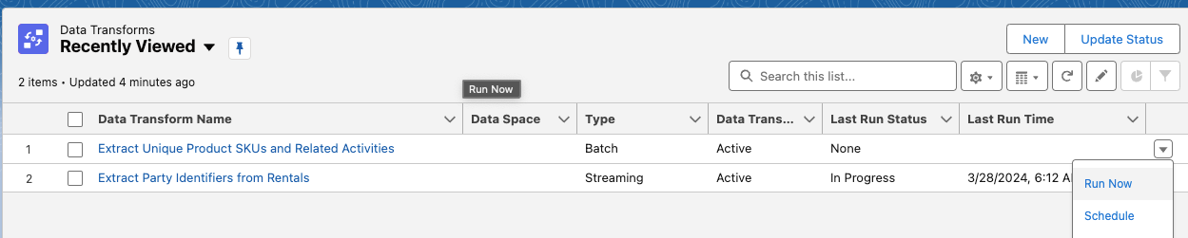Once the processing completes you will be able to verify the results in the corresponding data lake objects.

⚠️ *Note that first processing of the data transform might take a while to get started. You don’t need to wait until it’s finish, rather come back at the completion of the next exercise to verify records count as listed below.* ⚠️

**4. Validation**

Once you configured all above-listed data streams and data transforms, and the data for them has been ingested (you might need to use **Update Status** button to refresh it) and processed validate the **Total Records** counts for each respective stream under the **Data Streams** tab:

* Booking__c_<ORG_ALIAS> = 8
* Case__c_<ORG_ALIAS> = 5
* Contact__c_<ORG_ALIAS> = 100
* eComm Customer Profile = 100
* eComm Line Item = 649
* eComm Order = 252
* eComm Store Number Lookup = 35
* Rental__c_<ORG_ALIAS> = 22
* Rental_Preference__c_<ORG_ALIAS> = 7

As we have two data transforms configured navigate to the **Data Lake Objects** tab and verify **Total Records** count for the following objects (you might need to use **Update Status** button to populate the details):

* eComm Product Lookup = 125
* eComm Related Activity Lookup = 6
* Party Identification Collection = 16

**Configure Batch Data Transform:**

**Additional Steps - Evaluate If Required**

If you are exploring Batch Data Transform as an alternative to Streaming Data Transform, meaning you only configuring batch version then simply follow the document without any alterations.

If you are in fact configuring batch version **in addition** to streaming version then you need to create another data lake object as two data transforms as long as they are not both streaming type can not populate the same destination DLO. This will be quite easy, as you already created **Party Identification Collection** DLO.

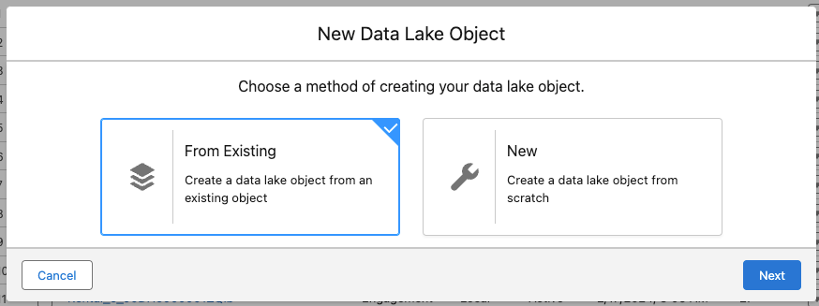Therefore for this guide create new DLO using **From Existing** option in the configuration dialog...

... and then selecting **Party Identification Collection** in the list

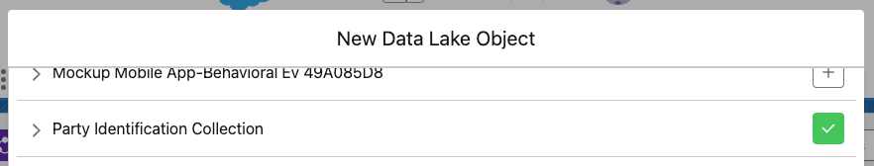Set the name to Party Identification Collection - Batch to distinguish both easily, choose Profile as category and save. Ensure to add this object to the **default** data space prior to continuing with the main section below.

This should be the only change needed in order to proceed with this guide and configure batch data transform in addition to the streaming version. Do note that you’ll need to use **Party Identification Collection - Batch** object in the output node of the last step of configurations below. Don’t worry, if you’ll forget this the platform will give you a warning with error notification upon attempt to save.

**Main Section**

This guide will walk you through the steps of configuration of the Batch Data Transform to extract necessary Party Identification records from various DLOs.

* Navigate to **Data Transforms** tab and create new data transform.
  + ***Note***: You may need to click the **More** in the navigation bar in order to view this tab:
  + 
* Select Batch Data Transform and click **Next**
  + 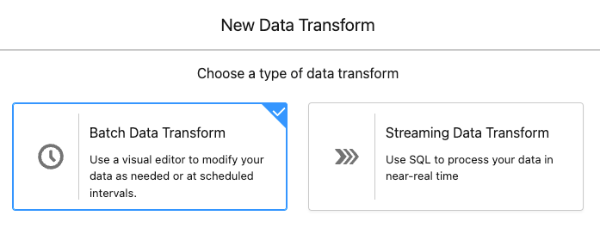
* Select Data Lake Objects and click **Next**
  + 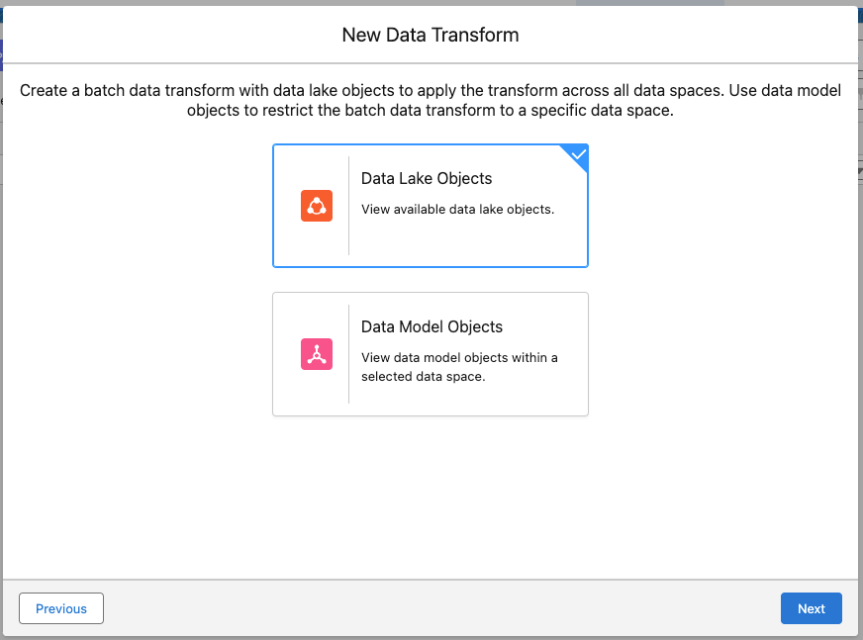
* The action will open the new browser tab/window where you will configure necessary transformation steps.

**1. Configure Input Data**

To begin with the transforms we first need to identify the source of the data that will be manipulated.

* Click on **Add Input Data** button
* Choose **Rental__c_<ORG_ALIAS>** object and remove selection from all fields clicking on the checkbox next to the **Name** title:
  + 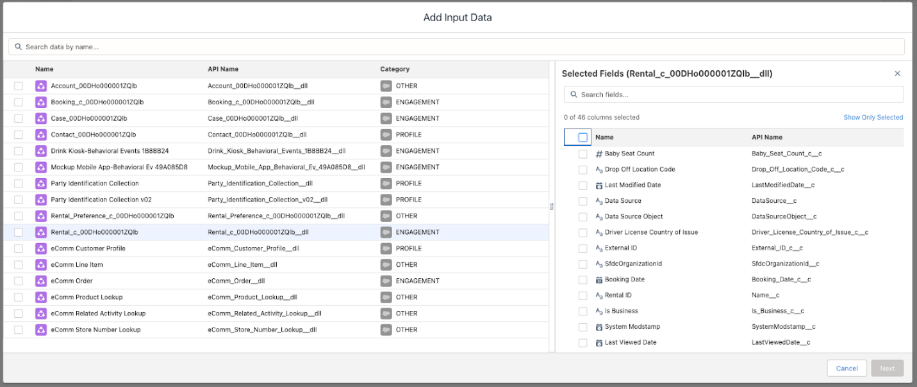
* Locate and select the following fields:
  + Customer
  + Driver License Number
  + Airline Membership Number
  + Motor Club Number
  + RAVG Retail Membership Number
  + 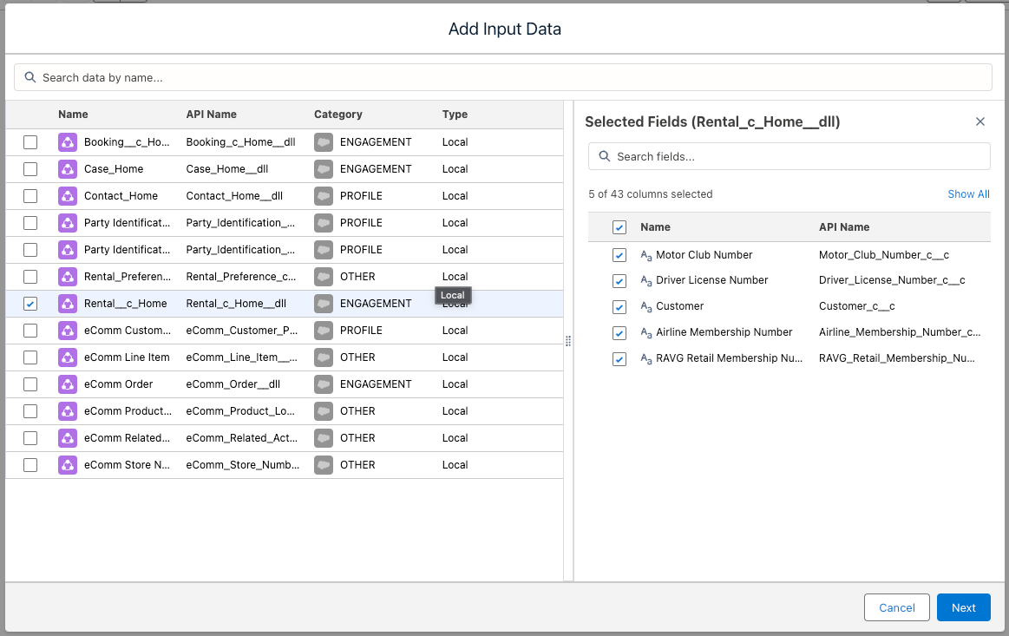
* Click **Next** to close the dialog. You will have new node added to the canvas:
  + 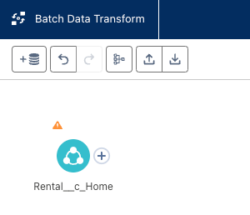

**2. Filter And Transform Records**

As we are operating with 4 various identifiers in the next steps we’ll be separating records that have respective identifiers provided with the rental records.

**2.1 Driver License Number**

This part of the process will extract details from records with Driver License Number specified in the Rental record.

* Add a new **Filter** node to the canvas:
  + 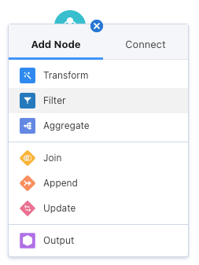
  + Click on 🔽 (arrow down) icon in the **Filters** pane and choose Add Custom Expression:
    - 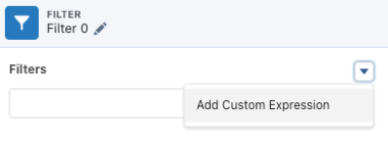
  + Use following expression value = char_length(Driver_License_Number_c__c) > 0
  + Verify that you get **22** records in the Preview (you’ll have to manually count rows)
    - 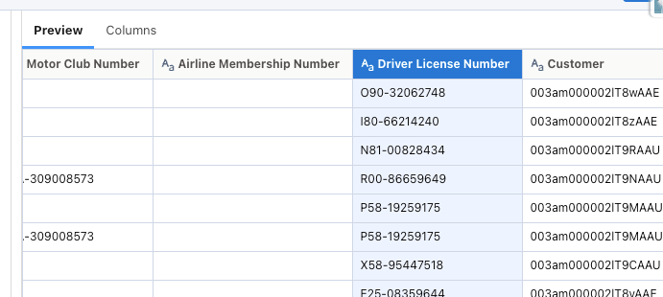
  + Update the name of the filter to Filter Driver Licenses:
    - 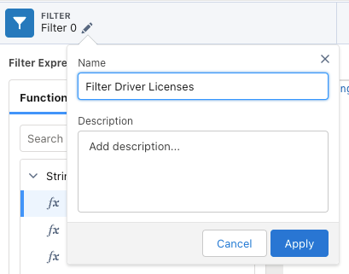
  + Apply changes. Your canvas should look similar to this:
    - 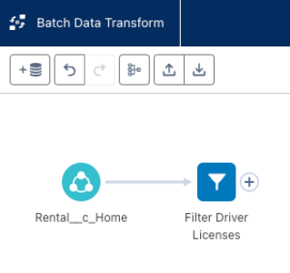
* Add a new **Transform** node after the previously configured filter:
  + 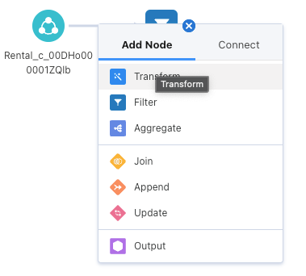
  + As we only focus on Driver Licenses let’s remove other identification columns. Click on **Drop Columns**:
    - 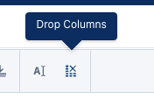
  + In the list of columns choose following:
    - RAVG Retail Membership Number (will be preselected)
    - Airline Membership Number
    - Motor Club Number
      * 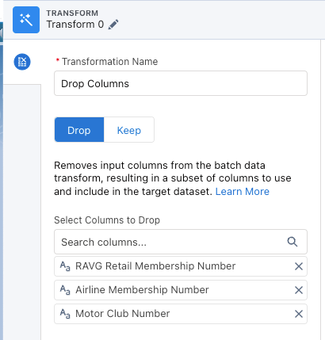
  + Click **Apply** to save the change
  + With selected **Driver License Number** column click on **Edit Attributes** icon:
    - 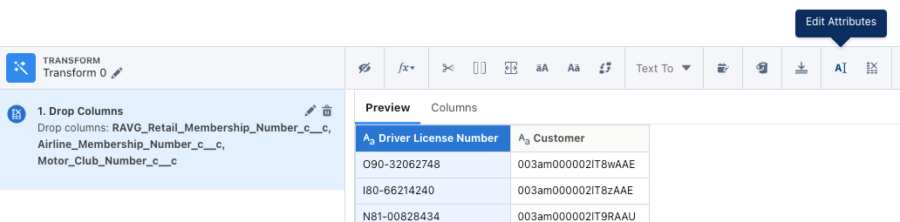
  + and update the details as follows:
    - Set **Label** = Identification Number
    - Set **API Name** = Identification_Number__c
      * 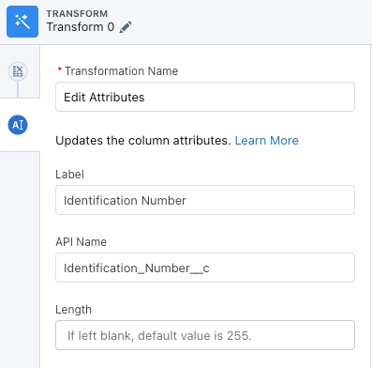
    - Click **Apply**
  + Update the name of the node to Drop and Rename DL Columns:
    - 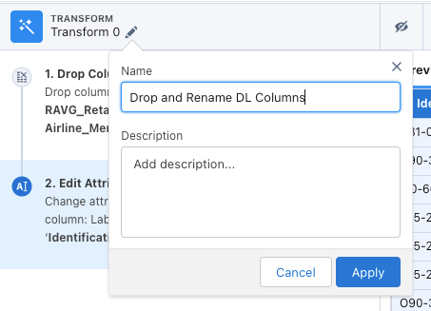

Notice that our resulting dataset contains duplicate values if you are to compare combination of **Identification Number** and **Customer** fields.

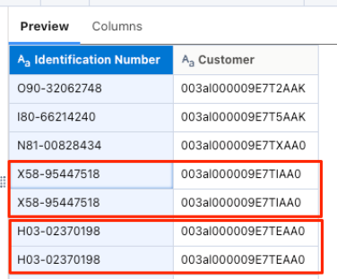

Let’s address this.

* Close the details of the Transform node and add a new **Aggregate** node to it:
  + 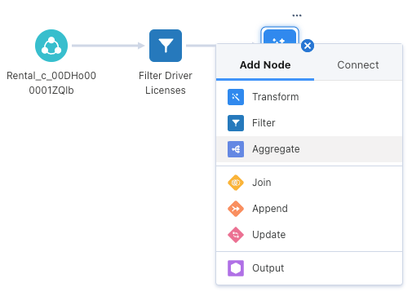
* Click on **+** to add new aggregate
  + Select **Unique** and then **Identification Number**
    - 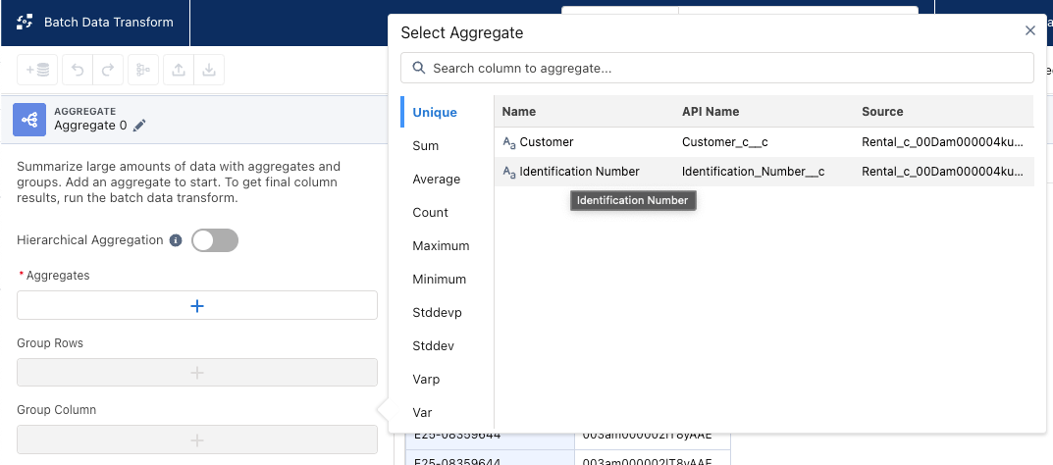
  + Add following **Group Rows** options in this exact order:
    - Customer
    - Identification Number
      * 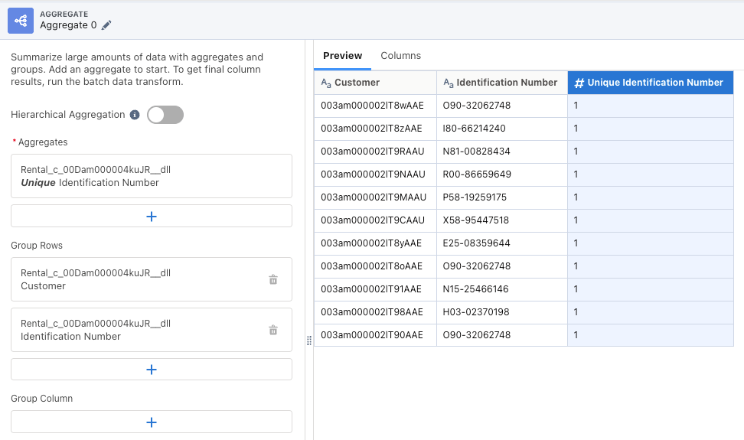
  + Click **Apply**
  + Notice in the Preview that you are now getting only **11** records
  + Rename the node to Select Unique DL Identifiers
  + Apply the changes. Your canvas should look similar to this:
    - 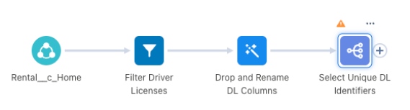
* There are few extra fields that we need for the final result. Let’s add those. Add a new **Transform** node after the previously configured aggregate:
  + 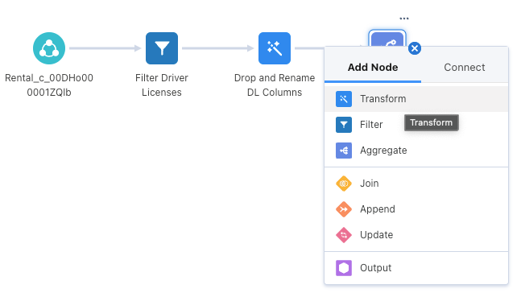
  + Add **Custom Formula**
    - 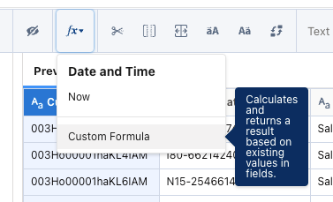
    - Set value = concat(Customer_c__c, '_', Identification_Number__c)
    - Set **Output Type** = Text
    - Keep **Length** with value **40**
    - Set **Column Label** = Party Identification ID
    - Set **API Name** = Party_Identification_ID__c
    - Click **Apply**
  + Add another **Custom Formula:**
    - Value = 'Person Identification' (notice single quote characters, as we are hardcoding text value)
    - Output Type = Text
    - Keep **Length** with value **40**
    - Column Label = Party Identification Type
    - API Name = Party_Identification_Type__c
  + Add another **Custom Formula:**
    - Value = 'Driver License' (including single quote characters, as we are hardcoding text value)
    - Output Type = Text
    - Keep **Length** with value **40**
    - Column Label = Identification Name
    - API Name = Identification_Name__c
  + The configuration of the node should look similar to this:
    - 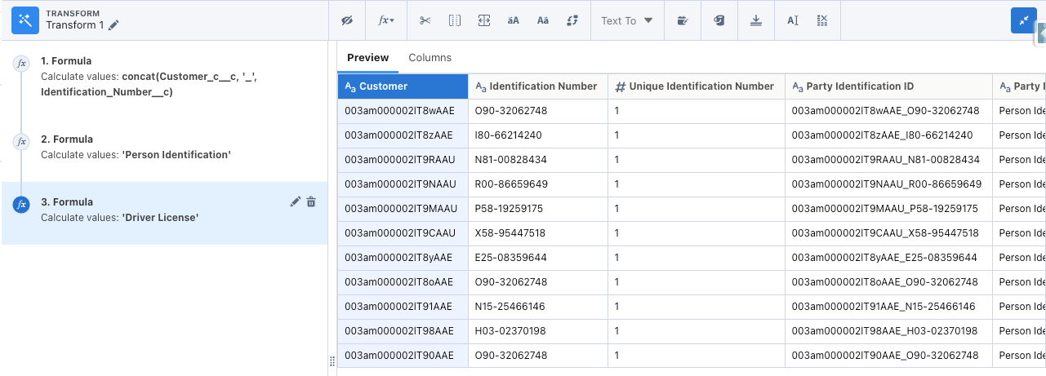
  + Rename the node to Add DL Formula Fields
  + Apply the changes. Your canvas should look similar to this:
    - 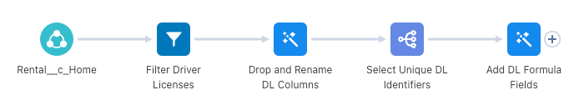

Now we can apply similar configurations for the other identifiers. Although before moving to next steps let’s save the progress by clicking the **Save** button in the top right, set the name Extract Party Identifications from Rentals (Batch) and try saving your progress. You’ll notice that the configuration will not be saved as there is no output node configured for the transform:

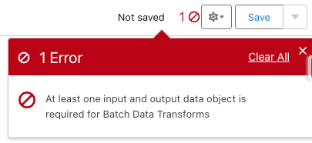

Let’s add one to ensure we can save the progress. Close the error notification and add **Output** node after the last transform:

* 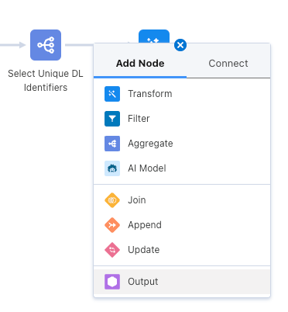
* Choose Party Identification Collection (or Party Identification Collection - Batch if you already have streaming insight configured) object and configure options as follows:
  + Notice that mapping is mostly completed for you as the names of the fields are matched
  + Map **Customer** field to the Party__c
  + Leave **# Unique Identification ...** unmapped (data source fields will be automatically populated in the destination DLO)
  + 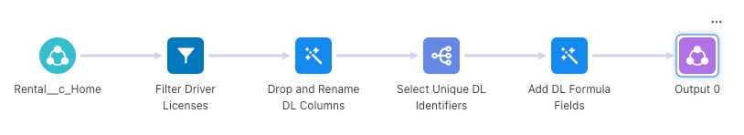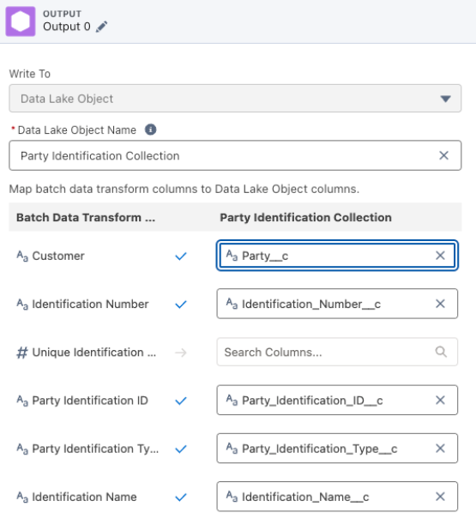
* Apply the changes. Your canvas should look similar to this:

Now let’s actually save your work. Click on the **Save** button, set the name Extract Party Identifications from Rentals (Batch) and save your progress. This time you should see confirmation of successful save.

**2.2 Airline Membership Number**

While we can repeat most of the configuration steps above let’s try simplifying the process a little. Select all the transformation nodes that you’ve configured in the previous section (excluding **Output 0**) with click-n-drag overlay over them:

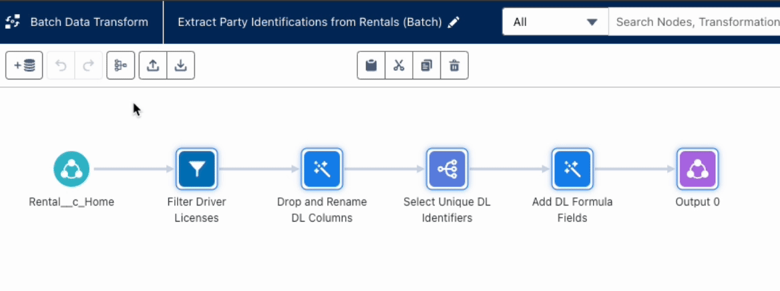

And once selected click on the **Duplicate nodes** icon above:

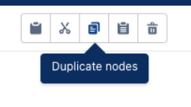

Before adjusting configuration of the duplicated nodes connect the Filter to the Input Data node:

* Click on the split-arrows icon on the **Rental** Input Data node:
  + 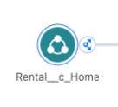
* Switch to the **Connect** tab and choose **Filter Driver Licenses Copy** node:
  + 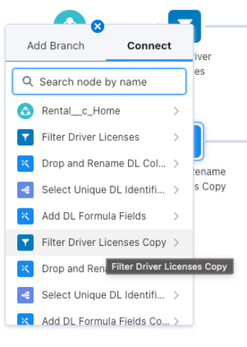
* and choose **Connect Nodes**:
  + 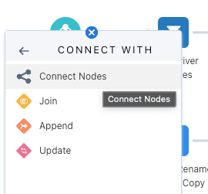

You’ll be switched to the configuration of the Filter node, so let’s reconfigure it as well as others for the next identifier.

* Update the name of the node to Filter Airline Membership Numbers
* Update the filter expression to char_length(Airline_Membership_Number_c__c) > 0
  + Verify that you get **5** records in the Preview
* Apply the changes
* Select **Drop and Rename DL Columns Copy** node
  + Update name to Drop and Rename AIR Columns
  + Delete second step in the transform:
    - 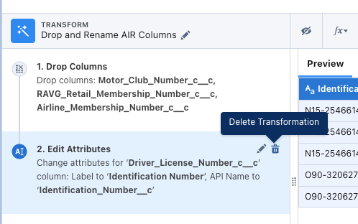
  + Click on 🖊️ icon to edit first step:
    - 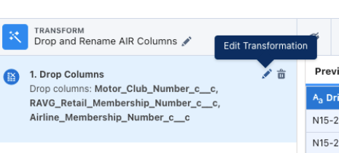
  + In the list of columns to drop remove **Airline Membership Number** and add **Driver License Number**:
    - 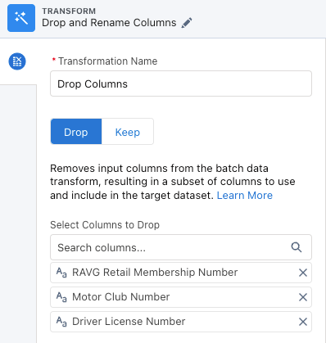
  + Apply the change and verify that you now see **Airline Membership Number** column in the Preview.
  + With selected **Airline Membership Number** column click on **Edit Attributes** icon and update details as follows:
    - Set **Label** = Identification Number
    - Set **API Name** = Identification_Number__c
  + Apply changes and close the details of the node.
* The following aggregate node will be highlighted with an error state and you will get an error notice popup on the right and that’s okay, as we’ll be correcting it next:
  + 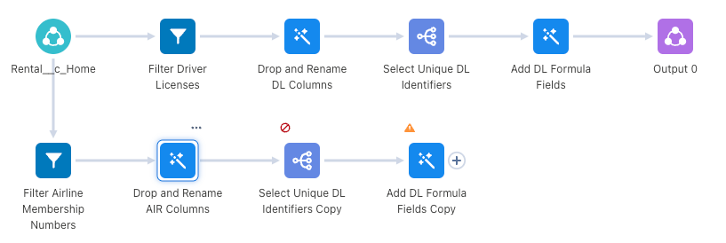
* Select **Select Unique DL Identifiers Copy** node
  + Update name to Select Unique AIR Identifiers
  + In the **Aggregates** click on the current value and change selection to **Unique** and **Identification Number**
  + In the **Group Rows** delete all fields but **Customer** and re-add **Identification Number:**
    - 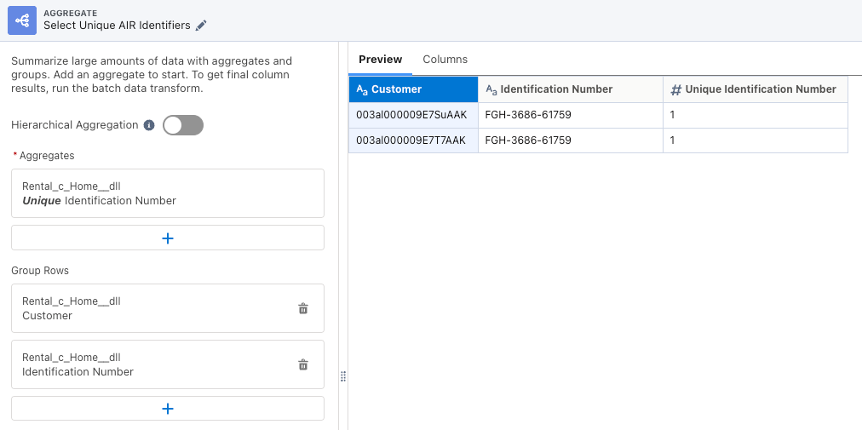
  + Notice that you now only get **2** records in the Preview.
  + Apply changes and close the details of the node.
* Select **Add DL Formula Fields Copy** node:
  + Rename to Add AIR Formula Fields
  + Click on the step 1 and then edit icon:
    - 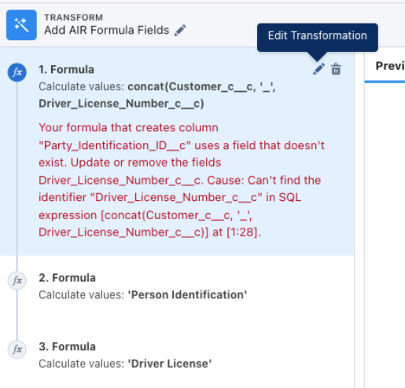
    - Update the formula expression to concat(Customer_c__c, '_', Identification_Number__c)
  + Select and edit step 2:
    - Update the formula expression to 'Loyalty Program'
  + Select and edit step 3:
    - Update the formula expression to 'Airline Membership'
  + The node configuration should look similar to this:
    - 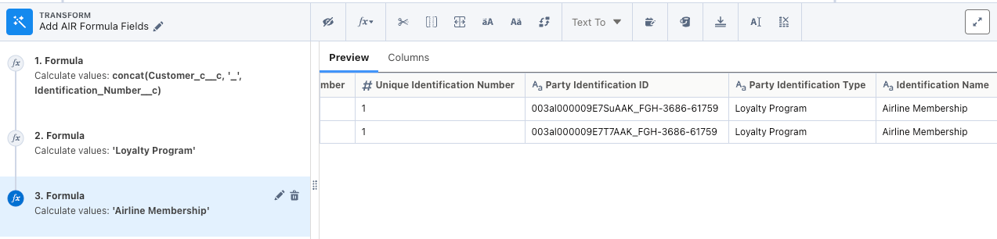

Two out of four identifiers are catered for, save the progress by clicking on the **Save** button and let’s move to the next one.

**2.3 Motor Club Membership**

Following a similar approach select and duplicate 4 nodes that you just configured for the Airline Membership Number and connect **Rental** Input Data node with the filter node:

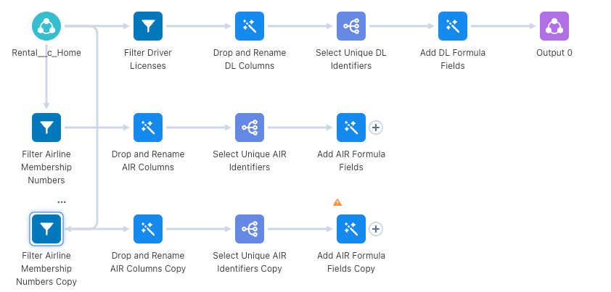

The layout got a little bit mixed up, but we’ll fix it shortly.

* Configure the opened filter activity as follows:
  + Set name = Filter Motor Club Numbers
  + Set expression = char_length(Motor_Club_Number_c__c) > 0
  + Verify that you get **2** records in the Preview
  + Apply the changes
* Configure the following transform node as follows:
  + Set name = Drop and Rename MC Columns
  + Delete second step in the transform
  + Click on 🖊️ icon to edit first step
  + In the list of columns to drop remove **Motor Club Number** and add **Airline Membership Number**
  + Apply the change and verify that you now see **Motor Club Number** column in the Preview.
  + With selected **Motor Club Number** column click on **Edit Attributes** icon and update details as follows:
    - Set **Label** = Identification Number
    - Set **API Name** = Identification_Number__c
  + Apply changes and close the details of the node.
* Configure the following aggregate node as follows:
  + Update name to Select Unique MC Identifiers
  + In the **Aggregates** click on the current value and change selection to **Unique** and **Identification Number**
  + In the **Group Rows** delete all fields but **Customer** and re-add **Identification Number**
  + Apply changes and close the details of the node
* Configure the following transform node as follows:
  + Rename to Add MC Formula Fields
  + Select and edit step 1 updating the expression to concat(Customer_c__c, '_', Identification_Number__c)
  + No need to update second step
  + Select and edit step 3 updating the expression to 'Motor Club Membership'

Now before we proceed to the next identifier let’s rearrange the nodes on the canvas. Click on the **Clean up nodes** button

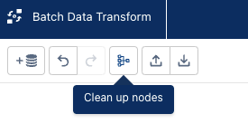

and the tool will lay the nodes in a nice way without any confusing intertwining:

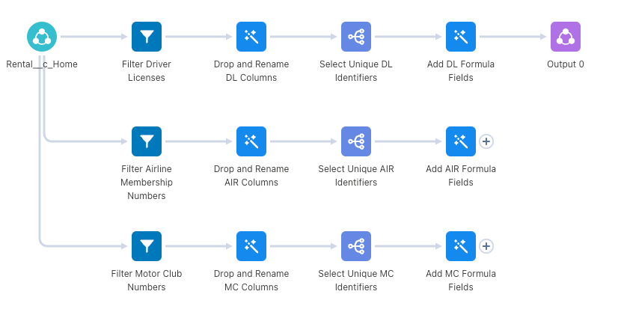

Save your progress. Now to the last remaining identifier.

**2.4 RAVG Retail Membership Number**

Continue with the previously chosen approach duplicate 4 nodes that you’ve just configured for the Motor Club Numbers connect **Rental** Input Data node with the filter node.

* Configure the opened filter activity as follows:
  + Set name = Filter RAVG Memberships
  + Set expression = char_length(RAVG_Retail_Membership_Number_c__c) > 0
  + Verify that you get **1** record in the Preview
  + Apply the changes
* Configure the following transform node as follows:
  + Set name = Drop and Rename RAVG Columns
  + Delete second step in the transform
  + Click on 🖊️ icon to edit first step
  + In the list of columns to drop remove **RAVG Retail Membership Number** and add **Motor Club Number**
  + Apply the change and verify that you now see **RAVG Retail Membership Number** column in the Preview.
  + With selected **RAVG Retail Membership Number** column click on **Edit Attributes** icon and update details as follows:
    - Set **Label** = Identification Number
    - Set **API Name** = Identification_Number__c
  + Apply changes and close the details of the node.
* Configure the following aggregate node as follows:
  + Update name to Select Unique RAVG Identifiers
  + In the **Aggregates** click on the current value and change selection to **Unique** and **Identification Number**
  + In the **Group Rows** delete all fields but **Customer** and re-add **Identification Number**
  + Apply changes and close the details of the node
* Configure the following transform node as follows:
  + Rename to Add RAVG Formula Fields
  + Select and edit step 1 updating the expression to concat(Customer_c__c, '_', Identification_Number__c)
  + No need to update second step
  + Select and edit step 3 updating the expression to 'RAVG Retail Membership'
* Click on the **Clean up nodes** button to re-arrange the canvas

**3. Combining Results**

At this stage we have 4 separate datasets that are representing selection of different records but with the same field structure plus one of the datasets is configured with the output node.

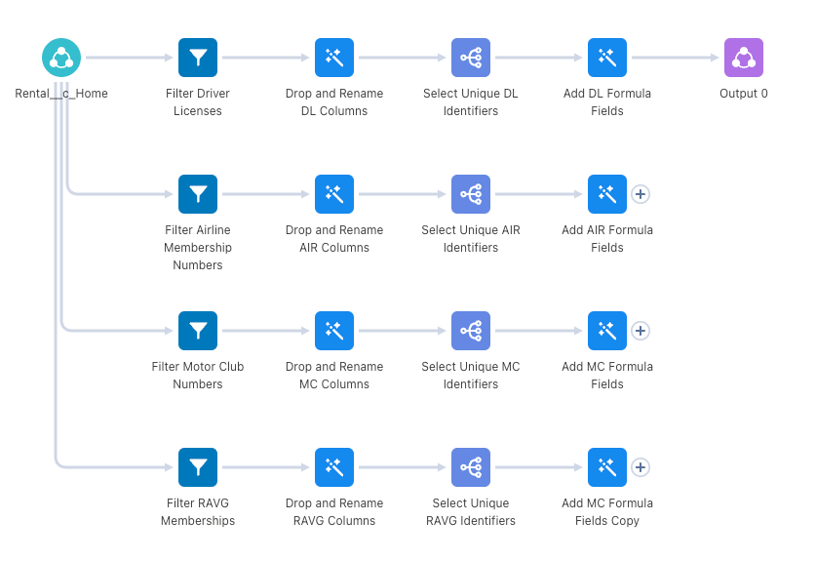

We are now going to combine all of the datasets together into a single dataset that will be later used as an overall output of this data transform.

* Starting at the second row, click on the **+** icon next to the **Add AIR Formula Fields** node and drag it to the one above it (**Add DL Formula fields**) and release the mouse key when you hover over the **Append** option:
  + 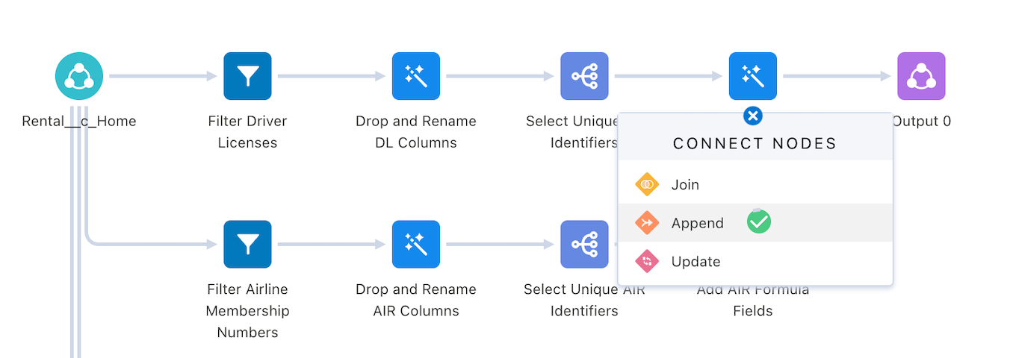
  + If you can’t make that work you can also click on the **+** icon next to the **Add AIR Formula Fields** node, in the dialog switch to **Connect** tab and then choose **Add DL Formula Fields** node in the list and choose **Append** option there
    - 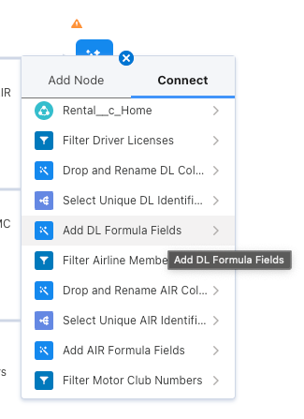
* Review the field mapping between those datasets, these should’ve been mapped for you as we’ve got the same names for each of the attributes:
  + 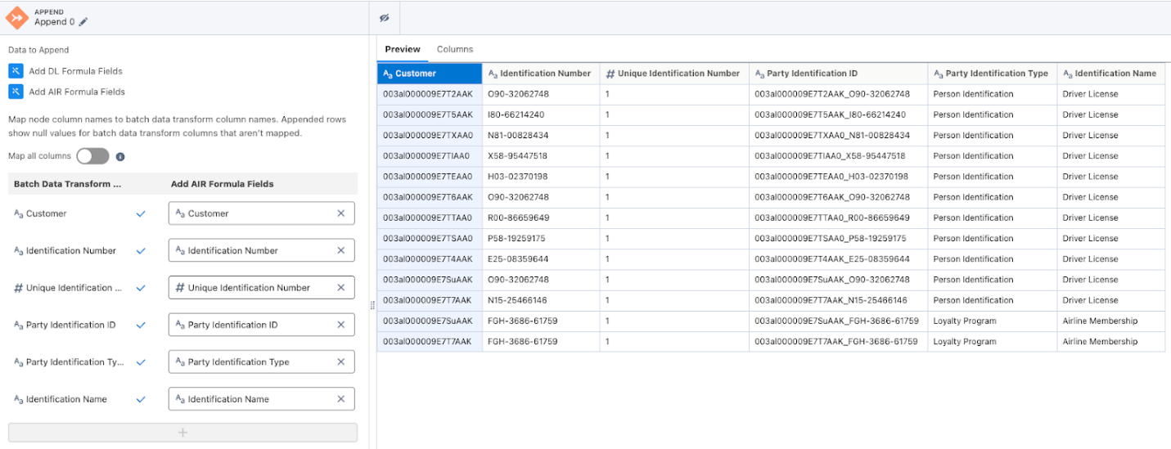
* Now repeat the approach connecting newly configured **Append 0** node with **Add MC Formula Fields** node
* Then repeat the process for **Append 1** and last **Add RAVG Formula Fields** node
* Feel free to use **Clean up nodes** button to clean up layout. The result of the configurations should look as follows:
  + 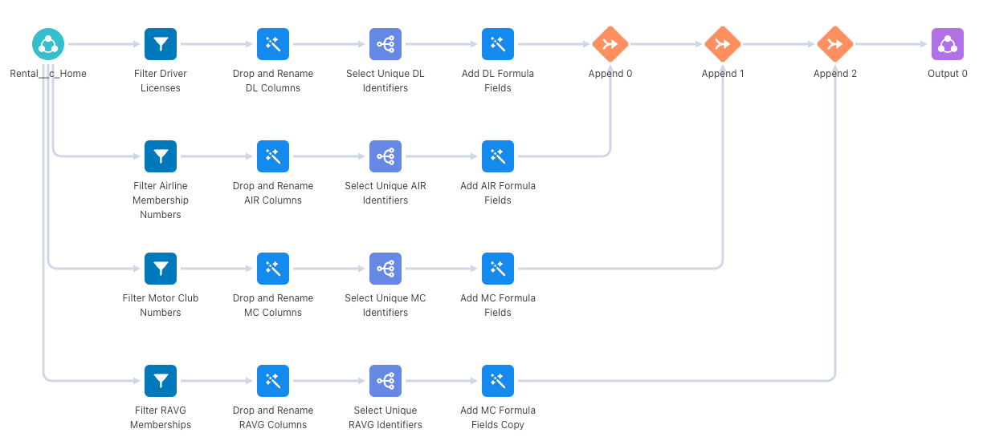

It’s time to save your progress and return to the Data Transforms list.

In the real implementation next logical step would be to set the schedule for the data transform to run. For the purpose of our exercise let’s initiate manual run to validate the results of the processing. Using 🔽 in the list view choose **Run Now** option from the dropdown:

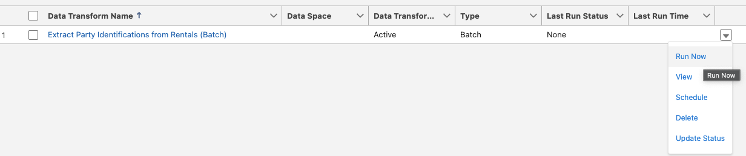Once the process completes (you’ll notice **Last Run Status** changing from **None** to **In Progress** to **Success**) navigate to the **Data Lake Objects** tab and verify that you get **16** records

In this exercise you will map previously configured data streams to the Customer 360 Data Model within your Data Cloud instance.